RBTX robotics marketplace now available in 18 countries
Powered by igus, RBTX continues to expand international offers, making Low Cost Automation accessible in ten additional countries

igus Low Cost Automation reflects the company's determination to lower the barriers to enter into the age of automation. RBTX.com has been part of this effort since 2019. The robotics marketplace helps interested parties find the right automation solution for their individual application as easily, quickly and cost-effectively as possible. Previously, RBTX was available in eight countries. Now igus is expanding the range and launching the robotics marketplace in ten additional countries - with three more soon to follow.

To ensure their own competitiveness, more and more companies are automating their processes. However, investment costs (usually high) and the lack of expertise still often represent an obstacle - especially for small and medium-sized companies. This is where RBTX powered by igus comes into play: the offer includes an online marketplace for cost-effective robotic components and complete solutions, the RBTXpert remote integration service and customer testing areas at various locations across the globe, where planned customer applications can be tested live before purchase. This follows our "test before you invest" principle. RBTX thus makes automation accessible to everyone - bakeries, pharmaceutical laboratories and automotive OEMs. "Our RBTX online marketplace grew significantly in the last year," says Alexander Mühlens, Head of the Automation Technology and Robotics Business Unit at igus. "We started in Germany in 2019. Since our offer was very well-received, and demand is constantly growing, we expanded RBTX to Austria, France, Great Britain, the US, Canada, India and Singapore in the last years. We are still continuously working on becoming active in other countries, though, to make Low Cost Automation more accessible worldwide. That's why, starting immediately, we are offering RBTX in ten more countries: Poland, Switzerland, Denmark, Italy, Japan, China, Taiwan, South Korea, Vietnam and Thailand. Three more will follow soon: Spain, Brazil and Turkey."

Rapid robot integration with remote services is booming
At RBTX.com, interested parties currently have access to more than 300 individual robotics components from 78 manufacturers and more than 150 complete solutions from real-world applications - including guaranteed hardware and software compatibility. The online marketplace also offers a place for humans and robots to meet. In the Customer Testing Area, customers can work with an RBTXpert in the remote integrator service to test the feasibility of their planned application. The RBTXpert engages in a video call from this environment with those interested in automation and provides individual advice. "In Germany alone, we implement up to 30 projects per week. We also have customer testing areas on site in many other countries, so the RBTXpert can offer support in various languages and time zones," says Alexander Mühlens. "This gives even more interested parties across the globe direct access to a wide range of cost-effective robotics.

Caption:

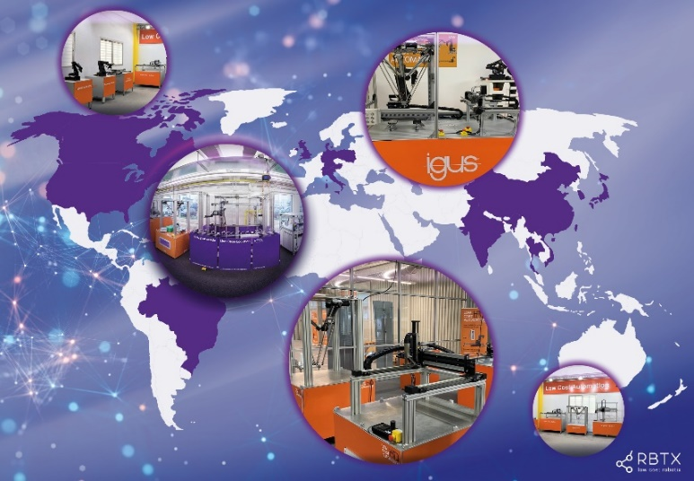
Picture PM0523-1
Driving automation worldwide: rapid integration is now possible in 18 countries thanks to RBTX remote services. (Source: igus GmbH)

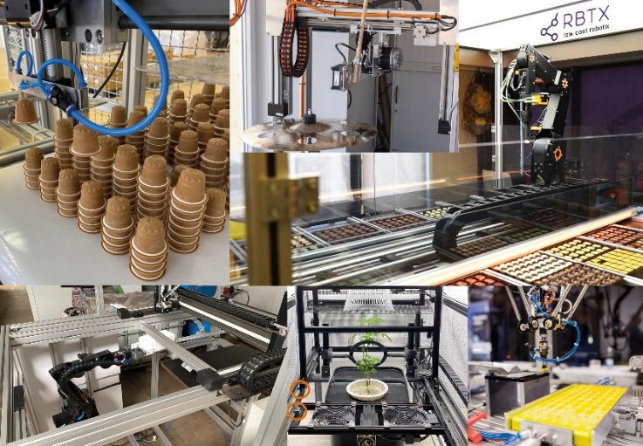
Picture PM0523-2
A praline-dispensing machine, a plant cultivation system or bulk goods sorting: interested parties can find cost-effective complete solutions for their individual automation tasks at RBTX.com. (Source: igus GmbH)

PRESS CONTACT:

Alexa Heinzelmann
Head of International Marketing

igus® GmbH
Spicher Str. 1a
51147 Cologne
Tel. 0 22 03 / 96 49-7272
aheinzelmann@igus.net
www.igus.eu/press

ABOUT IGUS:

igus GmbH develops and produces motion plastics. These lubrication-free, high-performance polymers improve technology and reduce costs wherever things move. In energy supplies, highly flexible cables, plain and linear bearings as well as lead screw technology made of tribo-polymers, igus is the worldwide market leader. The family-run company based in Cologne, Germany, is represented in 31 countries and employs 4,900 people across the globe. In 2021, igus generated a turnover of €961 million. Research in the industry's largest test laboratories constantly yields innovations and more security for users. 234,000 articles are available from stock and the service life can be calculated online. In recent years, the company has expanded by creating internal startups, e.g. for ball bearings, robot drives, 3D printing, the RBTX platform for Lean Robotics and intelligent "smart plastics" for Industry 4.0. Among the most important environmental investments are the "chainge" programme – recycling of used e-chains - and the participation in an enterprise that produces oil from plastic waste.

The terms "igus", “Apiro”, "chainflex", "CFRIP", "conprotect", "CTD", “drygear”, "drylin", "dry-tech", "dryspin", "easy chain", "e-chain", "e-chain systems", "e-ketten", "e-kettensysteme", "e-skin", "e-spool”, "flizz", “ibow”, “igear”, "iglidur", "igubal", “kineKIT”, "manus", "motion plastics", "pikchain", "plastics for longer life", "readychain", "readycable", “ReBeL”, "speedigus", "tribofilament“, "triflex", "robolink", “xirodur”, and "xiros" are protected by trademark laws in the Federal Republic of Germany and internationally, where applicable.

