igus is adding 2,046 new macros to the EPLAN circuit diagram software
EPLAN update for readycable cables that are compatible with Allen Bradley, Beckhoff, B&R, Heidenhain and Fanuc

To make the digital creation of circuit diagrams even more effective, igus is publishing 2,046 new macros for the EPLAN planning software. The addition now also allows pre-assembled readycable cables to be visualised in the software within seconds. The cables are compatible not only with drive components from Siemens, SEW and Bosch Rexroth, but also with those from Allen Bradley, Beckhoff, B&R, Heidenhain and Fanuc.

Mechanical and plant engineering daily routine: control cabinet project planning is on the agenda. It is a task that more and more engineers are accelerating with digital tools. Particularly popular and now an industry standard: EPLAN Electric P8 - planning software for creating circuit and plant diagrams. One of the reasons for its popularity is an online database called EPLAN Data Portal. Here, component manufacturers store so-called macros for their products - building blocks in a uniform data format that can be dragged and dropped into the digital circuit diagram - without any adjustment effort. The tool supports plant design, from end-to-end planning to production, commissioning, maintenance and repair.

Engineers save up to 50% of the time needed for electrical design
"Thanks to the EPLAN Electric P8 CAE software with its consistent, manufacturer-independent database, engineers save up to 50% of the time needed for electrical design. This is a real boost for the automation era, one we would like to support," says Markus Hüffel, Product Manager readychain and readycable at igus. “We have therefore decided to expand the EPLAN Data Portal, adding 2,046 new macros for pre-assembled readycable cables that are compatible with automation technology from Allen Bradley, Beckhoff, B&R, Heidenhain and Fanuc.” Macros for cables for Siemens, SEW and Bosch Rexroth were already available. "We hope that this update offers designers around the world even more options for economical automation solutions."

Macros allow quick, intuitive visualisation
The path to the new macros is open: engineers can select the right pre-assembled cable for their e-chain from the readycable range in the igus online shop - one of over 5,000 ready-to-connect signal, encoder, servo, motor or drive cables. Any EPLAN macro stored for this cable can be downloaded in seconds via a link to the EPLAN Data Portal and used in the planning software. The macro then allows such actions as visualising the cable, including pin assignment and core identification, and linking it to components from other manufacturers in the circuit diagram - as quickly and intuitively as in a computer game. The cables used for online ordering can also be automatically summarised in a parts list.

Video: Find the right EPLAN macro with just a few clicks.
https://igus.eu/how-to-find-eplan-data

Caption:
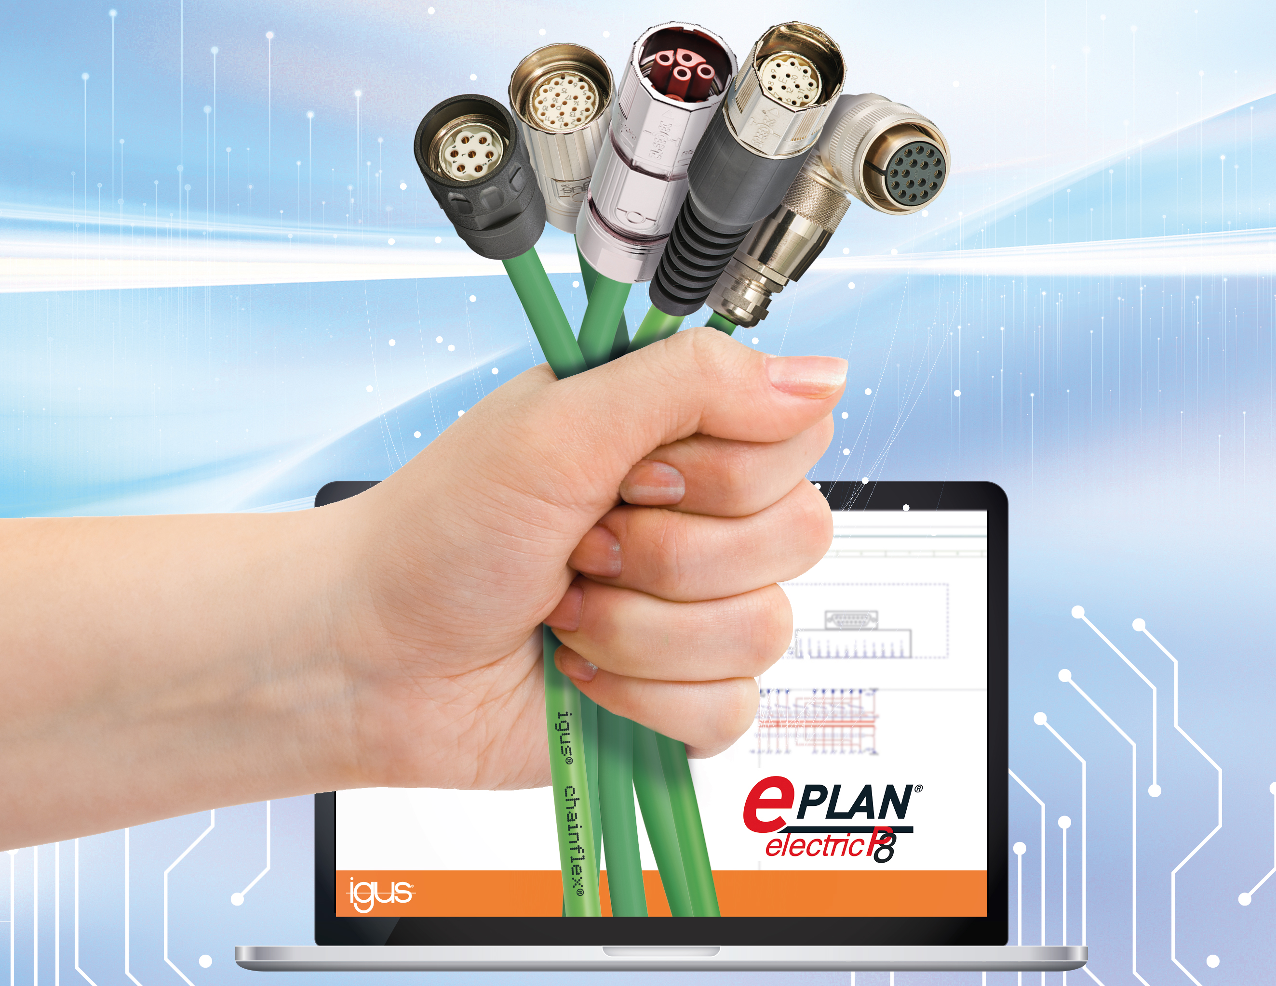
Picture PM4022-1
2,046 new EPLAN macros: the extension now also allows readycable cables to be visualised - cables that are compatible with automation technology from Allen Bradley, Beckhoff, B&R, Heidenhain and Fanuc. (Source: igus GmbH)

PRESS CONTACT:

Alexa Heinzelmann
Head of International Marketing

igus® GmbH
Spicher Str. 1a
51147 Cologne
Tel. 0 22 03 / 96 49-7272
aheinzelmann@igus.net
www.igus.eu/press

ABOUT IGUS:

igus GmbH develops and produces motion plastics. These lubrication-free, high-performance polymers improve technology and reduce costs wherever things move. In energy supplies, highly flexible cables, plain and linear bearings as well as lead screw technology made of tribo-polymers, igus is the worldwide market leader. The family-run company based in Cologne, Germany, is represented in 35 countries and employs 4,900 people across the globe. In 2021, igus generated a turnover of €961 million. Research in the industry's largest test laboratories constantly yields innovations and more security for users. 234,000 articles are available from stock and the service life can be calculated online. In recent years, the company has expanded by creating internal startups, e.g. for ball bearings, robot drives, 3D printing, the RBTX platform for Lean Robotics and intelligent "smart plastics" for Industry 4.0. Among the most important environmental investments are the "chainge" programme – recycling of used e-chains - and the participation in an enterprise that produces oil from plastic waste.

The terms "igus", “Apiro”, "chainflex", "CFRIP", "conprotect", "CTD", “drygear”, "drylin", "dry-tech", "dryspin", "easy chain", "e-chain", "e-chain systems", "e-ketten", "e-kettensysteme", "e-skin", "e-spool”, "flizz", “ibow”, “igear”, "iglidur", "igubal", “kineKIT”, "manus", "motion plastics", "pikchain", "plastics for longer life", "readychain", "readycable", “ReBeL”, "speedigus", "tribofilament“, "triflex", "robolink", “xirodur”, and "xiros" are protected by trademark laws in the Federal Republic of Germany and internationally, where applicable.

