igus offers new record guarantee of four years on cables
For even more planning security: guarantee period for the entire chainflex range extended from 36 months to four years

If cables break, machines and systems come to a standstill. However, companies weren't able to be sure how long a cable would last. Not until igus solved the problem: 10 years ago, igus was the first industrial company in the world to introduce a 36-month guarantee on moving cables. Just in time for the SPS 2023 automation trade fair, the plastics specialist is extending the guarantee period for its entire cable range by a further 12 months to four years. This gives customers even more functional and planning security. The guarantee, which is unique in the industry, is possible due to thousands of new customer applications and over 20 billion additional test cycles in the in-house chainflex laboratory carried out in the past decade.

Which cables are robust enough to guarantee a high degree of reliability and durability? This question is a worry to companies as many manufacturers of industrial cables don't provide a binding service life information. "We want to put an end to this uncertainty. We have therefore been giving customers a guarantee of 36 months on our entire chainflex range for 10 years, which is unusual in the industry," says Rainer Rössel, Head of the chainflex Cables Business Unit at igus. A promise that has even been certified by the US institute Underwriters Laboratories (UL). "In the past decade, we have gained valuable expertise, which is why we can now extend our guarantee promise to a full four years. This gives our customers even more functional and planning security," emphasises Rössel.

More than two billion test cycles per year
The unusually long guarantee period is possible due to the largest test laboratory for moving energy chain systems in the entire industry, which the plastics specialist operates at the company headquarters in Cologne. Here, experts test the chainflex cables in practical test with over two billion test cycles per year. The data obtained from the tests also forms the basis for the online service life calculator igus provides. Here, customers enter the parameters of their application for a cable of their choice - such as temperature, radius and travel. The service life of a cable can be calculated with just a few clicks. "We have now gained so much experience with cable designs, tests, online tool and customer requests that we are increasingly able to find the right cables for specific applications," emphasises Rössel. In the unlikely event that a cable fails during the guarantee period, igus quickly provides a free replacement, which reduces downtimes.

Extended guarantee contributes to sustainability strategy
The main reason for extending the guarantee period lies in igus's efforts to make its own products as sustainable as possible. "Every time a cable breaks, a replacement has to be produced - with a corresponding CO₂ impact in the entire production and transport chain," Rössel points out. This also means that products that last longer save more CO₂. "For this reason, we are constantly working on improving our cables and adapting them to a wide range of industrial applications." Today, the chainflex range comprises over 1,350 cable types from low-cost to high-end options - including bus, motor and servo cables, but also robot and measuring system cables. The ideal combination of materials is the key to the long service life of chainflex cables in the energy chain. Real-life tests over many years have already proven their suitability. The products are used worldwide, including in storage and retrieval machines, cranes, lifts and platforms.

Caption:

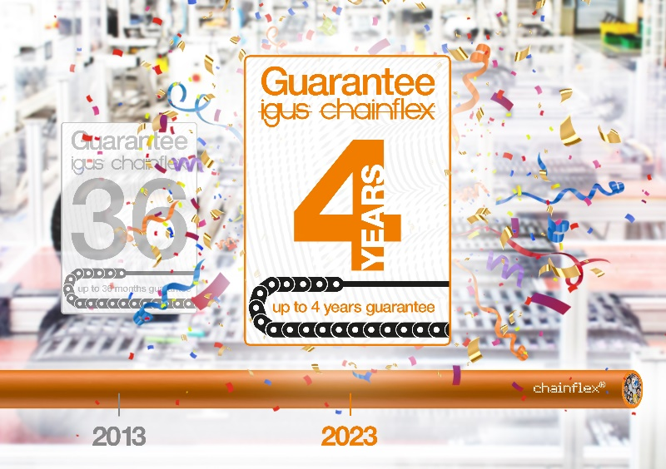
Picture PM6223-1
Based on over 20 billion additional test cycles in our in-house laboratory over the past decade, igus now offers a record guarantee of four years on the entire chainflex cable range. (Source: igus GmbH)

PRESS CONTACT:

Alexa Heinzelmann
Head of International Marketing

igus® GmbH
Spicher Str. 1a
51147 Cologne
Tel. 0 22 03 / 96 49-7272
aheinzelmann@igus.net
www.igus.eu/press

ABOUT IGUS:

igus GmbH develops and produces motion plastics. These lubrication-free, high-performance polymers improve technology and reduce costs wherever things move. In energy supplies, highly flexible cables, plain and linear bearings as well as lead screw technology made of tribo-polymers, igus is the worldwide market leader. The family-run company based in Cologne, Germany, is represented in 31 countries and employs 4,600 people across the globe. In 2022, igus generated a turnover of €1,15 billion. Research in the industry's largest test laboratories constantly yields innovations and more security for users. 234,000 articles are available from stock and the service life can be calculated online. In recent years, the company has expanded by creating internal startups, e.g. for ball bearings, robot drives, 3D printing, the RBTX platform for Lean Robotics and intelligent "smart plastics" for Industry 4.0. Among the most important environmental investments are the "chainge" programme – recycling of used e-chains - and the participation in an enterprise that produces oil from plastic waste.

The terms "igus", “Apiro”, "chainflex", "CFRIP", "conprotect", "CTD", “drygear”, "drylin", "dry-tech", "dryspin", "easy chain", "e-chain", "e-chain systems", "e-ketten", "e-kettensysteme", "e-skin", "e-spool”, "flizz", “ibow”, “igear”, "iglidur", "igubal", “kineKIT”, "manus", "motion plastics", "pikchain", "plastics for longer life", "readychain", "readycable", “ReBeL”, "speedigus", "tribofilament“, "triflex", "robolink", “xirodur”, and "xiros" are protected by trademark laws in the Federal Republic of Germany and internationally, where applicable.

