Eurobike 2022: igus shows how triboplastics
improves technology, reduces weight and eliminates maintenance
In Frankfurt, igus is presenting a world first as well as robust, light and maintenance-free motion plastics for the bicycle industry

Whether mountain bikes for outdoor use, record-breaking light racing bikes or ultra-robust e-cargo bikes: igus will be presenting new components made of high-performance plastic as an alternative to metal solutions for the bikes of the future from July 13th to 17th at the Eurobike 2022 in Frankfurt - including light and lubricant-free polymer plain bearings for mountain bikes, wear-resistant gears for e-bike motors and robust rod ends for e-cargo bikes. Visitors will also be able to see the concept of a bicycle that consists of over 90 percent plastic on the exhibition stand.

In mounted rear-wheel suspensions of mountain bikes, many manufacturers traditionally rely on metallic ball or needle roller bearings. “However, lubrication-free plain bearings made of high-performance plastic prove to be more maintenance-friendly, up to 80 percent lighter and dirt-resistant,” says Alexander Welcker, Bicycle Industry Manager at igus. At Eurobike 2022, the company is presenting a new line of thick-walled plain bearings made of the iglidur M210 polymer. The new bearing type makes it possible to replace needle roller bearings in the rear wheel swing arms of mountain bikes quickly and without redesigning the shaft or frame. Minimal effort with big effect. "Lightweight plastic components reduce the load on the frame and can make the bicycle easier to manoeuvre." Due to their higher flexibility, the bearings also have better vibration dampening than metallic bearing solutions, a specification that ensures better absorption of shocks and greater comfort for the rider.

New materials for suspension forks and pedals
Polymer bearings are also ideal for the bicycle industry for their dirt-resistance. The material components of the bearings are not applied in layers, but are mixed together homogeneously and as a result, there is no sliding film that can be worn away under loads, as is the case with traditional solutions with hard shells and soft coatings - for example, PTFE-coated plain bearings made of metal. But there is still improvements to be made. That's why igus is also presenting the new iglidur SG03 series plain bearings with felt seals at Eurobike 2022. These bearings provide additional protection against the ingress of dirt. “The felt seals are suitable for rough tolerances, where other seals may have problems. They also have a very low coefficient of friction,” says Welcker. “The new polymer bearings in the iglidur SG03 series are therefore ideally suited for use in, for example, bicycle pedals. There, they can ensure an increase in smooth running compared to metal bearings.” Another novelty being released in Frankfurt are the plastic plain bearings of the iglidur E series. igus has specifically developed these for use in suspension forks. The bearings are exceptionally suitable for linear movements in the guidance of the immersion tubes.

Tech up for bikes with tribo-gears and rod ends
The next innovation concerns the heart of e-bikes: the motor. At the exhibition, igus will present gears for planetary gearboxes made from high-performance plastic iglidur. “Tests in our in-house test laboratory show that iglidur gears significantly outperform other plastic alternatives in terms of service life,” emphasises Welcker. They are also quieter and lighter than metal solutions and in many cases, can be delivered faster. “Designers can design and commission the gears in just a few minutes using an online tool on the igus website. Production is carried out with 3D printers or by injection moulding - from one piece to high-volume production of several million.” Last but not least, igus will be showcasing a solution for cargo bikes at the exhibition, which are playing an increasingly important role in inner-city logistics traffic: metal-plastic rod ends of the igubal 2.0 series. Components that combine the advantages of stainless steel and plastic. A stainless steel housing and spherical ball in combination with an inner ring made of iglidur polymer ensure high stability and vibration dampening. “Combined with the advantages of being lubrication-free, maintenance-free and dirt-resistant, the hybrid rod ends are perfectly suited for the steering rods of cargo bikes,” says Welcker. And igus also has a solution for the sliding doors of cargo boxes: flat guides of the drylin N series. “The sliding linear system consists of a rail and a guide carriage, is compact with an installation height of between 9 and 12mm and impresses with constant performance without rattling.”
igus:bike platform for bikes made of plastic
The vision of igus: introduce high-performance plastics instead of metal for use in more and more places on the bicycle. But where does this transformation end? There are no limits to the imagination, as evidenced by the igus:bike project, the concept of a bicycle that consists of over 90 percent plastic - from the frame and bearings up to the toothed belt. A high proportion of the required raw materials can be covered by recycling plastic waste. As a partner, the startup mtrl presents the first model. The Dutch company will start producing and selling the mtrl.bike by the end of this year. The urban bike will be launched in Germany at the beginning of 2023.

Caption:
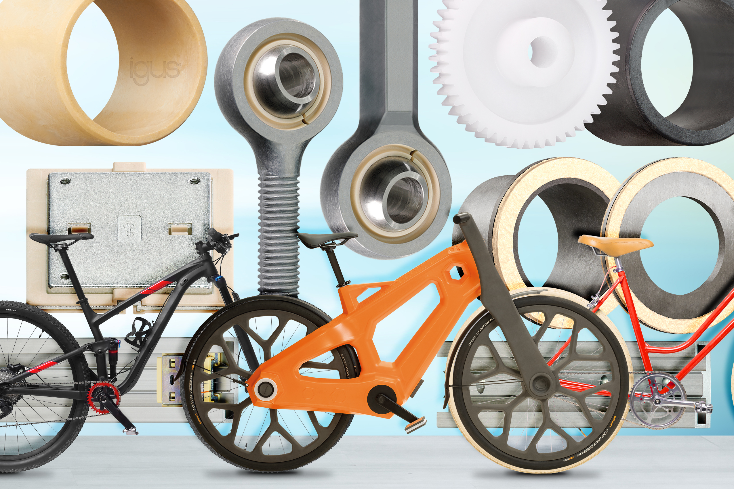
Picture PM3722-1
Maintenance-free, robust and lightweight: Lubrication-free motion plastics from igus improve technology and reduce costs in bicycles. (Source: igus GmbH)

PRESS CONTACT:

Alexa Heinzelmann
Head of International Marketing

igus® GmbH
Spicher Str. 1a
51147 Cologne
Tel. 0 22 03 / 96 49-7272
aheinzelmann@igus.net
www.igus.eu/press

ABOUT IGUS:

igus GmbH develops and produces motion plastics. These lubrication-free, high-performance polymers improve technology and reduce costs wherever things move. In energy supplies, highly flexible cables, plain and linear bearings as well as lead screw technology made of tribo-polymers, igus is the worldwide market leader. The family-run company based in Cologne, Germany, is represented in 35 countries and employs 4,900 people across the globe. In 2021, igus generated a turnover of €961 million. Research in the industry's largest test laboratories constantly yields innovations and more security for users. 234,000 articles are available from stock and the service life can be calculated online. In recent years, the company has expanded by creating internal startups, e.g. for ball bearings, robot drives, 3D printing, the RBTX platform for Lean Robotics and intelligent "smart plastics" for Industry 4.0. Among the most important environmental investments are the "chainge" programme – recycling of used e-chains - and the participation in an enterprise that produces oil from plastic waste.

The terms "igus", “Apiro”, "chainflex", "CFRIP", "conprotect", "CTD", “drygear”, "drylin", "dry-tech", "dryspin", "easy chain", "e-chain", "e-chain systems", "e-ketten", "e-kettensysteme", "e-skin", "e-spool”, "flizz", “ibow”, “igear”, "iglidur", "igubal", “kineKIT”, "manus", "motion plastics", "pikchain", "plastics for longer life", "readychain", "readycable", “ReBeL”, "speedigus", "tribofilament“, "triflex", "robolink", “xirodur”, and "xiros" are protected by trademark laws in the Federal Republic of Germany and internationally, where applicable.

