New igus heavy-duty rol e-chain for maximum service life on cranes
igus develops P4HD rol e-chain with wear-resistant materials, quickly replaceable side parts and smart monitoring

The new generations of cranes demand increasingly more from energy supply systems. Now an energy chain meets precisely these requirements for longer travels, higher accelerations and speeds as well as reliability. The new heavy-duty P4HD rol e-chain is made of highly abrasion-resistant materials. Special side parts, newly designed joining links, roller links as well as a triple stop-dog system minimise wear and reduce the drive energy even further. All parts can be replaced in case of maintenance. To monitor the service life, smart plastics sensors can be integrated into the pin/bore connection.

They are getting faster, longer and have to carry heavier fill weights: the energy chains in the new generations of ship-to-shore cranes. "Especially for these emerging trends in the world of cranes, we have already developed a new rol e-chain with the longest service life", says Jörg Ottersbach, e-chains Business Unit Manager at igus GmbH. This is why igus has launched a heavy-duty version based on its P4 rol e-chain range. The chain is said to have a service life - depending on the application - of up to 15 years. For this purpose, igus relies on tribologically optimised high-performance polymers. In order to further reduce abrasion at all points of the chain, igus has come up with a few design refinements. Amongst other things, a triple stop-dog system and a symmetrical design. The integrated rollers reduce the required drive energy by 57 per cent compared to a gliding chain. The rollers run on top of each other in a staggered manner. The comb-like autoglide crossbars keep the chain in its track, increasing the safety of the system and reducing costly unplanned downtime. In the new pin/bore connection, igus uses its expertise from polymer plain bearing technology and relies on a proven iglidur material, which also significantly increases the service life of the chain. "Tests in our in-house 3,800 square metre laboratory conclude that the P4HD has up to 50 per cent longer service life than its predecessor series P41.56", explains Jörg Ottersbach.

Fast and predictive maintenance
In case of maintenance, all parts of the chain can be replaced 1:1. Existing P4 energy chain systems can also be quickly retrofitted with the new chain thanks to identical dimensions. This reduces the effort, costs and materials required for maintenance. As an option, the P4HD can also be fitted with smart monitoring sensors. From a defined wear limit, the sensor sends a signal to the igus i.Cee:plus module, by which the maintenance of the rol e-chain can be planned in advance. It is integrated into a side part of the chain, which does not lead to any restrictions in the usable inner width. When the crane has reached the end of its service life, igus takes the chain back in the scope of the "chainge" programme and recycles it according to type. In return, the customer receives one voucher per kilogramme.

Learn more about the P4HD rol e-chain at:
https://www.igus.eu/info/roller-echain-p4hd

Caption:

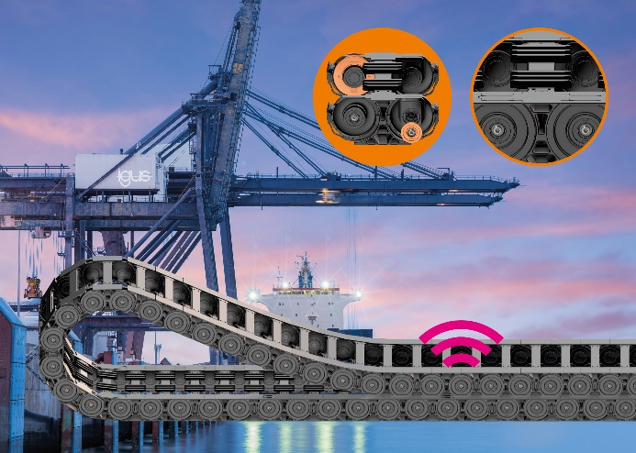
Picture PM3521-1
The P4HD heavy-duty rol e-chain uses new materials and a special pin/bore connection to provide a fail-safe energy supply on modern STS cranes.
(Source: igus GmbH)
ABOUT IGUS:

igus GmbH develops and produces motion plastics. These lubrication-free, high-performance polymers improve technology and reduce costs wherever things move. In energy supplies, highly flexible cables, plain and linear bearings as well as lead screw technology made of tribo-polymers, igus is the worldwide market leader. The family-run company based in Cologne, Germany, is represented in 35 countries and employs 4,150 people across the globe. In 2020, igus generated a turnover of €727 million. Research in the industry's largest test laboratories constantly yields innovations and more security for users. 234,000 articles are available from stock and the service life can be calculated online. In recent years, the company has expanded by creating internal startups, e.g. for ball bearings, robot drives, 3D printing, the RBTX platform for Lean Robotics and intelligent "smart plastics" for Industry 4.0. Among the most important environmental investments are the "chainge" programme – recycling of used e-chains - and the participation in an enterprise that produces oil from plastic waste (Plastic2Oil).

PRESS CONTACT:

Oliver Cyrus Anja Görtz-Olscher
Head of PR and Advertising Manager PR and Advertising

igus® GmbH igus® GmbH
Spicher Str. 1a Spicher Str. 1a
51147 Cologne 51147 Cologne
Tel. 0 22 03 / 96 49-459 Tel. 0 22 03 / 96 49-7153
ocyrus@igus.net agoertz@igus.net
www.igus.de/presse www.igus.de/presse

The terms "igus", “Apiro”, "chainflex", "CFRIP", "conprotect", "CTD", “drygear”, "drylin", "dry-tech", "dryspin", "easy chain", "e-chain", "e-chain systems", "e-ketten", "e-kettensysteme", "e-skin", "e-spool”, "flizz", “ibow”, “igear”, "iglidur", "igubal", “kineKIT”, "manus", "motion plastics", "pikchain", "plastics for longer life", "readychain", "readycable", “ReBeL”, "speedigus", "tribofilament“, "triflex", "robolink", “xirodur”, and "xiros" are protected by trademark laws in the Federal Republic of Germany and internationally, where applicable.

