Automatic lathe with six spindles wins gold vector award
Gildemeister Italiana S.p.A. wins first prize for a unique energy chain system

High speeds, long travels and compact installation spaces: every two years, igus GmbH bestows the vector award, with which fascinating and creative energy chain applications are honoured. This year, 266 entries from 32 countries were received. The gold vector was won by the multi-spindle lathe of Gildemeister Italiana S.p.A.. In a very restricted installation space, a total of eight harnessed energy chains guide cables and hoses reliably and safely.

Reduce lead times, set-up times and the effort required for process development and integration, and at the same time, do justice to the increasing degree of complexity involved: the new lathe from Gildemeister Italiana S.p.A., a subsidiary of DMG Mori AG, fulfils these requirements. The heart of the machine is the spindle drum with six spindles for simultaneous machining of several workpieces. The drum moves the workpieces to the tools quickly and very precisely. It only takes 0.65 seconds for one of the six spindles to travel to the next position. For spindles to return to the starting position after machining has been completed in the six stations, the drum has to turn 300 degrees in reverse. For this, the unit, which weighs over three metric tons, only needs one second. The biggest challenge: a safe energy supply system for all six spindles. The solution: a unique energy supply system that rotates with the drum and enables the linear movements of the spindle drums. A total of 8 igus energy chains, 64 cables and 73 hoses are used in the automatic multi-spindle lathe. An application for which Gildemeister Italiana has now won the gold vector and 5,000 euros in prize money. Awarded every two years, the prize is given for fascinating and spectacular energy chain applications. The jury consists of representatives from specialist journals/publications, as well as from the areas of industry and research.

Silver and bronze go to Austria and Germany
The silver vector award goes to AlpinaTec GmbH from Austria and its work on the GESTRA project for the Fraunhofer Institute. GESTRA is a radar-based system that is used to search for and map space debris. A complex rotary energy supply system specially designed for the azimuth axis and a two-sided double chain system for the elevation axis are used. The bronze vector award has been won by Grenzebach Maschinenbau with its stir friction welding machine. The energy and media supply components within the welding head as well as the adjacent construction all had to be flexible. For confined installation spaces, the coupling of a twisterband with an R4 energy chain proved to be a creative and fail-safe solution.

Premiere: Green vector award for sustainable products
Sustainability is very important to igus. For example, igus has been taking back used energy chains and recycling them since the end of 2019. For this reason, the jury also wanted to bestow an award for especially sustainable energy chain projects. The green vector award includes prize money of 1,000 euros and goes to the company Drop Water in the USA and the German company Huber SE. Drop Water received the prize for an automatic machine that fills biodegradable containers with beverages at the press of a button. The water for the beverage does not have to be transported as the automatic machine is connected to a water source. A harnessed readychain ensures that the cables of the linear robot used are guided safely and reliably. In a water treatment plant in Egypt, Huber SE, the other winner, relies on solar energy to dry sewage sludge. Dewatered sticky sludge is reduced in mass and volume to about a quarter by solar drying and transformed into a granular material. The plant will be used for the treatment of drinking water for 500,000 people drawn from the polluted Bahr El-Baqar canal system. For the dependable supply of power and energy to the automatic machine, igus energy chains with chainflex cables are used in 128 units over a travel of 100 metres.

Comprehensive information about the competition, the prize giving process and the entire variety of all the entries sent in can be obtained at www.igus.eu/vector

Captions:

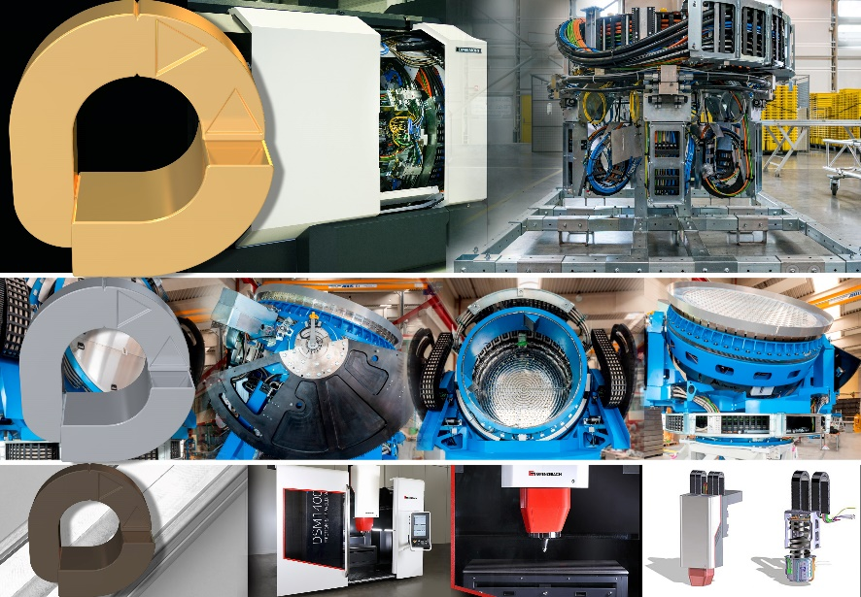
Picture PM3320-1
The winner: the golden vector award goes to Gildemeister Italiana for the complex integration of an energy chain system in a multi-spindle lathe. The silver vector award honours the space surveillance radar of the Austrian AlpinaTec GmbH. The bronze vector award goes to Grenzebach Maschinenbau GmbH for their friction stir welding gantry system. (Source: igus GmbH)

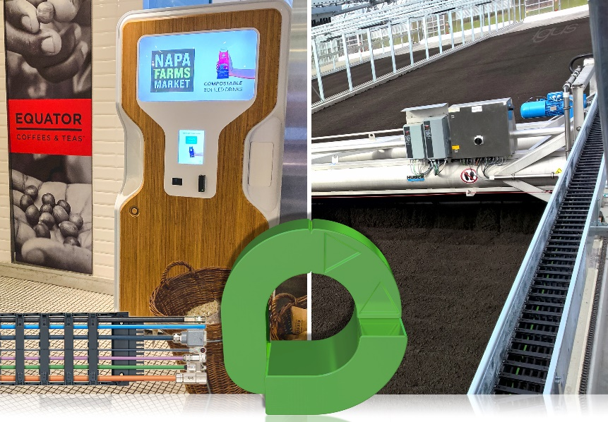
Picture PM3320-2
This year, igus awarded the green vector award for the first time. The prize went to a sustainable drinks machine from Drop Water Co. and the sewage sludge turner from Huber SE. (Source: igus GmbH)

PRESS CONTACT:  Oliver Cyrus  Head of PR and Advertising  Anja Görtz-Olscher  PR and Advertising  igus® GmbH  Spicher Str. 1a  51147 Cologne  Tel. 0 22 03 / 96 49-459 or -7153  Fax 0 22 03 / 96 49-631  ocyrus@igus.net  agoertz@igus.net  www.igus.eu/press | ABOUT IGUS:  igus GmbH is a global leading manufacturer of energy chain systems and polymer plain bearings. The Cologne-based family business has offices in 35 countries and employs 4,150 people around the world. In 2019, igus generated a turnover of 764 million euros from motion plastics, plastic components for moving applications. igus operates the largest test laboratories and factories in its sector to offer customers quick turnaround times on innovative products and solutions tailored to their needs.

The terms "igus", “Apiro”, "chainflex", "CFRIP", "conprotect", "CTD", “drygear”, "drylin", "dry-tech", "dryspin", "easy chain", "e-chain", "e-chain systems", "e-ketten", "e-kettensysteme", "e-skin", "e-spool”, "flizz", “ibow”, “igear”, "iglidur", "igubal", “kineKIT”, "manus", "motion plastics", "pikchain", "plastics for longer life", "readychain", "readycable", “ReBeL”, "speedigus", "triflex", "robolink", “xirodur”, and "xiros" are protected by trademark laws in the Federal Republic of Germany and internationally, where applicable.

