Freedom for articulated arm robots: 7th axis from igus extends the working space by up to 400 percent
The drylin toothed belt axis is now compatible with all lightweight robot manufacturers thanks to a Plug & Play kit
Articulated arm robots can travel over six metres, quadrupling their working space: the 7th axis offered by igus for this job is now compatible with all lightweight articulated arm robots worldwide thanks to a simple Plug & Play kit. So far, models from Universal Robots, Epson and the robolink series from igus have benefited from this increased mobility. Now Omron, Franka Emika, Doosan, Yuanda Robotics and many other lightweight robotics suppliers are joining the list.
The first users of the so-called 7th axis, a linear axis with an electric toothed belt drive that igus launched in the summer of 2020, were thrilled according to Alexander Mühlens: "Suddenly, thanks to the additional axis, their articulated arm robots are as mobile as humans. This enables them to take on multiple tasks in automation environments making them significantly more productive," says the Head of Automation Technology at igus. "We therefore decided to extend the compatibility of the system to all manufacturers worldwide - such as Omron, Franka Emika, Doosan and Yuanda Robotics. With a matching Plug & Play kit of hardware and software we make customisation possible."
Ready-to-connect complete solution for all lightweight articulated arm robots
In the future, all lightweight articulated arm robots with a weight range of 10 to 50 kilograms or, depending on the dynamics, a payload of 2 to 20 kilograms can use the 7th axis. igus supplies the system as a ready-to-connect complete solution from a single source. It consists of a drylin ZLW toothed belt axis with a length of up to six metres and two parallel rails made of aluminium. These can be mounted on the floor, walls or ceilings and a toothed belt drive with stepper motor for a positioning accuracy of 0.3 millimetres. Also included is: an energy chain for guiding energy and data cables; a switch cabinet integration kit with cables; motor control system and the respective software solution, as well as a carriage with the adapter plate that igus adapts to the geometry of thousands of articulated arm robots. All components are perfectly matched, so that users can quickly put the system into operation and benefit from the new mobility without expensive design and tuning work.

Save operating costs: 7th axis is lubrication-free and maintenance-free
Users save time and money not only in planning and purchasing the 7th axis, but also in operation. All made possible because the system works maintenance-free. The reason: the carriages move on the aluminium rails with the help of drylin linear technology. The high-performance plastic of the bearings enables low-friction and maintenance-free dry operation. The absence of lubricants also makes the system hygienic. The stainless steel version with FDA-compliant components makes the linear guide ideally suited for sectors such as the food industry.

Caption:

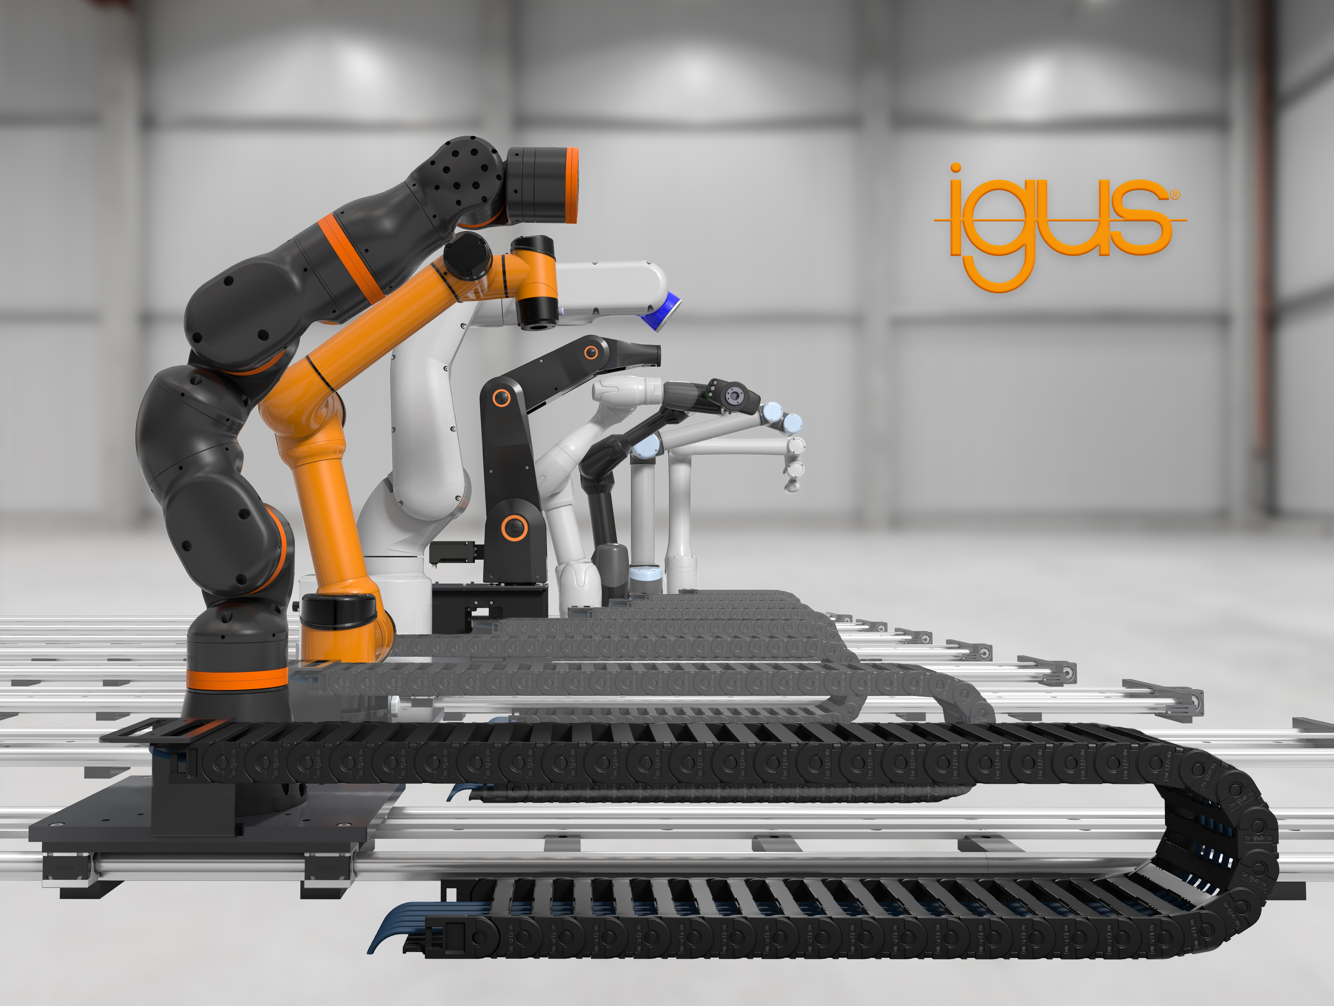
Picture PM6421-1
Moving articulated robots without lubrication and maintenance: The 7th robot axis for articulated arm robots is now compatible with all manufacturers. (Source: igus GmbH)
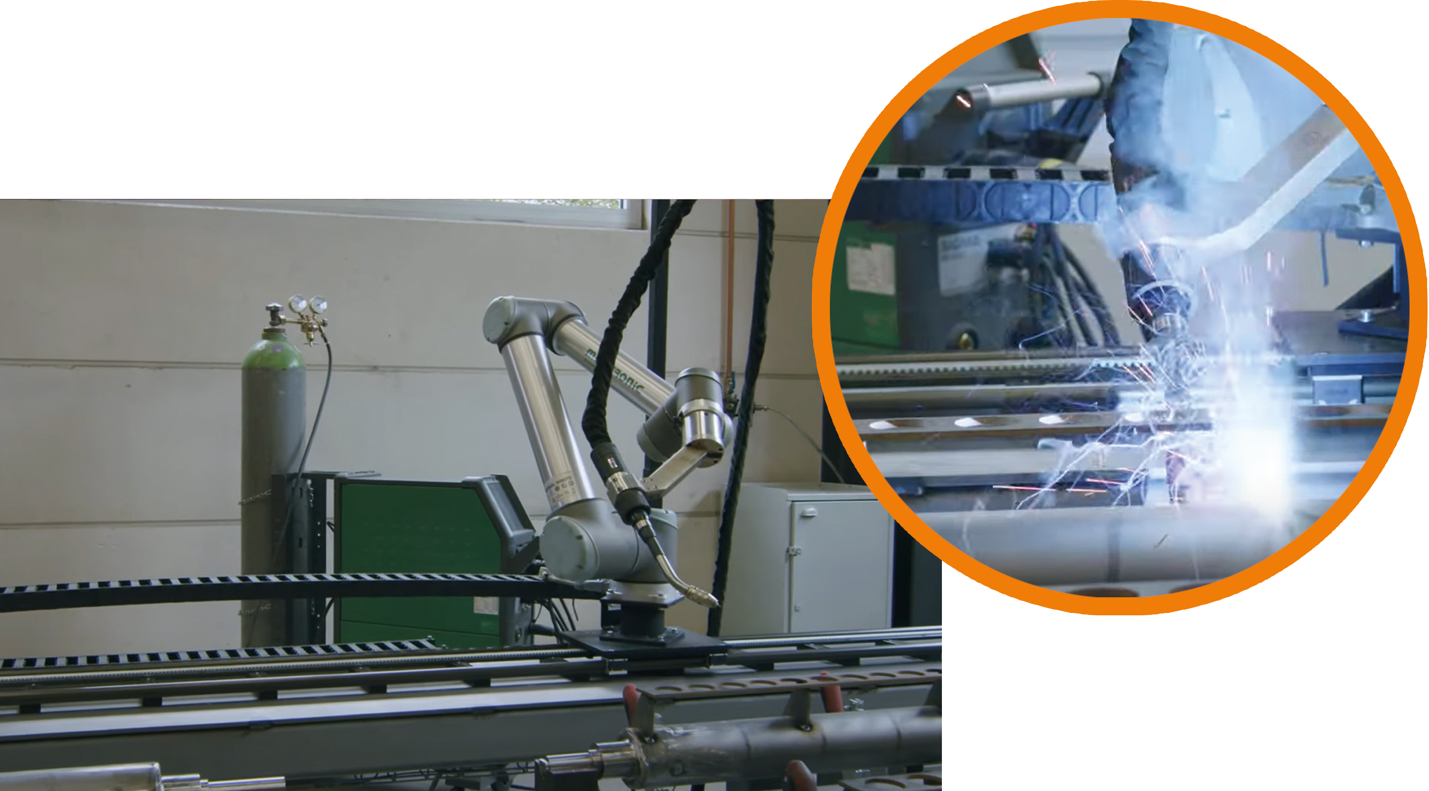

Picture PM6421-2
The 7th axis can quadruple the working space of lightweight articulated arm robots, making lightweight articulated arm robots even more productive. (Source: igus GmbH)

PRESS CONTACT:

Alexa Heinzelmann
Head of International Marketing

igus® GmbH
Spicher Str. 1a
51147 Cologne
Tel. 0 22 03 / 96 49-7272
aheinzelmann@igus.net
www.igus.eu/press

ABOUT IGUS:

igus GmbH develops and produces motion plastics. These lubrication-free, high-performance polymers improve technology and reduce costs wherever things move. In energy supplies, highly flexible cables, plain and linear bearings as well as lead screw technology made of tribo-polymers, igus is the worldwide market leader. The family-run company based in Cologne, Germany, is represented in 35 countries and employs 4,150 people across the globe. In 2020, igus generated a turnover of €727 million. Research in the industry's largest test laboratories constantly yields innovations and more security for users. 234,000 articles are available from stock and the service life can be calculated online. In recent years, the company has expanded by creating internal startups, e.g. for ball bearings, robot drives, 3D printing, the RBTX platform for Lean Robotics and intelligent "smart plastics" for Industry 4.0. Among the most important environmental investments are the "chainge" programme – recycling of used e-chains - and the participation in an enterprise that produces oil from plastic waste (Plastic2Oil).

The terms "igus", “Apiro”, "chainflex", "CFRIP", "conprotect", "CTD", “drygear”, "drylin", "dry-tech", "dryspin", "easy chain", "e-chain", "e-chain systems", "e-ketten", "e-kettensysteme", "e-skin", "e-spool”, "flizz", “ibow”, “igear”, "iglidur", "igubal", “kineKIT”, "manus", "motion plastics", "pikchain", "plastics for longer life", "readychain", "readycable", “ReBeL”, "speedigus", "tribofilament“, "triflex", "robolink", “xirodur”, and "xiros" are protected by trademark laws in the Federal Republic of Germany and internationally, where applicable.

