Digital innovations exhibition: more than 18,000 visitors at the igus trade show stand
The motion plastics specialist shows that an exhibition stand can also be well attended in corona times

Since the beginning of May, the igus innovations exhibition has been located in an exhibition hall in Cologne Porz-Lind. 100 motion plastics News are exhibited at the real igus trade show stand, and can be explored digitally either independently or together with igus experts. In June more than 18,000 visitors had already taken advantage of the unique offer and found out how they can improve the technology of their moving application and save costs with motion plastics.

100 motion plastics News are currently being presented by igus at its 400 square metre trade show stand at its main location in Cologne Porz-Lind. As is usual on the orange igus trade show stands at Hannover Messe, Motek or SPS, the latest motion plastics innovations can be found here, with which customers can improve their technology and save costs: Low Cost Automation robots, intelligent plain bearing technology or the e-chain autoglide 5 as an easy-to-install and low-maintenance alternative to the busbar system. Only visitors are not to be seen at the igus trade show stand.

Only at first glance - because more than 18,000 interested parties have already visited the igus stand via the Internet; on their own initiative in a virtual version or within the framework of a digital visit together with an igus specialist on site or online. At the individual stations, display screens, films and texts, provide information about product innovations, from SPE cables specifically for the e-chain up to the lightweight drylin polymer telescopic guide and 2-component 3D printing. Links take the user to more detailed technical information and videos on the website. "While a catalogue provides an initial broader overview, a guided digital tour is extremely helpful, especially with the variety of new products", says visitor Themistoklis Savvidis, Head of Mechanical Design at ISC International Service & Consulting GmbH from Remscheid. "You experience the new things immediately and, together with the igus consultant, focus exactly on what interests you in your daily work." This personal, fast consultation is actually very efficient, even in contrast to a real trade show, agrees Design Engineer René Wirt of CKO Maschinen und Systemtechnik GmbH. "At a trade show stand, I may have to wait longer because of the high number of visitors. Here, making appointments is quick and the News tour is not particularly time-consuming, but all the more customised. In the current situation, the digital exhibition from igus is an interesting alternative to a real exhibition stand", emphasises Uwe Kinze, Development Manager at the Velbert-based fittings manufacturer Haps. Nevertheless, he is convinced that it will not replace the classic igus trade show presence in the medium term. "I like to have the tactile aspect of a trade show stand, I like to take the products in my hands and have a close look at the product details." But igus also made this possible and simply sent him the appropriate samples after the appointment. So that even more interested parties can experience the innovations personally, the trade show will go on a tour of customers from September. At the show, igus employees will present the latest motion plastics, consider the application scenarios for the products together with the company's employees and help with the design.

A trade show stand in motion
The igus trade show stand in Cologne is continuously developing and is actively used for igus communication under the motto "Cost down, Tech up. It's our job". It served as a location for the annual press conference, for reports from news broadcasters and for the presentation of new products on YouTube. The vector award 2020, which honours exciting and creative energy chain applications was also awarded here. The golden vector was won by Gildemeister Italiana S.p.A. with its Multisprint processing system. In a very restricted installation space in the multi-spindle lathe, a total of eight harnessed energy chains guide cables and hoses reliably and safely. In addition, an online seminar studio is currently being set up near the trade show stand. Here, customers can find out everything about current developments in the field of tribo-polymers - from materials science and project planning to assembly aids, the recycling of plastics or how to build their own 3D printers. An overview of current online seminars can be found at https://www.igus.eu/info/igus-academy

Caption:

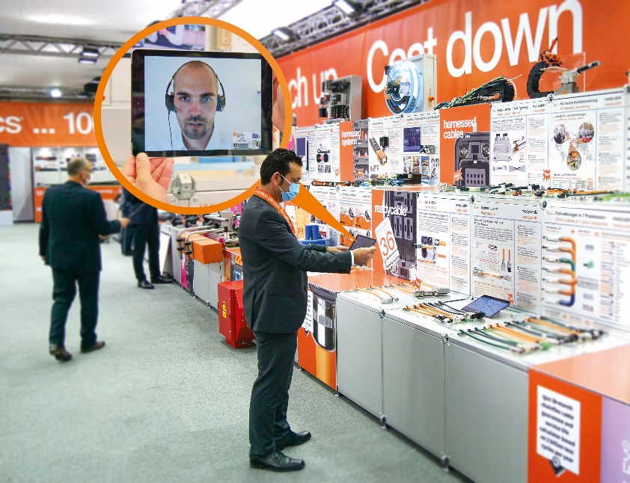
Picture PM3420-1
The igus trade show stand can be explored virtually, on your own or together with a consultant. Making an appointment is particularly easy, the consultation is efficient and individual, emphasise the visitors so far. (Source: igus GmbH)

PRESS CONTACT:  Oliver Cyrus  Head of PR and Advertising  Anja Görtz-Olscher  PR and Advertising  igus® GmbH  Spicher Str. 1a  51147 Cologne  Tel. 0 22 03 / 96 49-459 or -7153  Fax 0 22 03 / 96 49-631  ocyrus@igus.net  agoertz@igus.net  www.igus.eu/press | ABOUT IGUS:  igus GmbH is a global leading manufacturer of energy chain systems and polymer plain bearings. The Cologne-based family business has offices in 35 countries and employs 4,150 people around the world. In 2019, igus generated a turnover of 764 million euros from motion plastics, plastic components for moving applications. igus operates the largest test laboratories and factories in its sector to offer customers quick turnaround times on innovative products and solutions tailored to their needs.

The terms "igus", “Apiro”, "chainflex", "CFRIP", "conprotect", "CTD", “drygear”, "drylin", "dry-tech", "dryspin", "easy chain", "e-chain", "e-chain systems", "e-ketten", "e-kettensysteme", "e-skin", "e-spool”, "flizz", “ibow”, “igear”, "iglidur", "igubal", “kineKIT”, "manus", "motion plastics", "pikchain", "plastics for longer life", "readychain", "readycable", “ReBeL”, "speedigus", "triflex", "robolink", “xirodur”, and "xiros" are protected by trademark laws in the Federal Republic of Germany and internationally, where applicable.

