Linear systems from igus as space-saving solution in award-winning furniture design
drylin linear guides ensure a clean pull-out in the multifunctional cube SQR

Living, working and cooking in confined spaces is currently part of everyday life for many people worldwide. This is why more and more practical furniture such as the multifunctional cube SQR is in demand. A square solution that combines kitchen, workplace and dining table. To create plenty of storage space, the inventor relied on the lubrication-free and long-lasting drylin linear guides from igus.

At the end of 2016, Daniel Pracht lived in a small flat with no kitchen. The then budding master carpenter developed a practical quadratic solution: the SQR. A multifunctional cube with an extendable induction area, with which one or more persons can not only cook, but also stay, work and live in a compact space. Perfectly suited, especially at times when a home office is more than ever, the order of the day. To create a lot of storage space, the inventor was looking for a pull-out solution. Normal roller guides took up too much installation space and did not meet the requirements for a simple and elegant design. Daniel Pracht found what he was looking for in the drylin linear systems from igus: "The guides convinced me right from the start, both in terms of design and smooth operation."

Industry and furniture technology = functionality and design
When choosing the drylin WSQ linear system, one decisive criterion was not only the functionality - the wear-resistant and long-lasting opening and closing of the drawers - but also the processing of the rails. "The combination of the aluminium of the rail and the oak of the cube complements one another, which was very important to me. Just like the square shape of the guide", explains Pracht. Each of the five drawers contains two guides. Liners made of the high-performance iglidur J200 polymer ensure smooth operation. It is lubrication-free and maintenance-free, thanks to the use of solid lubricants. A great advantage in potential contact with food. Furthermore, dirt and dust cannot adhere to the bearings. The guides and bearings are easy to clean with household chemicals. An all-round hygienic solution.

Quadratic and compact design convinces professional juries
The concept convinced not only the inventor himself, but also a wide audience. Daniel Pracht won the Design Prize at the exhibition of masterpieces at his school. After that everything went very fast. Due to the increasing attention of his furniture, he registered a utility model protection, secured the brand name "SQR" and founded BODI e.K. as the registered merchant of a new distribution channel for his special piece of furniture. Pracht took part in the Red Dot Design Award in 2018 and won the award. In 2019 he was nominated for the German Design Award.

PRESS CONTACT:  Oliver Cyrus  Head of PR and Advertising  Anja Görtz-Olscher  PR and Advertising  igus® GmbH  Spicher Str. 1a  51147 Cologne  Tel. 0 22 03 / 96 49-459 or -7153  Fax 0 22 03 / 96 49-631  ocyrus@igus.net  agoertz@igus.net  www.igus.eu/press | ABOUT IGUS:  igus GmbH is a global leading manufacturer of energy chain systems and polymer plain bearings. The Cologne-based family business has offices in 35 countries and employs 4,150 people around the world. In 2019, igus generated a turnover of 764 million euros from motion plastics, plastic components for moving applications. igus operates the largest test laboratories and factories in its sector to offer customers quick turnaround times on innovative products and solutions tailored to their needs.

The terms "igus", “Apiro”, "chainflex", "CFRIP", "conprotect", "CTD", “drygear”, "drylin", "dry-tech", "dryspin", "easy chain", "e-chain", "e-chain systems", "e-ketten", "e-kettensysteme", "e-skin", "e-spool”, "flizz", “ibow”, “igear”, "iglidur", "igubal", “kineKIT”, "manus", "motion plastics", "pikchain", "plastics for longer life", "readychain", "readycable", “ReBeL”, "speedigus", "triflex", "robolink", “xirodur”, and "xiros" are protected by trademark laws in the Federal Republic of Germany and internationally, where applicable.

Captions:

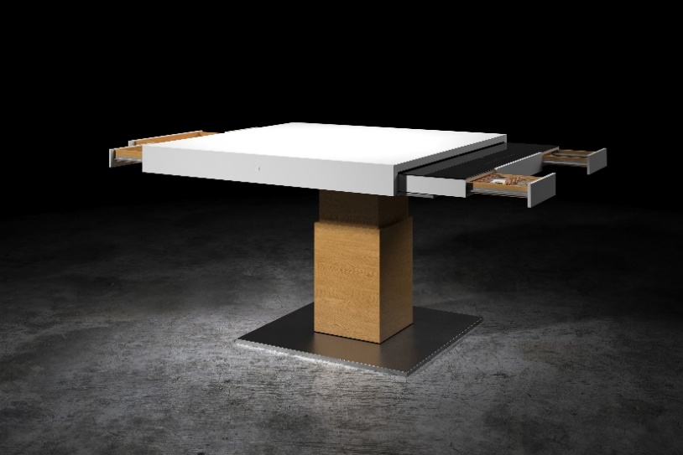
Picture PM4020-1
Combines kitchen with dining table and workplace: the square multifunctional cube SQR. (Source: Bodi Interiors)

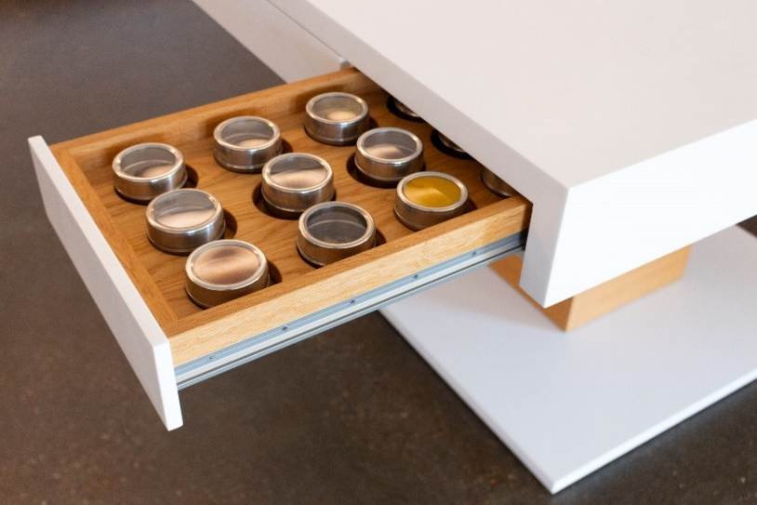
Picture PM4020-2
Thanks to their compact design, the drylin linear guides from igus provide more storage space. The linear bearing made of the high-performance polymer iglidur J200, ensures a quiet and lubrication-free operation. (Source: igus GmbH)

