Supporting a new generation: igus is the top training company in 2022 - with its own
trainee company
Cause for celebration: igus receives the Deutschlandtest "Germany's Best Training Companies in 2022" seal from Focus Money
Cologne, 21th February 2022 - igus aims at further strengthening the company's successful training model. In the "Germany's Best Training Companies in 2022" study, the motion plastics specialist was awarded the third prize in the category rubber and plastics industry companies for its commitment to supporting young talent. But how does igus promote the next generation of skilled workers specifically? One answer: with their own trainee company.

The shortage of skilled workers is one of the biggest challenges companies are facing. The Research Unit on Securing Skilled Labour (Kompetenzzentrum Fachkräftesicherung, Kofa), a project by the Cologne Institute for Economic Research (Institut der deutschen Wirtschaft, IW), says that the shortfall of skilled workers in Germany more than doubled last year. The main driver is demographic change, with the Corona pandemic further exacerbating the problem. It is quickly becoming clear that companies must actively promote the next generation of skilled workers.

Investing in the future: trainees are tomorrow's experts
The igus Young Talents programme offers young people professional guidance and helps them launch their careers. It also provides lots of "on the job" experience. igus currently employs 32 trainees and four students involved in cooperative studies. 14 more trainees are to be added in 2022 - and their chances of finding permanent employment at igus are good. The rate at which trainees are hired on a permanent basis is currently 80 percent. The continuing education opportunities at igus are also diverse: stays abroad, English and exam preparation courses, targeted product training, and technical and personal continuing education. "Being recognised as the top training company once again confirms the success of our concept for promoting young talent. One thing in particular is important to us: we want to give our young talent the opportunity to contribute their own ideas, work independently and take on responsibility", says Frank Blase, igus GmbH CEO.

Sustainably good: reguse trainee project adds value twice
One of many young talent projects at igus is reguse - the in-house trainee company. The project emerged at the end of 2019 from the IT trainee idea of saving old devices from becoming electronic waste. This idea, combined with the motto "reduce, reuse, recycle" and the affiliation to igus, was the origin of the "reguse" name. What the project looks like in practice is as follows: the IT trainees deal with the technology of the old devices, the industrial business trainees handle the legal issues and two media designer trainees take care of marketing. "Each of us has fixed areas of competence and responsibility. The reguse project gives us the opportunity to organise ourselves in a completely autonomous manner and gain valuable practical experience - with a lasting learning effect", says Annika Schulze, Media Design Trainee at igus.

Since April 2021, all igus employees have been able to purchase reconditioned devices for private use at a cost-effective price at the reguse online shop. This pays off in two ways: trainees gain business experience and make an important contribution to environmental protection. All proceeds and some of the refurbished equipment are donated to sustainable projects. It's a win-win situation for employees and the environment.

Separating the wheat from the chaff
The "Germany's Best Training Companies" study was launched by Deutschlandtest and the Focus Money business magazine in order to identify companies that successfully promote young talent. This year's study, conducted by the Institute for Management and Economic Research (Institut für Management- und Wirtschaftsforschung, IMWF), surveyed Germany's 20,000 largest companies. Among the criteria evaluated were training success, the number of trainees hired on a permanent basis, support programmes and additional offers for trainees. Social listening, which involves evaluating various internet sources, such as social media and employer rating portals, documented around 400,000 mentions of the 20,000 companies surveyed. The overall result is based on the scores from the online questionnaire and from social listening.
Captions:

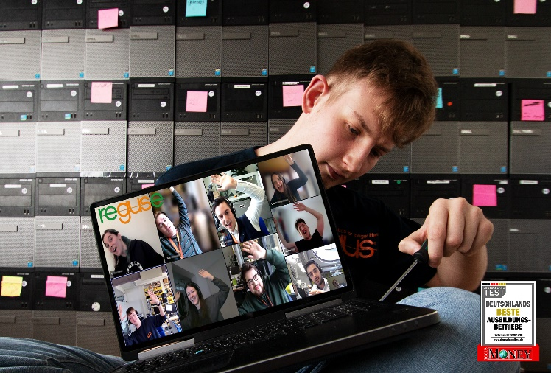
Picture PM0922-1
Continuously supporting young talent pays off: The trainees at igus have independently set up the "reguse" project - and are even contributing to environmental protection (Source: igus GmbH)

PRESS CONTACT:

Alexa Heinzelmann
Head of International Marketing

igus® GmbH
Spicher Str. 1a
51147 Cologne
Tel. 0 22 03 / 96 49-7272
aheinzelmann@igus.net
www.igus.eu/press

ABOUT IGUS:

igus GmbH develops and produces motion plastics. These lubrication-free, high-performance polymers improve technology and reduce costs wherever things move. In energy supplies, highly flexible cables, plain and linear bearings as well as lead screw technology made of tribo-polymers, igus is the worldwide market leader. The family-run company based in Cologne, Germany, is represented in 35 countries and employs 4,900 people across the globe. In 2020, igus generated a turnover of €727 million. Research in the industry's largest test laboratories constantly yields innovations and more security for users. 234,000 articles are available from stock and the service life can be calculated online. In recent years, the company has expanded by creating internal startups, e.g. for ball bearings, robot drives, 3D printing, the RBTX platform for Lean Robotics and intelligent "smart plastics" for Industry 4.0. Among the most important environmental investments are the "chainge" programme – recycling of used e-chains - and the participation in an enterprise that produces oil from plastic waste.

The terms "igus", “Apiro”, "chainflex", "CFRIP", "conprotect", "CTD", “drygear”, "drylin", "dry-tech", "dryspin", "easy chain", "e-chain", "e-chain systems", "e-ketten", "e-kettensysteme", "e-skin", "e-spool”, "flizz", “ibow”, “igear”, "iglidur", "igubal", “kineKIT”, "manus", "motion plastics", "pikchain", "plastics for longer life", "readychain", "readycable", “ReBeL”, "speedigus", "tribofilament“, "triflex", "robolink", “xirodur”, and "xiros" are protected by trademark laws in the Federal Republic of Germany and internationally, where applicable.

