New igus adapter reduces assembly time of energy chains by 80%
Customer-specific adapter for the Module Connect interface concept receives 2021 German Design Award

Connecting cables individually not only takes time, but is also prone to errors. This is why igus has developed the Module Connect interface concept, with which energy chains can be easily plugged together. To connect the connector to the energy chain, the user can now use an individual adapter. The energy chain thus becomes an interface that saves 80 per cent of the installation time. The design and functionality of the adapter also convinced the jury of the German Design Award 2021.

Safe and quick connecting, that is the idea behind the Module Connect interface concept, which igus developed for applications where a large number of connected cables come together in a very small space. Instead of connecting each cable individually, the energy chain systems can be plugged in in seconds through the low-profile and space-saving housing. Depending on the housing, the user can choose up to four Harting Han Modular inserts, e.g. for pneumatics, power, BUS and signal, from a modular system. The connectors can be individually connected to each other. A high contact density is thus possible for every application. igus developed an adapter so that the connector can also be safely connected to the energy chain. Depending on the chain series, chain width and number of Module Connect connectors, igus manufactures the adapter for each customer in 3D printing and soon also as a modular series part in injection moulding. It is then simply fastened on the Module Connect and attached to the chain using a snap-in mechanism.

80% assembly time saved
The Module Connect becomes an interface with the adapter, which reduces assembly time by 80 per cent. An example: a user has 16 cables which he wants to insert into an energy chain ready to plug & play. Four variable inserts fit into one Module Connect. By combining four Module Connect modules, the customer creates his individual interface.
By comparison, a conventional system would require him to install, plug and lock the individual plug-in connectors into the system. "With further work steps, such as installing and filling the empty energy chain, adjusting the overhangs and laying the cables, we have an installation time of several hours", explains Markus Hüffel, readychain Product Manager at igus GmbH. "With the help of the Module Connect adapter, the entire assembly can be connected quickly. This means that it is only plugged in once and locked once. The self-coding of the Module Connect excludes the possibility of errors. In this way, we reduce the installation time from several hours to minutes." In the event of service, the maintenance technician can simply disconnect the energy chain with the adapter, re-insert a harnessed energy supply system and put the machine or system back into operation.

Prize-winning design
The Module Connect adapter is a product that not only convinced customers but also the jury of the German Design Award 2021. The adapter received the award of the International Design Council in the category Excellent Product Design. The Module Connect itself won the reddot Design Award in 2018.

Learn more about the Module Connect adapter in the video:
https://youtu.be/zuy6Kth-WNk

Caption:

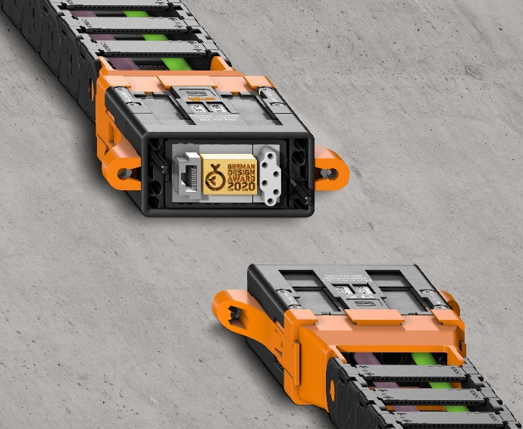
Picture PM5820-1
The new, ready to plug & play Module Connect adapter has an excellent design. (Source: igus GmbH)

PRESS CONTACT:  Oliver Cyrus  Head of PR and Advertising  Anja Görtz-Olscher  PR and Advertising  igus® GmbH  Spicher Str. 1a  51147 Cologne  Tel. 0 22 03 / 96 49-459 or -7153  Fax 0 22 03 / 96 49-631  ocyrus@igus.net  agoertz@igus.net  www.igus.eu/press | ABOUT IGUS:  igus GmbH is a global leading manufacturer of energy chain systems and polymer plain bearings. The Cologne-based family business has offices in 35 countries and employs 4,150 people around the world. In 2019, igus generated a turnover of 764 million euros from motion plastics, plastic components for moving applications. igus operates the largest test laboratories and factories in its sector to offer customers quick turnaround times on innovative products and solutions tailored to their needs.

The terms "igus", “Apiro”, "chainflex", "CFRIP", "conprotect", "CTD", “drygear”, "drylin", "dry-tech", "dryspin", "easy chain", "e-chain", "e-chain systems", "e-ketten", "e-kettensysteme", "e-skin", "e-spool”, "flizz", “ibow”, “igear”, "iglidur", "igubal", “kineKIT”, "manus", "motion plastics", "pikchain", "plastics for longer life", "readychain", "readycable", “ReBeL”, "speedigus", "triflex", "robolink", “xirodur”, and "xiros" are protected by trademark laws in the Federal Republic of Germany and internationally, where applicable.

