Passed the IPA test! Three-layered e-skin flat energy chain gets Cleanroom Class 1
The modular alternative to ribbon cable proves its freedom from particles in the Fraunhofer test

Particle-free energy chains are required to guide cables and hoses safely in cleanrooms. igus developed the e-skin flat, a modular design, a cost-effective alternative to ribbon cables. In the Fraunhofer cleanroom test, the energy supply system has proved its freedom from particles in accordance with ISO Class 1 not only as a single-layer, but also as a three-layered ready-to-connect energy chain system.

Cleanrooms around the world in which LEDs, microchips, and semiconductors are manufactured are characterised by little space and the absence of particles. In order to guide cables safely in compact installation spaces, igus has developed the e-skin flat. Cables and hoses can be quickly installed into the flat profiles and replaced during maintenance. igus uses a special high-performance plastic that has been regularly tested in the in-house cleanroom laboratory throughout the entire development process. The e-skin flat is resistant to wear and abrasion, and its single-layer variant has been Cleanroom Class 1 since its introduction in 2019. The invention also won over the 2021 REINER! awards judges. "Since the e-skin flat is rarely installed with just one layer, but often with three, we wanted to achieve the highest cleanroom class here " says Peter Mattonet, cleanroom technology industry manager at igus GmbH. The Fraunhofer Institute IPA therefore tested an e-skin flat energy supply system with three layers of four chambers each, including support chains, cables, and hoses. During operation, the testers checked emissions at three key points. In the test, the chain was the only cleanroom energy chain to receive ISO Class 1 according to ISO 14644-1 with a bend radius of 70 millimetres. "The e-skin flat stands out as a particle-free, compact energy supply system for the cleanroom, that saves the user space and therefore greatly reduces costs," says Mattonet.

CFCLEAN provides a ready-to-connect system
The e-skin flat energy supply system is configurable depending on the application scenario. It can consist of up to six chambers per layer. Three-layered structure supports chains in the lowest layer which ensures chain stability. igus has also developed the CFCLEAN series specifically for use in the e-skin flat. The cable cores can transmit energy and signals for motor control, bus, and Ethernet. The user can receive, upon request, a complete cleanroom system that is certified and ready to connect right away.

Learn more about ISO Class 1 cleanroom products from igus here:
https://www.igus.eu/info/industries-cleanroom

Caption:

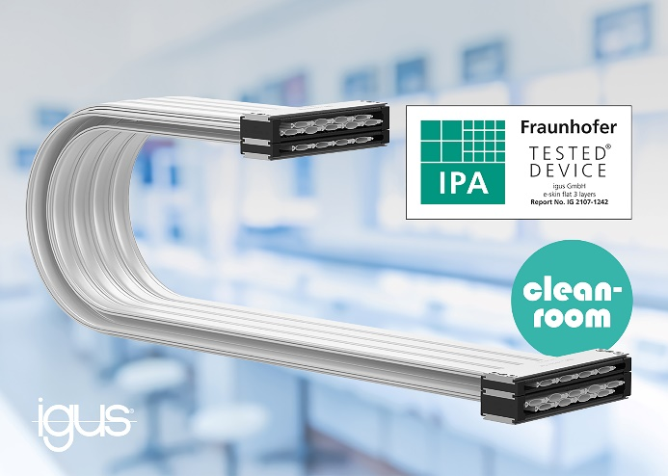
Picture PM4721-1
The e-skin flat received the Fraunhofer Institute's highest cleanroom class for its three-layered construction with a compact bend radius of 70 millimetres. (Source: igus GmbH)

ABOUT IGUS:

igus GmbH develops and produces motion plastics. These lubrication-free, high-performance polymers improve technology and reduce costs wherever things move. In energy supplies, highly flexible cables, plain and linear bearings as well as lead screw technology made of tribo-polymers, igus is the worldwide market leader. The family-run company based in Cologne, Germany, is represented in 35 countries and employs 4,150 people across the globe. In 2020, igus generated a turnover of €727 million. Research in the industry's largest test laboratories constantly yields innovations and more security for users. 234,000 articles are available from stock and the service life can be calculated online. In recent years, the company has expanded by creating internal startups, e.g. for ball bearings, robot drives, 3D printing, the RBTX platform for Lean Robotics and intelligent "smart plastics" for Industry 4.0. Among the most important environmental investments are the "chainge" programme – recycling of used e-chains - and the participation in an enterprise that produces oil from plastic waste (Plastic2Oil).

PRESS CONTACT:

Oliver Cyrus Anja Görtz-Olscher
Head of PR and Advertising Manager PR and Advertising

igus® GmbH igus® GmbH
Spicher Str. 1a Spicher Str. 1a
51147 Cologne 51147 Cologne
Tel. 0 22 03 / 96 49-459 Tel. 0 22 03 / 96 49-7153
ocyrus@igus.net agoertz@igus.net
www.igus.de/presse www.igus.de/presse

The terms "igus", “Apiro”, "chainflex", "CFRIP", "conprotect", "CTD", “drygear”, "drylin", "dry-tech", "dryspin", "easy chain", "e-chain", "e-chain systems", "e-ketten", "e-kettensysteme", "e-skin", "e-spool”, "flizz", “ibow”, “igear”, "iglidur", "igubal", “kineKIT”, "manus", "motion plastics", "pikchain", "plastics for longer life", "readychain", "readycable", “ReBeL”, "speedigus", "tribofilament“, "triflex", "robolink", “xirodur”, and "xiros" are protected by trademark laws in the Federal Republic of Germany and internationally, where applicable.

