As strong as a tree: bionic design makes igus plastic pillow blocks robust
New igubal pillow blocks are a maintenance-free, economically effective alternative to classic cast iron housing bearings

Nature is often the best model: The shape of the new igubal pillow block is based on the design principles of a tree. Flattened radii ensure maximum resistance to mechanical stresses. This bionic shape makes the housings with their high-performance plastics that require no lubrication or maintenance a real alternative to classic cast iron housing bearings.

Whether in pulleys on conveyor belts in the cement factory or in tipping devices on trailers in the field: cast housing bearings with metal ball bearings quickly reach their limits in dusty, wet and dirty environments. A high degree of contamination and inadequate lubrication are responsible for 80 percent of premature bearing failures. Then there is the constant risk of corrosion. Reason enough to replace the ball bearings with lubricant-free bearing inserts made of high-performance plastic. igubal polymer pillow blocks in the standard sizes 20, 25, and 30 millimetres enable quick one-to-one replacement. Also available: two-hole and four-hole flange bearings in the sizes of 20, 30, and 40 millimetres.

The tree is the model: rounding ensures even stress distribution
Engineers at igus use two strategies to ensure that the plastic pillow blocks are sufficiently robust in industrial applications. The first is working with fibres and fillers that reinforce the igubal plastic so that it withstands high surface pressure and edge loads even under continuous stress. The second is following a model from nature: the tree crotch, a connection found between branches and trunk or where the tree is firmly anchored in the ground. It is considered particularly efficient and robust. The designers have optimised the shape of the housing notches and done away with constant radii in order to distribute the stress more evenly. This makes igubal housing bearings highly resilient. Their chemical resistance, freedom from corrosion and insensitivity to dirt give the bearing inserts made of the iglidur J tribo-polymer a significantly longer service life in numerous customer applications over the metallic bearings previously used. The absence of lubricants also reduces maintenance and cleaning requirements and enhances environmental protection. There are no lubricants at any point in the system that could get into the environment or onto the product.

igus expands the igubal series range
The new pillow blocks and flange bearings are not the only products igus is adding to the igubal range. New to the range are three bearing inserts for the imperial market, now available in 1, 1.5, and 2 inch inside diameter sizes. The price for FDA-compliant iglidur A350 plain bearings will also be reduced by around 50 percent in future. This is because igus no longer manufactures the bearing exclusively by turning bar stock, but has recently added the more cost-effective injection moulding process.

Caption:

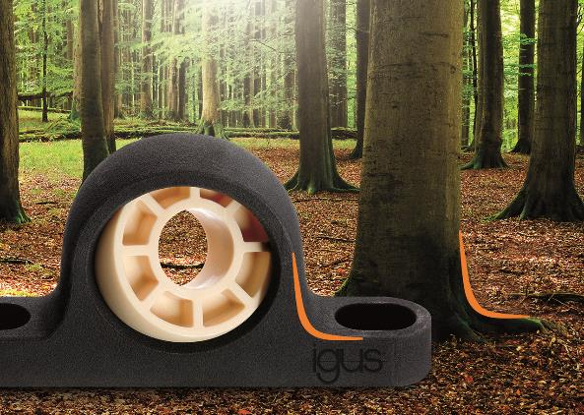
Picture PM6621-1
In the bionic design of the robust, maintenance-free igubal pillow blocks, the igus designers use a tree crotch as a model. (Source: igus GmbH)

PRESS CONTACT:

Alexa Heinzelmann
Head of International Marketing

igus® GmbH
Spicher Str. 1a
51147 Cologne
Tel. 0 22 03 / 96 49-7272
aheinzelmann@igus.net
www.igus.eu/press

ABOUT IGUS:

igus GmbH develops and produces motion plastics. These lubrication-free, high-performance polymers improve technology and reduce costs wherever things move. In energy supplies, highly flexible cables, plain and linear bearings as well as lead screw technology made of tribo-polymers, igus is the worldwide market leader. The family-run company based in Cologne, Germany, is represented in 35 countries and employs 4,150 people across the globe. In 2020, igus generated a turnover of €727 million. Research in the industry's largest test laboratories constantly yields innovations and more security for users. 234,000 articles are available from stock and the service life can be calculated online. In recent years, the company has expanded by creating internal startups, e.g. for ball bearings, robot drives, 3D printing, the RBTX platform for Lean Robotics and intelligent "smart plastics" for Industry 4.0. Among the most important environmental investments are the "chainge" programme – recycling of used e-chains - and the participation in an enterprise that produces oil from plastic waste (Plastic2Oil).

The terms "igus", “Apiro”, "chainflex", "CFRIP", "conprotect", "CTD", “drygear”, "drylin", "dry-tech", "dryspin", "easy chain", "e-chain", "e-chain systems", "e-ketten", "e-kettensysteme", "e-skin", "e-spool”, "flizz", “ibow”, “igear”, "iglidur", "igubal", “kineKIT”, "manus", "motion plastics", "pikchain", "plastics for longer life", "readychain", "readycable", “ReBeL”, "speedigus", "tribofilament“, "triflex", "robolink", “xirodur”, and "xiros" are protected by trademark laws in the Federal Republic of Germany and internationally, where applicable.

