Flexibility meets safety: first monitoring system for robot e-chains from igus
New i.Sense TR.B sensor enables condition monitoring for triflex R energy chains in three-dimensional applications

Robots have long been an integral part of many areas of industrial manufacturing - and their range of tasks continues to grow in the wake of digitalisation. Whether for welding, painting, soldering or palletising, industrial robots work dynamically. A flexible 3D energy chain such as the triflex R from igus makes it possible to guide robot cables safely. To detect potential chain breaks due to extreme loads in good time and to avoid unplanned machine breakdowns, igus is presenting i.Sense TR.B, the world's first breakage monitoring system for 3D energy chains at automatica 2022.

Increasing material and energy efficiency, compensating for supply bottlenecks through domestic production and alleviating labour shortages: these are, according to the 2022 trend index at the world's leading trade show automatica, some of the most frequently cited reasons why industrial robots are important for the German economy. However, one thing above all is essential for an industrial robot to work reliably: safe cable guidance. Robot cables must withstand numerous flexing cycles as well as loads due to torsion and tension. With the triflex R, igus has developed a round energy chain with a defined bend radius specifically for industrial robots in order to protect the cables even during dynamic rotational and pivoting movements. After all, a chain break can be disastrous: plant downtime, production stoppages and delivery delays cost time and money. The motion plastics specialist igus has developed a new and cost-effective solution to determine chain breakage at lightning speed and prevent expensive consequential damage: i.Sense TR.B - a real-time breakage monitoring system for the three-dimensional triflex R energy chain.

Smart real-time condition monitoring - also for 3D applications
With i.Sense TR.B, the proven i.Sense breakage monitoring of igus smart plastics is now also possible for dynamic, three-dimensional applications. Customers can thus increase the safety of their robot systems with an investment of just a few hundred euros. The i.Sense TR.B sensor is connected directly to the PLC customer control - without additional software costs. If a chain link breaks, the system detects the change in length of the rope installed in the chain and can accordingly send out a digital signal to the system control. Instant breakage detection enables immediate maintenance measures and can thus avoid unplanned downtimes and total failures in the event of individual chain link breakages. "Particularly in applications such as automotive production lines with extremely high output, any downtime can cause costs of several €100,000. Real-time status monitoring of the energy supply system in industrial robots therefore offers users considerable added value," explains Richard Habering, Head of Business Unit smart plastics at igus.

Sustainable maintenance with smart plastics
With the help of numerous test series in the industry's largest test laboratory, igus is continuously working on further optimising the quality and durability of its products. The combination of flexible triflex R 3D chain with high tensile force absorption and i.Sense TR.B sensor makes it possible to safely guide and protect robot cables - and thus significantly increase their service life. Condition-based maintenance using the TR.B sensor also makes maintenance more sustainable, as users can avoid unnecessary or premature product replacement. And if there is a chain break, the sensor can be reused after correct emergency shutdown of the system.

Caption:

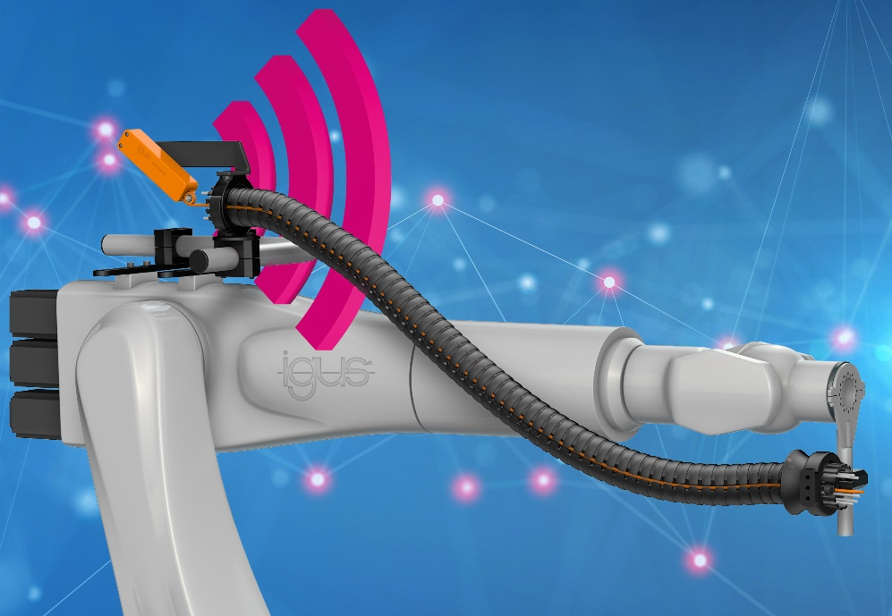
Picture PM3322-1
Thanks to the new i.Sense TR.B sensor, intelligent condition monitoring is now also possible for the triflex R 3D energy chains from igus. (Source: igus GmbH)

PRESS CONTACT:

Alexa Heinzelmann
Head of International Marketing

igus® GmbH
Spicher Str. 1a
51147 Cologne
Tel. 0 22 03 / 96 49-7272
aheinzelmann@igus.net
www.igus.eu/press

ABOUT IGUS:

igus GmbH develops and produces motion plastics. These lubrication-free, high-performance polymers improve technology and reduce costs wherever things move. In energy supplies, highly flexible cables, plain and linear bearings as well as lead screw technology made of tribo-polymers, igus is the worldwide market leader. The family-run company based in Cologne, Germany, is represented in 35 countries and employs 4,900 people across the globe. In 2021, igus generated a turnover of €961 million. Research in the industry's largest test laboratories constantly yields innovations and more security for users. 234,000 articles are available from stock and the service life can be calculated online. In recent years, the company has expanded by creating internal startups, e.g. for ball bearings, robot drives, 3D printing, the RBTX platform for Lean Robotics and intelligent "smart plastics" for Industry 4.0. Among the most important environmental investments are the "chainge" programme – recycling of used e-chains - and the participation in an enterprise that produces oil from plastic waste.

The terms "igus", “Apiro”, "chainflex", "CFRIP", "conprotect", "CTD", “drygear”, "drylin", "dry-tech", "dryspin", "easy chain", "e-chain", "e-chain systems", "e-ketten", "e-kettensysteme", "e-skin", "e-spool”, "flizz", “ibow”, “igear”, "iglidur", "igubal", “kineKIT”, "manus", "motion plastics", "pikchain", "plastics for longer life", "readychain", "readycable", “ReBeL”, "speedigus", "tribofilament“, "triflex", "robolink", “xirodur”, and "xiros" are protected by trademark laws in the Federal Republic of Germany and internationally, where applicable.

