Complete robotic solution designed in just one minute with the RBTX Machine Planner
New online tool from RBTX powered by igus® allows users to design robot working environments quickly and without CAD knowledge

Ideally, a customer can decide on a suitable robot quickly. But how do you create the perfect workplace for the new assistant? The Machine Planner on RBTX.com, the online marketplace for Low Cost Robotics, helps with the design of a complete automation solution, from robotics to frames to conveyor belts to grippers to safety systems. Price and delivery time are calculated in real time.

Configuring a new robot workstation is usually a complex undertaking, because there is more to it than just selecting a robot model. An automated production environment also requires the right workplace design which often involves manipulating complex structures in CAD programs. It is time-consuming and stressful. First of all, it is necessary to obtain offers from different suppliers via sales. Then the components must be harmonised. Besides the time it takes, it requires expertise on the part of the customer, who is ultimately responsible for compatibility and function. It can quickly run to weeks. Small and medium-sized businesses in the trades or manufacturing industry in particular, need this time to invest in their own products. With its Machine Planner on RBTX.com, igus® creates a simple solution for quickly configuring robot workstations and machine frames with robotics and conveyor technology. The new free tool is integrated into the RBTX platform, the marketplace for Low Cost Robotics. "Our new online configurator for cost-effective automation solutions makes inexpensive robotics accessible to everyone, because the user does not need any design knowledge. The Machine Planner takes over the engineering and thus combines robotic components correctly. The tool can be called up easily with a browser", says Alexander Mühlens, Head of igus® Low Cost Automation Business Unit. The Machine Planner provides a selection of different machines and application designs. Doors and back panels can be installed with just a few clicks. The size can be individually adjusted. In addition to feed automation such as conveyor belts or spiral bowl conveyors in the work area, the configurator can be used to select robots from the RBTX marketplace, including accessories such as grippers and linear systems. A few clicks and the solution is fully configured within a minute without any CAD drawings or technical clarification. A design library on the platform offers additional guidance. The solution can be adapted to your own individual requirements. Users benefit not only from speed, but also from transparency: at the touch of a button, you receive a cost calculation with the corresponding delivery time. Easy-to-understand instructions allow the customer to assemble the application on site. igus® also supplies a CE template.

Quick 3D configuration for individual applications
"I was looking for an individual gluing machine without having to hire an external design engineer for planning and execution. The Machine Planner from igus® enabled me to design my gluing machine with just a few clicks", says Sven Achenbach, CEO of Sigamo GmbH. "The robot is used in production. It guarantees our customers a 100 per cent identical adhesive application on components." Its application is just one of many possible designs that can be implemented on RBTX with the Machine Planner. Gripping robots for bakeries or pick & place applications in industry: the 3D tool is suitable for a variety of industries in which processes can be automated. With the new configurator, igus® is expanding its leading RBTX platform for Low Cost Automation with a new tool in a complete package. Alexander Mühlens sums it up: "Our goal is to make automation possible simply, quickly and cost-effectively. The Machine Planner does just that for the customer."

Caption:

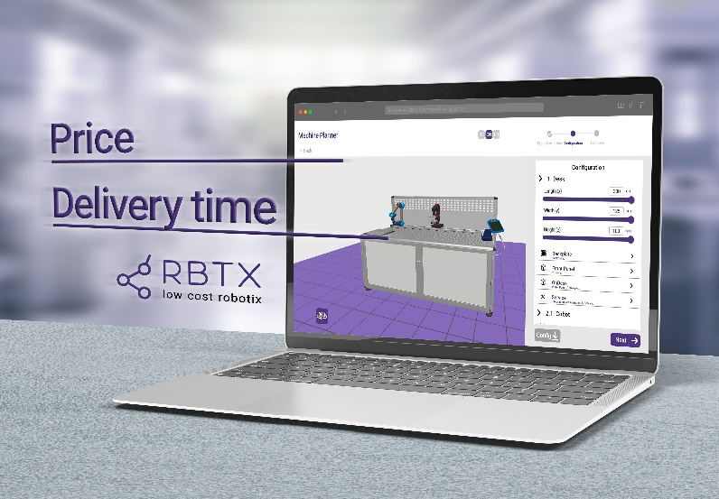
Picture PM3423-1
The Machine Planner from igus® allows the quick design of complete automation solutions involving robots without any programming knowledge. (Source: igus® GmbH)

PRESS CONTACT:

Alexa Heinzelmann
Head of International Marketing

igus® GmbH
Spicher Str. 1a
51147 Cologne
Tel. 0 22 03 / 96 49-7272
aheinzelmann@igus.net
www.igus.eu/press

ABOUT IGUS:

igus GmbH develops and produces motion plastics. These lubrication-free, high-performance polymers improve technology and reduce costs wherever things move. In energy supplies, highly flexible cables, plain and linear bearings as well as lead screw technology made of tribo-polymers, igus is the worldwide market leader. The family-run company based in Cologne, Germany, is represented in 31 countries and employs 4,600 people across the globe. In 2022, igus generated a turnover of €1,15 billion. Research in the industry's largest test laboratories constantly yields innovations and more security for users. 234,000 articles are available from stock and the service life can be calculated online. In recent years, the company has expanded by creating internal startups, e.g. for ball bearings, robot drives, 3D printing, the RBTX platform for Lean Robotics and intelligent "smart plastics" for Industry 4.0. Among the most important environmental investments are the "chainge" programme – recycling of used e-chains - and the participation in an enterprise that produces oil from plastic waste.

The terms "igus", “Apiro”, "chainflex", "CFRIP", "conprotect", "CTD", “drygear”, "drylin", "dry-tech", "dryspin", "easy chain", "e-chain", "e-chain systems", "e-ketten", "e-kettensysteme", "e-skin", "e-spool”, "flizz", “ibow”, “igear”, "iglidur", "igubal", “kineKIT”, "manus", "motion plastics", "pikchain", "plastics for longer life", "readychain", "readycable", “ReBeL”, "speedigus", "tribofilament“, "triflex", "robolink", “xirodur”, and "xiros" are protected by trademark laws in the Federal Republic of Germany and internationally, where applicable.

