Low-maintenance and durable: A flexible operating concept allows a clear view in construction machinery
igus linear technology prevents dirt and dust from sticking to Gessmann's shifting system

Construction sites can be daunting, given all the machines, material and people. Keeping track of everything is difficult. A flexible new operating concept for driver's cabs from Gessmann helps to ensure that operators always have the best possible overview of their surroundings. Because the tribo-plastics from igus used in the machinery require no lubricants or maintenance and therefore it remains relable over a long period of time.

The fact that there are no road traffic regulations on construction sites makes it all the more important for construction machine drivers to have good all-round visibility. This is not always easy, especially with particularly wide excavators or wheel loaders, whose field of vision is very limited. To achieve a full view of his surroundings, the driver must stop the vehicle and leave his seat. Gessmann's operating concept focuses on offering the driver maximum flexibility by shifting his control station, and using igus linear technology makes lubrication and maintenance unnecessary.

Durable solution for a wide range of machines
During development, the objectives of W. Gessmann GmbH were clear: the driver's seat needed to rotate around its own axis and to move transversely in the direction of travel. The operator was to be able to change position within seconds in order to have an overview of the entire machine environment, again as quickly as possible. In addition to the high degree of flexibility, the seat operation must also withstand the harsh construction site conditions and require minimal maintenance. The designers therefore used drylin linear technology from igus. The tribologically optimized high-performance plastics are light, corrosion-free and, most importantly, require no external lubrication. This increases service life in the moving application, dirt will not stick to the bearing point. This was also the conclusion the Gessmann developers reached after initial tests. The design was originally to be guided with recirculating ball bearings and a stainless steel guide shaft. The hardened steel balls rolled over the ground stainless steel guide, so the system was not optimal for the planned application due to the construction machines vibrating. This can cause the steel balls to damage the stainless steel shaft, increasing shifting force and greatly reducing service life. The designers used a far more cost-effective system, drylin W guide rail and drylin hybrid double roller bearings. The drylin W series's require a small installation space, meaning that the guide system can be mounted below the machine floor. This protects the system from the weather and contamination.

Varied igus construction machinery range
Over 20,000 customers worldwide in the construction machinery sector are already capitalizing on these advantages. Wear-resistant plain bearings for heavy-duty applications can be found in excavators, wheel loaders, and telescopic handlers. Available directly from stock or as a custom-made product. For example, igus has introduced the new iglidur TX2 slide bearings this year for use in bearing points subject to particularly high loads. The high-strength composite fibre construction with incorporated solid lubricants ensures low-friction and a maintenance-free operation. By eliminating external lubrication means that no greases are released into the environment. In addition to bearing technology, energy chains such as the E4.1 ensure cable protection and guidance in the construction machinery sector, in such applications as handling excavators, telescopic handlers, and drills. igus also offers UV-resistant and temperature-resistant cables for dynamic continuous movements. The service life of all components can be calculated. Online tools that can be used free of charge are available for this purpose on the igus website. They are freely accessible.

Caption:

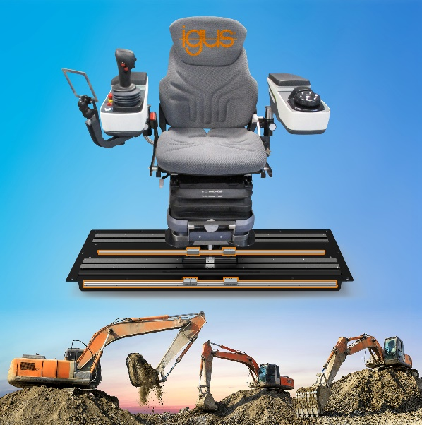
Picture PM4421-1
In the Gessmann displacement system, lubrication-free igus linear technology prevents dust and dirt from sticking. (Source: igus GmbH)

ABOUT IGUS:

igus GmbH develops and produces motion plastics. These lubrication-free, high-performance polymers improve technology and reduce costs wherever things move. In energy supplies, highly flexible cables, plain and linear bearings as well as lead screw technology made of tribo-polymers, igus is the worldwide market leader. The family-run company based in Cologne, Germany, is represented in 35 countries and employs 4,150 people across the globe. In 2020, igus generated a turnover of €727 million. Research in the industry's largest test laboratories constantly yields innovations and more security for users. 234,000 articles are available from stock and the service life can be calculated online. In recent years, the company has expanded by creating internal startups, e.g. for ball bearings, robot drives, 3D printing, the RBTX platform for Lean Robotics and intelligent "smart plastics" for Industry 4.0. Among the most important environmental investments are the "chainge" programme – recycling of used e-chains - and the participation in an enterprise that produces oil from plastic waste (Plastic2Oil).

PRESS CONTACT:

Oliver Cyrus Anja Görtz-Olscher
Head of PR and Advertising Manager PR and Advertising

igus® GmbH igus® GmbH
Spicher Str. 1a Spicher Str. 1a
51147 Cologne 51147 Cologne
Tel. 0 22 03 / 96 49-459 Tel. 0 22 03 / 96 49-7153
ocyrus@igus.net agoertz@igus.net
www.igus.de/presse www.igus.de/presse

The terms "igus", “Apiro”, "chainflex", "CFRIP", "conprotect", "CTD", “drygear”, "drylin", "dry-tech", "dryspin", "easy chain", "e-chain", "e-chain systems", "e-ketten", "e-kettensysteme", "e-skin", "e-spool”, "flizz", “ibow”, “igear”, "iglidur", "igubal", “kineKIT”, "manus", "motion plastics", "pikchain", "plastics for longer life", "readychain", "readycable", “ReBeL”, "speedigus", "tribofilament“, "triflex", "robolink", “xirodur”, and "xiros" are protected by trademark laws in the Federal Republic of Germany and internationally, where applicable.

