Tech up, cost down: igus presents cutting-edge technology at EMO 2023
Among other things, igus is presenting low-cost robotics, its online CNC service, a 3D-printed assembly frame, and economical energy chains for sustainable, cost-optimised production

In addition to the shortage of skilled workers, high energy costs combined with increasing cost pressure and declining incoming orders remain the biggest challenges for the machine tool industry. To survive in this environment, companies must produce even better and more cost-effectively. So igus will be presenting cutting-edge technologies at EMO 2023. These are technologies that take the pressure off companies: low-cost robots that are as easy to operate as a computer game, an online service for rapid production of CNC components made of high-performance plastics, a 3D-printed assembly frame, and a low-cost energy chain for unsupported applications.

The situation in the German industry is getting more difficult. According to the Leibniz Institute for Economic Research at the University of Munich, 43.1 per cent of companies were complaining of a shortage of skilled workers in August of 2023. One possible solution is automation. If people are no longer available, robots can take on the tasks of joining, loading, assembling, and gluing. This has so far been the privilege of large companies with sufficient budget and expertise. "In these times of crisis, the aim must be to ensure that small and medium-sized companies across the board can enjoy 'tech up, cost down'. We implement automation projects for as little as 2,000 euros – quickly and with little risk," says Alexander Mühlens, head of the Low Cost Automation business unit at igus. "We do this with RBTX, an online marketplace where companies can assemble modular low-cost components from more than 100 suppliers, supported by our RBTXpert service. A free remote video call puts customers in touch with our automation experts, who work together with them to find a customised solution. We have already implemented four hundred projects which can be viewed online, and 95 per cent of them have an investment of less than 12,000 euros". At EMO 2023, igus will display the ReBeL cobot "made in Cologne", an articulated arm robot made of high-performance plastic with a net weight of just 8kg for 4,970 euros. Its payload of 2kg makes it suitable for loading and unloading machines and light pick-and-place tasks on the assembly line. The free igus robot control software with a digital twin makes it as easy to operate as a computer game – with minimal programming knowledge.

Individual solutions – fast and easy
In times when external factors are putting many manufacturing companies under pressure, smooth processes are crucial. This starts with the procurement of special components manufactured on CNC machines. "In order to reduce coordination effort, especially in time-critical cases, we offer our online CNC service and now allow even faster, more convenient processing with just a few clicks," says Patrick Schwitalla, iglidur bar stock lean engineer. All customers have to do is upload a 3D model of their component as a STEP file. The tool performs an automated feasibility analysis and provides visual feedback on production-critical points. Individual machined parts can be configured and ordered in just three minutes. Ready-to-install energy chain systems can also be delivered to the machine quickly and safely with igus: With the 3D-printed p-rack igus has developed a fast, simple, almost infinitely customisable transport and assembly solution. "It can be adapted to the relevant customer requirements with millimetre precision. All attachments are printed within 36 hours," says Christian Stremlau, head of the readychain and readycable business unit. A solution that not only reduces assembly time by up to 66 per cent, but is also around 80 per cent lighter than its metal counterparts. Another highlight is that all attachments can also be printed from compostable corn starch.

Low-cost energy chain for unsupported applications
In times of rising costs, it is increasingly important for industrial companies to avoid oversizing and invest in functions that are actually needed. So igus has developed the E4Q.64L for applications with medium loads, for which the proven E4Q e-chain was previously oversized. "We can offer users the advantages of our proven E4Q energy chain at a price that is as much as 20 percent lower," says Christian Ziegler, head of e-chain product management. One of the reasons for this is that the design has been modified. For example, the chain links' side links are narrower. But the advantages of the E4Q remain. Thanks to a clip mechanism, users can open the e-chain crossbars in seconds with just two fingers. And by eliminating the need for tools, they reduce installation time by around 40 per cent.

Less scraping with tribo-tape
Tribo-tape liner made of iglidur high-performance plastics enables igus to meet a variety of customer challenges. It is suitable for lining tribologically stressed surfaces and moulds and optimising transport tasks. It can be used as edge protection and as embossed liner for machine beds. This new development helps igus achieve its goal of eliminating machine bed scraping. The embossed liner creates the optimum interface for friction between two surfaces, reducing not only scraping effort, but also wear and the stick-slip effect.

Revolutionary simplicity: Product development in the metaverse
But igus goes one step further in product development and has created its own metaverse, the iguverse. In the future, machines and systems can be developed faster, more cost-effectively, and more sustainably than ever before. Customers, engineers, and salespeople from all over the world can implement entire engineering projects together in virtual reality. Collaborative product development in the virtual world allows feasibility analyses that reveal design weaknesses at an early stage. Assembly and installation simulations can also be performed in virtual reality to avoid planning errors. For example, automation solutions can be planned, controlled, and tested in virtual space. igus will also be demonstrating the iguverse's diverse application possibilities with new use cases at EMO.

Visit us at EMO 2023 in Hall 9, Stand E24!

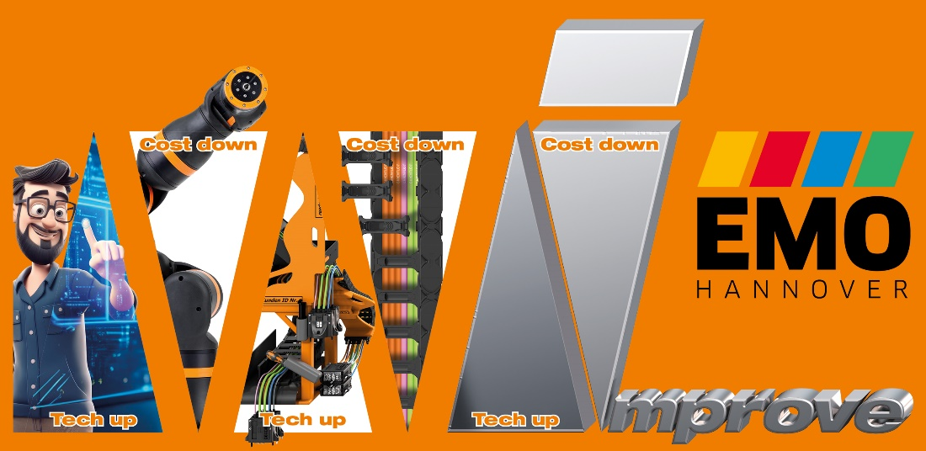

Picture PM5023-1
Tech up, cost down: At EMO 2023, igus will show how to make production cost-efficient and sustainable. (Source: igus GmbH)

PRESS CONTACT:
Alexa Heinzelmann
Head of International Marketing

igus® GmbH
Spicher Str. 1a
51147 Cologne
Tel. 0 22 03 / 96 49-7272
aheinzelmann@igus.net
www.igus.eu/press

ABOUT IGUS:

igus GmbH develops and produces motion plastics. These lubrication-free, high-performance polymers improve technology and reduce costs wherever things move. In energy supplies, highly flexible cables, plain and linear bearings as well as lead screw technology made of tribo-polymers, igus is the worldwide market leader. The family-run company based in Cologne, Germany, is represented in 31 countries and employs 4,600 people across the globe. In 2022, igus generated a turnover of €1,15 billion. Research in the industry's largest test laboratories constantly yields innovations and more security for users. 234,000 articles are available from stock and the service life can be calculated online. In recent years, the company has expanded by creating internal startups, e.g. for ball bearings, robot drives, 3D printing, the RBTX platform for Lean Robotics and intelligent "smart plastics" for Industry 4.0. Among the most important environmental investments are the "chainge" programme – recycling of used e-chains - and the participation in an enterprise that produces oil from plastic waste.

The terms "igus", “Apiro”, "chainflex", "CFRIP", "conprotect", "CTD", “drygear”, "drylin", "dry-tech", "dryspin", "easy chain", "e-chain", "e-chain systems", "e-ketten", "e-kettensysteme", "e-skin", "e-spool”, "flizz", “ibow”, “igear”, "iglidur", "igubal", “kineKIT”, "manus", "motion plastics", "pikchain", "plastics for longer life", "readychain", "readycable", “ReBeL”, "speedigus", "tribofilament“, "triflex", "robolink", “xirodur”, and "xiros" are protected by trademark laws in the Federal Republic of Germany and internationally, where applicable.

