e-spool flex: guide cables from start to end without slip ring
New igus cable reel with worm guide ensures more safety on operating panels and in assembly areas

Move cables safely and stow them away quickly - that is the aim of e-spool flex. The new igus cable reel can guide all cables and hoses for the transmission of energy, media and data without interruption. This increases safety at manual workstations and operating panels. For quick installation of the cable reel, the developers opted for a worm guide. The cable is inserted in a few simple steps and the e-spool flex is ready for use.

In order to be able to use tools and operating panels flexibly in production, they require appropriately long cables and hoses. However, these are often strewn across the hall floor without any protection and constitute a tripping hazard. Cable reels with slip rings offer a solution for energy transmission, but are often only available as a complete package with a new cable. A further disadvantage: the fast transmission of large amounts of data and media is very complicated with slip rings. This is why igus has now developed the e-spool flex, a cable reel with a worm guide. The new cable winder does not require a slip ring at all, so that bus cables and hoses for air and liquids can also be guided without interruption. "The user can easily install his existing cable in the system. This saves costs and increases the safety of his workplace", explains Jörg Ottersbach, Head of the e-chains Business Unit at igus GmbH. For fast assembly, igus relies on a worm guide in which the cable or hose is inserted. The guide is then inserted into the outer and winding housing of the e-spool flex in a few simple steps. This means that cables can move flexibly in free use and are quickly and cleanly stowed away after use.

Extension lengths of up to 15 metres possible
The new e-spool flex is available in two versions: one is a low-cost version with a manual turner to wind up the cable or an automatic solution with a brake and a spring-driven return mechanism. The e-spool flex is available in three sizes for cables with a diameter of 5 to 11 millimetres and an extension length of 5 to 15 metres. The cables can be quickly replaced at any time. In addition to a subsequent integration of the e-spool flex with an existing cable, igus also offers the cable reel solution fully harnessed with chainflex cables specifically designed for moving applications. Thanks to numerous tests in the company's own 3,800 square metre test laboratory, igus gives a unique 36-month guarantee on all cables.

Caption:

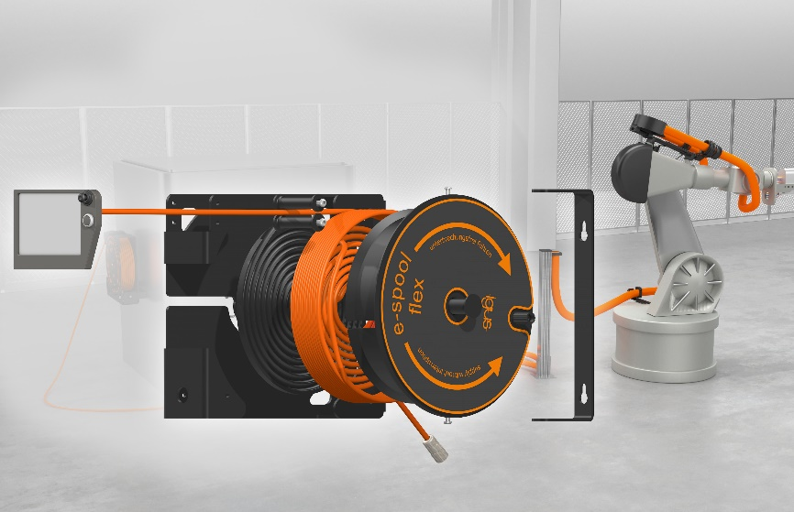
Picture PM2120-1
With the modular e-spool flex, cables can be stowed away easily and safely, for example, on robot operating panels. (Source: igus GmbH)

