Record-low costs and sustainability: our new slewing ring bearing
igus is adding a ready-to-install low-cost variant made from regranulated high-performance plastics to its iglidur PRT series
It is affordable, compact, lightweight and ready to install with a mouse click: igus has added a minimalist low-cost variant to the portfolio of its iglidur PRT series of slewing ring bearings. The PRT-05-15-PC not only reduces costs, but also protects the environment. The new slewing ring bearing consists of 97% regranulated high-performance plastics.

From packaging machine to assembly line to operating table: slewing ring bearings are used in a large number of rotary movements around a fixed axis. However, for many bearing points with low loads, such as those found in furniture construction or display technology, the bearings are often oversized and too expensive. Therefore, such applications often contain metal ball bearings. The problem is that the rolling bearings often take up a great deal of space and require assembly work because they often need fitting. They are also maintenance-intensive as they require continuous lubrication to function. "To eliminate these disadvantages, we decided to add a ready-to-install, low-cost variant to our slewing ring bearing portfolio," says Marc Trenkler, iglidur PRT Product Manager at igus. "So far, there have been hardly any ready-to-install, relatively inexpensive slewing ring bearings on the market," says Trenkler.

Minimalist design reduces required installation space, weight and costs
The new low-cost slewing ring bearing design follows minimalist principles. "Our goal was to produce a light, compact, ready-to-install bearing with as few components as possible," says Trenkler. The PRT-05-15-PC consists of just an inner ring and an outer ring, which slide over each other without balls. It is manufactured in a cost-effective injection-moulding process entirely from lightweight high-performance plastic - without an ounce of metal. It has a diameter of 100 millimetres, is only ten millimetres high and weighs 72 grammes. The reduced complexity makes the new low-cost slewing ring bearing not only compact and lightweight, but also quick to assemble. "Our employees only have to put the inner and outer ring together with a clip bearing. This allows us to offer the bearing to our customers at low cost," says Trenkler.

Low-cost slewing ring bearing made of 97% regranulate
The PRT-05-15-PC not only reduces costs, but also protects the environment. The new low-cost slewing ring bearing has a 97% content of regranulated iglidur M260 and iglidur P4 high-performance plastics. These are materials, such as production sprue, that have already been processed. Valuable plastics are thus saved from incineration and transferred to a sustainable circular economy. The plastic also has microscopic integrated solid lubricants that are released during operation and allow low-friction dry operation without lubricating grease for an additional environmentally friendly effect, which is a great advantage. Every year, millions of tons of lubricants pollute the environment. Finally, the new PRT is durable, especially outdoors. The polymer bearings do not corrode and are resistant to contamination from grease and dirt. This means that they don't have to be replaced as often. "The iglidur PRT-05-15-PC thus contributes to the EU sustainability strategy," says Trenkler. That strategy is aimed at making Europe the first climate-neutral continent by 2050 while boosting economic growth.

Caption:
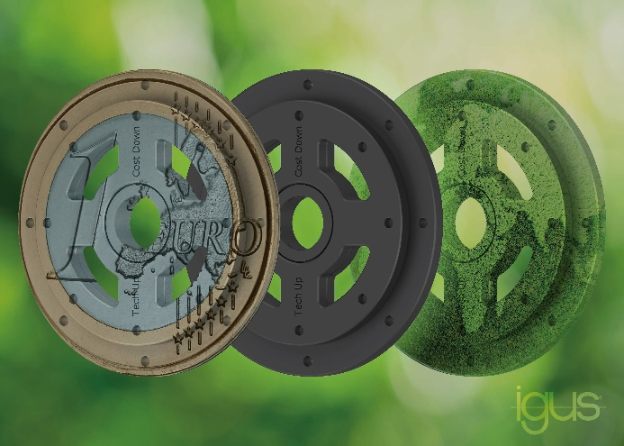
Picture PM4123-1
The new igus slewing ring bearing consist of 97% regranulated plastic, which makes it not only sustainable but also cost-effective. (Source: igus GmbH)

PRESS CONTACT:

Alexa Heinzelmann
Head of International Marketing

igus® GmbH
Spicher Str. 1a
51147 Cologne
Tel. 0 22 03 / 96 49-7272
aheinzelmann@igus.net
www.igus.eu/press

ABOUT IGUS:

igus GmbH develops and produces motion plastics. These lubrication-free, high-performance polymers improve technology and reduce costs wherever things move. In energy supplies, highly flexible cables, plain and linear bearings as well as lead screw technology made of tribo-polymers, igus is the worldwide market leader. The family-run company based in Cologne, Germany, is represented in 31 countries and employs 4,600 people across the globe. In 2022, igus generated a turnover of €1,15 billion. Research in the industry's largest test laboratories constantly yields innovations and more security for users. 234,000 articles are available from stock and the service life can be calculated online. In recent years, the company has expanded by creating internal startups, e.g. for ball bearings, robot drives, 3D printing, the RBTX platform for Lean Robotics and intelligent "smart plastics" for Industry 4.0. Among the most important environmental investments are the "chainge" programme – recycling of used e-chains - and the participation in an enterprise that produces oil from plastic waste.

The terms "igus", “Apiro”, "chainflex", "CFRIP", "conprotect", "CTD", “drygear”, "drylin", "dry-tech", "dryspin", "easy chain", "e-chain", "e-chain systems", "e-ketten", "e-kettensysteme", "e-skin", "e-spool”, "flizz", “ibow”, “igear”, "iglidur", "igubal", “kineKIT”, "manus", "motion plastics", "pikchain", "plastics for longer life", "readychain", "readycable", “ReBeL”, "speedigus", "tribofilament“, "triflex", "robolink", “xirodur”, and "xiros" are protected by trademark laws in the Federal Republic of Germany and internationally, where applicable.

