Completely relaxed gliding! Reliable motion of e-pedal boats through low-maintenance tribo-bearings from igus
Corrosion-free and lubrication-free plain bearing technology improves Ceclo technology and saves maintenance costs

Just relax on the lake or glide completely carefree through the lagoon, all this is made possible by the electrically assisted "Ceclo". To ensure that the ride remains very smooth for a long time, the French manufacturer of the same name now installs polymer plain bearings from igus instead of metallic ball bearings in their e-pedal boats. As a result, the lubrication-free and maintenance-free rotation of the propeller reduces maintenance costs and also meets strict environmental regulations.

The futuristic appearance of the Ceclo promises many a relaxed hour. On a lake or in shallow beach waters, it glides smoothly over the water surface. To make this possible, a new type of electrically supported drive and pedal system was developed for the e-pedal boat. The developers relied on iglidur H1 plain bearings. They replace metal ball bearings in the mechanical transmission to the propeller. Plain bearings made of the iglidur G material also ensure low-wear operation on aluminium shafts in the drive element. The freedom from lubricants and corrosion of the igus tribo-polymer plain bearings, especially in maritime environments, convinced the designers in their tests. And the Ceclo customer also benefits directly from this: maintenance intervals are extended, and the reliability and service life of the vehicle is increased. "Thanks to these positive specifications of iglidur plain bearings, we are now in a position to offer a maintenance service that was previously unavailable", emphasises Florence Rouquart, Quality Manager at Ceclo. "And we can also comply with the strict environmental regulations by dispensing with additional lubrication."

See the Ceclo also in the video below:
https://www.youtube.com/watch?v=W0JG1BmLeeQ

Caption:

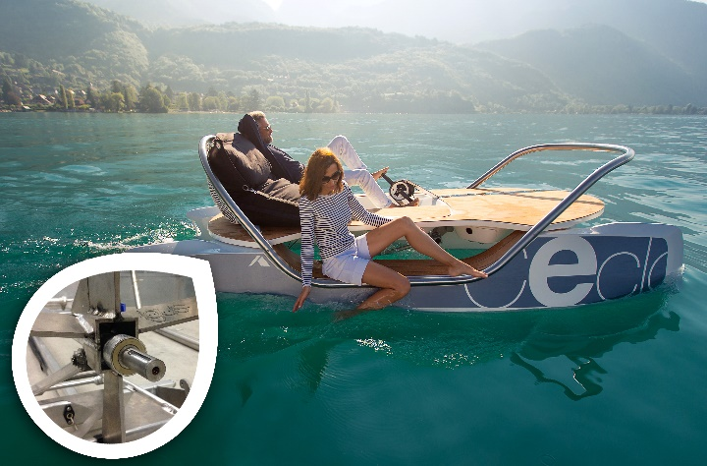
Picture PM5020-1
With iglidur plain bearings instead of metallic ball bearings on the propeller, maintenance of the Ceclo is reduced and costs are saved. (Source: igus GmbH)

PRESS CONTACT:  Oliver Cyrus  Head of PR and Advertising  Anja Görtz-Olscher  PR and Advertising  igus® GmbH  Spicher Str. 1a  51147 Cologne  Tel. 0 22 03 / 96 49-459 or -7153  Fax 0 22 03 / 96 49-631  ocyrus@igus.net  agoertz@igus.net  www.igus.eu/press | ABOUT IGUS:  igus GmbH is a global leading manufacturer of energy chain systems and polymer plain bearings. The Cologne-based family business has offices in 35 countries and employs 4,150 people around the world. In 2019, igus generated a turnover of 764 million euros from motion plastics, plastic components for moving applications. igus operates the largest test laboratories and factories in its sector to offer customers quick turnaround times on innovative products and solutions tailored to their needs.

The terms "igus", “Apiro”, "chainflex", "CFRIP", "conprotect", "CTD", “drygear”, "drylin", "dry-tech", "dryspin", "easy chain", "e-chain", "e-chain systems", "e-ketten", "e-kettensysteme", "e-skin", "e-spool”, "flizz", “ibow”, “igear”, "iglidur", "igubal", “kineKIT”, "manus", "motion plastics", "pikchain", "plastics for longer life", "readychain", "readycable", “ReBeL”, "speedigus", "triflex", "robolink", “xirodur”, and "xiros" are protected by trademark laws in the Federal Republic of Germany and internationally, where applicable.

