A sustainable combination: igus successfully tests plastic bearings with wooden shafts
A new igus design study shows how smoothly linear, plain bearings made from recycled material work on wooden shafts

Wood and plastic? Is that a good combination? The motion plastics specialist igus has researched the idea in a recent design study and tested the friction and wear behaviour of its plastic linear bearings on a wide variety of wood, and the result is impressive. The drylin econ J4 plain bearing has demonstrated its exceptional compatibility with various kinds of wood, opening new possibilities for furniture makers and design engineers when choosing materials.

The iglidur J4 made up of as much as 97 percent regranulate material, provides igus with a plastic that has a CO2 footprint of at least 60 percent smaller than a standard bearing. It is a cost-effective, dry-running linear plain bearing with large contact surfaces and has already proven itself as a wear-resistant mating partner on soft shafts such as aluminium and carbon fibre. Now a new material is being added: wood.
Lars Fenger, product developer at igus GmbH, explains the idea, "We were trying to think through our sustainability concept. We have been working with recyclate in our maintenance-free high-performance plastics for years. We asked how we could replace the shaft material with a sustainable solution, and wood was an obvious choice."
The igus solution gives the customer a metal-free, lightweight, cost-effective linear guide. Flexural strength tests were first carried out on different wood types to determine the right type of wood from the diverse selection available.
"We then tested various linear plain bearings on the wooden shafts and compared them with the values on steel shafts. We used the same test equipment and applied the same conditions for all of this. The result was a bit of a surprise," says Lars Fenger.

Coefficients of friction comparable to those of steel and aluminium
The tests were performed in the in-house 3,800-square-metre igus test laboratory in Cologne, where igus tests its products to complete failure. The wear coefficients determined for iglidur J4 with wood shafts differed only slightly from those for steel and aluminium. The friction coefficients showed that wooden shafts with wooden bearings fail quickly without lubrication. At the same time, a liner made of iglidur J4 can help reduce displacement resistance for a long time and do it almost silently.
Since wood is a working material that changes with temperature and humidity, the application should be checked in advance, including in the igus laboratory. But it is highly recommended wherever environmental conditions remain constant, such as interior design for small living spaces or furniture construction. Many igus customers already use plastic, plain bearings in conjunction with wood. An important reason for this is the easy assembly and disassembly of the liners, which allows materials to be separated cleanly at the end of the product life cycle.

Caption:

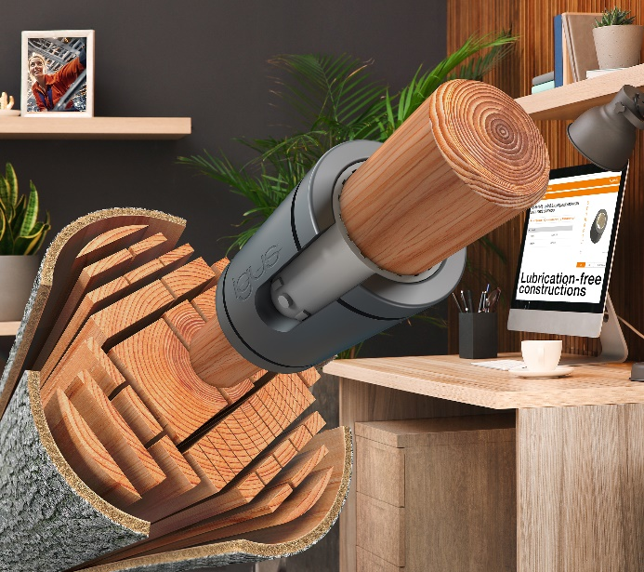
Picture PM3123-1
A new igus design study shows that dry-running plastic bearings such as
iglidur J4 are ideal mating partners for wooden shafts. (Source: igus GmbH)

PRESS CONTACT:

Alexa Heinzelmann
Head of International Marketing

igus® GmbH
Spicher Str. 1a
51147 Cologne
Tel. 0 22 03 / 96 49-7272
aheinzelmann@igus.net
www.igus.eu/press

ABOUT IGUS:

igus GmbH develops and produces motion plastics. These lubrication-free, high-performance polymers improve technology and reduce costs wherever things move. In energy supplies, highly flexible cables, plain and linear bearings as well as lead screw technology made of tribo-polymers, igus is the worldwide market leader. The family-run company based in Cologne, Germany, is represented in 31 countries and employs 4,600 people across the globe. In 2022, igus generated a turnover of €1,15 billion. Research in the industry's largest test laboratories constantly yields innovations and more security for users. 234,000 articles are available from stock and the service life can be calculated online. In recent years, the company has expanded by creating internal startups, e.g. for ball bearings, robot drives, 3D printing, the RBTX platform for Lean Robotics and intelligent "smart plastics" for Industry 4.0. Among the most important environmental investments are the "chainge" programme – recycling of used e-chains - and the participation in an enterprise that produces oil from plastic waste.

The terms "igus", “Apiro”, "chainflex", "CFRIP", "conprotect", "CTD", “drygear”, "drylin", "dry-tech", "dryspin", "easy chain", "e-chain", "e-chain systems", "e-ketten", "e-kettensysteme", "e-skin", "e-spool”, "flizz", “ibow”, “igear”, "iglidur", "igubal", “kineKIT”, "manus", "motion plastics", "pikchain", "plastics for longer life", "readychain", "readycable", “ReBeL”, "speedigus", "tribofilament“, "triflex", "robolink", “xirodur”, and "xiros" are protected by trademark laws in the Federal Republic of Germany and internationally, where applicable.

