Lubrication-free igus linear axis in hygienic design for clean use in food technology
drylin ZLW toothed belt axis with FDA-compliant materials can be cleaned quickly and is maintenance-free thanks to tribopolymer technology

The time-consuming cleaning of machines leads to longer and expensive downtimes in many companies in the food industry. To reduce this effort, igus is now launching a ready-to-connect toothed belt axis on the market, which is constructed according to the guidelines of hygienic design. It relies on FDA-compliant materials and the advantages of the lubrication-free and maintenance-free high-performance plastics from the motion plastics specialist.

After mixing waffle batter, clean the bowl and mixing sticks: an unruly business. Large bakeries can tell you a thing or two about it. They face the challenge of regularly cleaning huge vats and mixers - including the linear axes and linear carriages on which the mixers lower themselves into the containers. If classic linear axes are used here, there is a great risk that dough scraps will be deposited in hard-to-reach places, making cleaning considerably more difficult and possibly posing a risk of contamination. "In order to reduce the cleaning of systems in the food industry or even in the pharmaceutical and cosmetics industries, we have now expanded our portfolio of ZLW toothed belt axes," says Michael Hornung, igus Product Manager for drylin linear and drive technology. "The new model can be cleaned particularly quickly and thoroughly - whether with high-pressure steam jets, chemicals or simply running water. This also increases product safety."
Based on the hygienic design cleaning is simplified
The new linear axis is easy to clean because the design engineers at igus followed the guidelines of hygienic design during development. Undercuts in the entire system are minimised where food remnants could accumulate. Likewise, there are no gaps that can occur, for example, if screw heads disappeared into a recess in order to be flush with the surface. "We deliberately avoided countersinking the screws. True to the motto: "Form follows functionality, in this case easy cleaning," emphasises Hornung. Equally important: rounded corners, which ensure that water can flow better during high-pressure cleaning and carry dirt particles along more easily. Water cannot deposit and the formation of germs is reduced. Wherever a dead end was unavoidable, boreholes ensure that liquid drains away completely.
Lubrication-free plain bearings reduce risk of contamination
The igus developers use only FDA-compliant materials for the new toothed belt axis. The shaft end supports and linear carriages are made of corrosion-resistant stainless steel. The plain bearings, on which the carriage moves over the rail, are made of the food-grade tribo-plastic iglidur A160, which enables low-friction dry operation - without external lubricants, which could become a contamination hazard and pollute the environment. This also makes the drylin ZLW toothed belt axis extremely durable. This is illustrated by approximately 1.5 million double strokes at a speed of 0.5m/s and an acceleration of 2m/s² with a load of 3 kilograms, in igus' own test laboratory. The drylin ZLW toothed belt axis can now be ordered with a maximum stroke length of up to 3,000 millimetres and can optionally be equipped with a suitable stepper motor.

Caption:

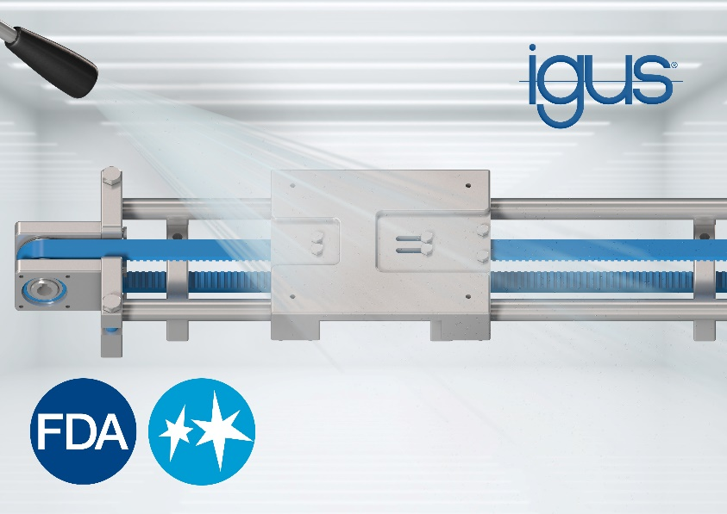
Picture PM6021-1
Easy to clean, lubrication-free and maintenance-free: the new drylin ZLW toothed belt axis is based on hygienic design principles and uses FDA-compliant materials. (Source: igus GmbH)
PRESS CONTACT:

Alexa Heinzelmann
Head of International Marketing

igus® GmbH
Spicher Str. 1a
51147 Cologne
Tel. 0 22 03 / 96 49-7272
aheinzelmann@igus.net
www.igus.eu/press

ABOUT IGUS:

igus GmbH develops and produces motion plastics. These lubrication-free, high-performance polymers improve technology and reduce costs wherever things move. In energy supplies, highly flexible cables, plain and linear bearings as well as lead screw technology made of tribo-polymers, igus is the worldwide market leader. The family-run company based in Cologne, Germany, is represented in 35 countries and employs 4,150 people across the globe. In 2020, igus generated a turnover of €727 million. Research in the industry's largest test laboratories constantly yields innovations and more security for users. 234,000 articles are available from stock and the service life can be calculated online. In recent years, the company has expanded by creating internal startups, e.g. for ball bearings, robot drives, 3D printing, the RBTX platform for Lean Robotics and intelligent "smart plastics" for Industry 4.0. Among the most important environmental investments are the "chainge" programme – recycling of used e-chains - and the participation in an enterprise that produces oil from plastic waste (Plastic2Oil).

The terms "igus", “Apiro”, "chainflex", "CFRIP", "conprotect", "CTD", “drygear”, "drylin", "dry-tech", "dryspin", "easy chain", "e-chain", "e-chain systems", "e-ketten", "e-kettensysteme", "e-skin", "e-spool”, "flizz", “ibow”, “igear”, "iglidur", "igubal", “kineKIT”, "manus", "motion plastics", "pikchain", "plastics for longer life", "readychain", "readycable", “ReBeL”, "speedigus", "tribofilament“, "triflex", "robolink", “xirodur”, and "xiros" are protected by trademark laws in the Federal Republic of Germany and internationally, where applicable.

