Find and order linear modules quickly with the igus drive technology configurator
A new online tool helps with the configuration of customised, maintenance-free linear drive systems

Lead screw, gear rack or toothed belt drive? Miniature or heavy-load axle? Motor or hand wheel? Looking for the right linear module is time-consuming. This is exactly why igus has now developed the drive technology configurator. After the application parameters are entered, the smart product finder shows the customer all suitable drylin drive technology solutions along with their service life. Depending on the filter settings, the user can choose the optimal linear module system and further configure and order it with compatible accessories such as motor and control system.

To help customers find the right linear module for their application, igus has made a new drive technology configurator available free of charge. The online tool uses application data such as installation position, load, stroke length, speed and self-locking to make suitable product suggestions that fulfil the customer's requirements. "The special feature is that with the help of our test data from our in-house laboratory, we can make a lifetime statement for each linear module as well as the motor load in the individual application and display them online. The customer can be sure that the module will work reliably and maintenance-free in the machine and system", says Michael Hornung, igus GmbH's International Product Manager for drylin. Other filter options such as for usage conditions like high temperatures or food service can be used to customise the selection further. The user can then continue to equip the module with suitable accessories as desired. This allows everything from manual operation with a hand wheel to the right motor to a control system. "By displaying and selecting only compatible products, we give the user confidence that they will get a linear module that be connected right away", says Hornung. The price is automatically calculated and shown in the application. This allows the effects of the selected options, including on price, to be considered, which also eliminates time lost to queries. In a final step, the configuration can be stored or forwarded, the parts list and technical information downloaded, and the linear module ordered with a mouse click.

drylin SLN: small linear modules for big tasks
With drylin drive technology, igus offers linear modules for a variety of application areas. These may be for format shifts in the packaging industry, measuring in inspection and testing automation, or adjustment in laser marking systems. The core of all systems are self-lubricating plain bearings made of igus high-performance polymers, which are characterised by precision and reliability, a long, predictable service life, freedom from maintenance and resistance to corrosion. The linear module product range includes drylin SLN. The miniature linear module is designed for the smallest installation spaces and moves on the low-profile drylin N linear guide from igus. The compact series offers users three carriage versions and a plain bearing or a ball bearing mounted lead screw. The module is used in laboratory analysis systems, pipetting technology and sensors, amongst other applications – wherever handling must be performed in very tight installation spaces.

Try the new drive technology configurator yourself:
https://drylin-drive-technology-configurator.igus.tools/requirements?l=en&c=DE

Caption:

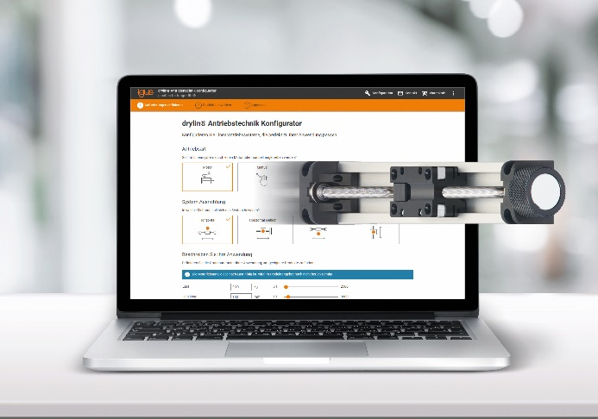
Picture PM3621-1
The drive technology configurator quickly finds the right linear module for the individual application. (Source: igus GmbH)

ABOUT IGUS:

igus GmbH develops and produces motion plastics. These lubrication-free, high-performance polymers improve technology and reduce costs wherever things move. In energy supplies, highly flexible cables, plain and linear bearings as well as lead screw technology made of tribo-polymers, igus is the worldwide market leader. The family-run company based in Cologne, Germany, is represented in 35 countries and employs 4,150 people across the globe. In 2020, igus generated a turnover of €727 million. Research in the industry's largest test laboratories constantly yields innovations and more security for users. 234,000 articles are available from stock and the service life can be calculated online. In recent years, the company has expanded by creating internal startups, e.g. for ball bearings, robot drives, 3D printing, the RBTX platform for Lean Robotics and intelligent "smart plastics" for Industry 4.0. Among the most important environmental investments are the "chainge" programme – recycling of used e-chains - and the participation in an enterprise that produces oil from plastic waste (Plastic2Oil).

PRESS CONTACT:

Oliver Cyrus Anja Görtz-Olscher
Head of PR and Advertising Manager PR and Advertising

igus® GmbH igus® GmbH
Spicher Str. 1a Spicher Str. 1a
51147 Cologne 51147 Cologne
Tel. 0 22 03 / 96 49-459 Tel. 0 22 03 / 96 49-7153
ocyrus@igus.net agoertz@igus.net
www.igus.de/presse www.igus.de/presse

The terms "igus", “Apiro”, "chainflex", "CFRIP", "conprotect", "CTD", “drygear”, "drylin", "dry-tech", "dryspin", "easy chain", "e-chain", "e-chain systems", "e-ketten", "e-kettensysteme", "e-skin", "e-spool”, "flizz", “ibow”, “igear”, "iglidur", "igubal", “kineKIT”, "manus", "motion plastics", "pikchain", "plastics for longer life", "readychain", "readycable", “ReBeL”, "speedigus", "tribofilament“, "triflex", "robolink", “xirodur”, and "xiros" are protected by trademark laws in the Federal Republic of Germany and internationally, where applicable.

