New E4Q e-chain with extender crossbars for safe guidance of large hoses
A clever adapter system ensures quick and easy adjustment of the E4Q energy chain to the hose diameter

To be able to safely guide large hoses, igus has now developed a new extender crossbar design for its E4Q modular energy chain series. With the help of an adapter system, the chain can be individually adapted to the hose diameter. The tool-free E4Q opening mechanism ensures easy installation and filling of the energy supply.

In 2019, igus launched a new series of energy chains under the name E4Q, which has already proven itself in applications worldwide - from machine tools to linear robots. The E4Q scores points with long unsupported lengths and long travels. It is particularly popular because of its modularity. In addition, the user can save 40% assembly time and 10% weight compared to the standard E4.1 series. "Some customers wanted to guide large hoses in addition to cables, which is why we have now developed the E4Q e-chain with extender crossbars in a design study," explains Phillip Hagedorn, Product Manager e-chains at igus GmbH. The extender crossbar can be mounted on the energy chain with an adapter system. For inserting hoses, e.g. those used in the wood industry, igus relies on the proven E4Q crossbars. These can be opened and closed without any tools and are available in 15 different widths. This offers users a high level of variability when configuring their energy supply.

Guide hoses and cables safely in one system
"We have developed two different widths and heights of the adapters," explains Hagedorn. "This gives the customer the option of adapting the extender crossbar to the hose diameter." By using the extender crossbars, the interior space of the energy chain increases significantly. In addition to the hoses, other cables can also be accommodated and routed that way. With the product range of cable-friendly interior separation elements, the energy chain can be easily divided so that customers can lay out their cables and hoses as desired. Costs can also be saved with the new e-chain with extender crossbars, because instead of a large energy chain, the user can simply insert a smaller chain with extended crossbars for more inner height.

Find out more about the E4Q e-chain with extender crossbars at: https://www.igus.eu/info/e4q-clamp

Caption:
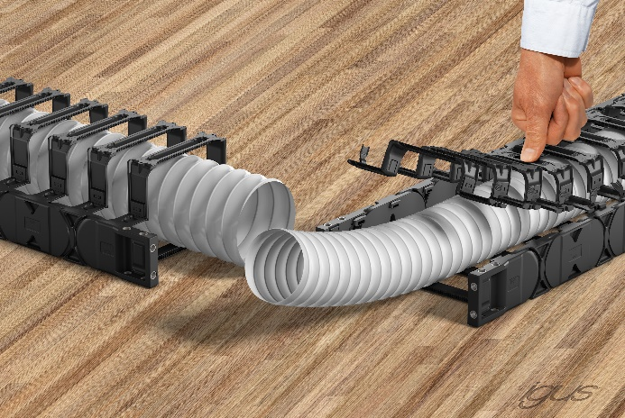
Picture PM0923-1
The E4Q can be quickly adapted to the hose diameter with an easily installable adapter system. (Source: igus GmbH)

PRESS CONTACT:

Alexa Heinzelmann
Head of International Marketing

igus® GmbH
Spicher Str. 1a
51147 Cologne
Tel. 0 22 03 / 96 49-7272
aheinzelmann@igus.net
www.igus.eu/press

ABOUT IGUS:

igus GmbH develops and produces motion plastics. These lubrication-free, high-performance polymers improve technology and reduce costs wherever things move. In energy supplies, highly flexible cables, plain and linear bearings as well as lead screw technology made of tribo-polymers, igus is the worldwide market leader. The family-run company based in Cologne, Germany, is represented in 31 countries and employs 4,900 people across the globe. In 2021, igus generated a turnover of €961 million. Research in the industry's largest test laboratories constantly yields innovations and more security for users. 234,000 articles are available from stock and the service life can be calculated online. In recent years, the company has expanded by creating internal startups, e.g. for ball bearings, robot drives, 3D printing, the RBTX platform for Lean Robotics and intelligent "smart plastics" for Industry 4.0. Among the most important environmental investments are the "chainge" programme – recycling of used e-chains - and the participation in an enterprise that produces oil from plastic waste.

The terms "igus", “Apiro”, "chainflex", "CFRIP", "conprotect", "CTD", “drygear”, "drylin", "dry-tech", "dryspin", "easy chain", "e-chain", "e-chain systems", "e-ketten", "e-kettensysteme", "e-skin", "e-spool”, "flizz", “ibow”, “igear”, "iglidur", "igubal", “kineKIT”, "manus", "motion plastics", "pikchain", "plastics for longer life", "readychain", "readycable", “ReBeL”, "speedigus", "tribofilament“, "triflex", "robolink", “xirodur”, and "xiros" are protected by trademark laws in the Federal Republic of Germany and internationally, where applicable.

