**Ready for direct connection: igus hybrid cable for new motor generation**

**Harnessed readycable for the e-chain transmits energy and data securely in a compact installation space**

**In order to supply modern motors with energy and data, users need appropriate cables that function dependably even at high accelerations and on long travels. Especially for use in motion, igus has now developed a hybrid cable that is offered as a drive solution for the new Bosch Rexroth motors. It combines energy and data cable in one and is therefore also suitable for compact installation spaces. igus offers the cable as a fully harnessed readycable that is accurate to the centimetre. This saves the user costs.**

Ever smaller and more compact with an even higher output: such a trend is becoming increasingly apparent in the field of motor development. But not only the motor but also the cables used must meet the new requirements. Hybrid cables are one solution. They combine energy and data supply in one by integrating the encoder cable into the servo cable. This eliminates the need for cabling with a separate measuring system for the encoder. Especially for use in the energy chain, igus has now developed a new [hybrid cable](https://www.igus.eu/product/20291) suitable for Bosch Rexroth MS2N and IndraDrive Mi motors. A halogen-free PUR outer jacket ensures oil resistance and increases the service life of the cable. The user receives the drive solution already fully harnessed with connector as the so-called readycable from igus. "While other manufacturers on the market only offer cables in metre lengths, customers can order their solutions from us down to the centimetre. This way we avoid unnecessary waste or residual stock. As readycable, the cable can be connected directly to the machine. This saves additional harnessing and installation times", explains Markus Hüffel, Product Manager readycable at igus GmbH.

**readycable finder helps in product selection**

All cables are tested and inspected under real conditions in the company's own 3,800 square metre test laboratory. Tests have shown that the new hybrid cable with a bend radius of up to 10xd in the e-chain can safely withstand 10 million double strokes over the long term. Due to the realistic tests, igus is the only cable manufacturer in the world capable of providing a 36-month guarantee on its chainflex cables. In total, igus has over 4,200 drive cables suitable for 24 manufacturer standards in its readycable range. For a quick selection of the suitable solution, with the [readycable product finder](https://www.igus.eu/readycableproductfinder/search) igus offers a practical online tool. Simply enter the igus part number or the manufacturer, or select the name of the drive manufacturer from the menu; then click on the required cable type and the product finder will list all matching parts. An overview provides the different cable qualities such as outer jacket, bend radius, travel and price. The integrated service life calculator also determines the running time. One click is all it takes to order the matching cable in the desired length and have it delivered within 24 hours.

**Caption:**

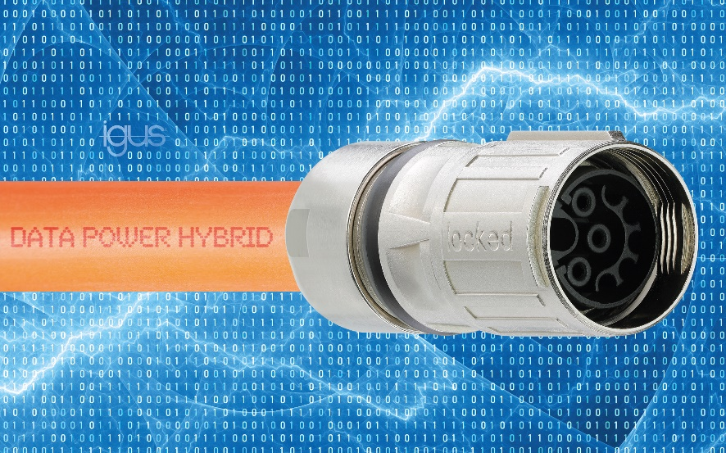

**Picture PM2020-1**

The new cost-effective hybrid cable suitable for Bosch Rexroth motors ensures a reliable supply of energy and data during motion. (Source: igus GmbH)