chainflex cable increases the reliability of machines with Fanuc drives
igus is expanding its CF270.UL.D servo cable range, adding a new e-chain cable that works with Fanuc motors

In the area of machine tools, many users around the world rely on Fanuc motors and control systems. In order to reliably supply the drives with energy while they are in motion, igus has now developed a highly flexible servo cable. It is designed specifically for use in dynamic applications. The cable has an oil-resistant PUR jacket, UL certification, and a UL-verified, certified guarantee promise for up to 36 months.

A servo cable is what connects the machine to its drive and sets it in motion. That is why it is very important in mechanical engineering. Used in an energy chain, it must be fail-safe, highly flexible, durable and oil-resistant, whilst fulfilling a wide variety of standards and certifications for use in the global market. igus' CF270.UL.D range offers 32 cable cross-sections that work with drives from 24 manufacturers and were developed for use in e-chains. igus has now expanded the series to include a new cable design with (6G1.0)C for the βi Fanuc motor series. "We offer more than 20 different chainflex cable ranges specifically for the machine tool area", says Katharina Esch, International chainflex cable Product Manager for igus GmbH. "Since more and more machine builders are using Fanuc motors, we have developed a cable for them, one that can handle the demanding environmental conditions and high movement speeds and accelerations." The CF270.UL.10.06 has a PUR outer jacket that is resistant to oil and coolant and is coloured according to DESINA and certified according to 1000V UL AWM. As it does for all of its 1,350 cables, igus guarantees a service life of up to 36 months, certified and UL verified.

Cable can handle up to 18 million strokes
In test 4831 in igus' 3,800-square-metre in-house laboratory in Cologne, the chainflex cable held up for 18 million strokes. Its durability in a given application can be determined free of charge with the freely accessible online service life calculator. igus offers the new Fanuc cable either by the metre (one metre minimum) from stock, or harnessed with a suitable connector as a ready-to-connect readycable. If the user is looking for a ready-to-connect energy supply system consisting of e-chain, cables and connectors, they can use igus' readychain service.

Find out more about the new Fanuc servo cable at
https://www.igus.eu/info/n21-cf-hybridcable-for-fanuc

Caption:

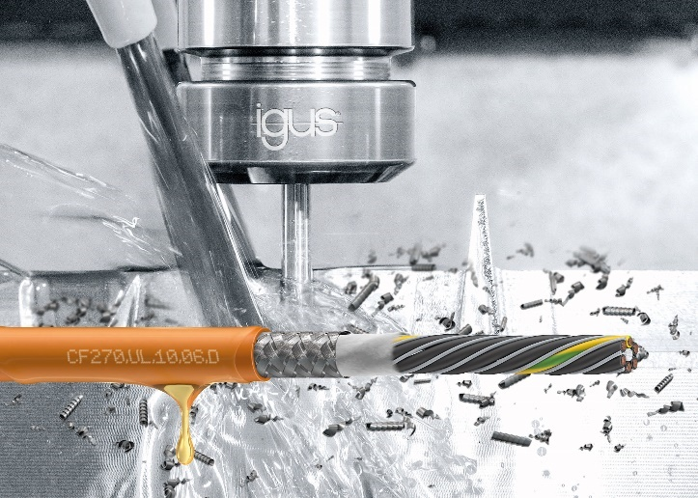
Picture PM3421-1
The new chainflex servo cable has been designed specifically for dynamic applications with Fanuc drives in machine tools. (Source: igus GmbH)

PRESS CONTACT:  Oliver Cyrus  Head of PR and Advertising  Anja Görtz-Olscher  PR and Advertising  igus® GmbH  Spicher Str. 1a  51147 Cologne  Tel. 0 22 03 / 96 49-459 or -7153  Fax 0 22 03 / 96 49-631  ocyrus@igus.net  agoertz@igus.net  www.igus.eu/press | ABOUT IGUS:  igus GmbH develops and produces motion plastics. These lubrication-free, high-performance polymers improve technology and reduce costs wherever things move. In energy supplies, highly flexible cables, plain and linear bearings as well as lead screw technology made of tribo-polymers, igus is the worldwide market leader. The family-run company based in Cologne, Germany, is represented in 35 countries and employs 3,800 people across the globe. In 2019, igus generated a turnover of €764 million. Research in the industry's largest test laboratories constantly yields innovations and more security for users. 234,000 articles are available from stock and the service life can be calculated online. In recent years, the company has expanded by creating internal startups, e.g. for ball bearings, robot drives, 3D printing, the RBTX platform for Lean Robotics and intelligent "smart plastics" for Industry 4.0. Among the most important environmental investments are the "chainge" programme – recycling of used e-chains - and the participation in an enterprise that produces oil from plastic waste. (Plastic2Oil).

The terms "igus", “Apiro”, "chainflex", "CFRIP", "conprotect", "CTD", “drygear”, "drylin", "dry-tech", "dryspin", "easy chain", "e-chain", "e-chain systems", "e-ketten", "e-kettensysteme", "e-skin", "e-spool”, "flizz", “ibow”, “igear”, "iglidur", "igubal", “kineKIT”, "manus", "motion plastics", "pikchain", "plastics for longer life", "readychain", "readycable", “ReBeL”, "speedigus", "tribofilament“, "triflex", "robolink", “xirodur”, and "xiros" are protected by trademark laws in the Federal Republic of Germany and internationally, where applicable.

