Five times the distance: world's first cable for hanging applications suitable for SEW-EURODRIVE
igus chainflex CFSPECIAL.192 hybrid cable for hanging travels of up to 50 metres

Machines have to work reliably around the clock in such areas as material handling. Warehouses are getting bigger, and increasing mast heights mean high demands on the cables. To ensure trouble-free operation even in demanding hanging applications, igus has developed the CFSPECIAL.192 hybrid cable. It is the only cable on the market specifically for hanging applications in e-chains, suitable for SEW-EURODRIVE's MOVILINK DDI. A high-tensile aramid support element in the cable jacket allows mast heights five times that of standard cables.

With 1,354 cable types for data, bus and hybrid systems, control systems and drives, igus offers an extensive range of cables for moving applications in a wide variety of industries. igus has developed the chainflex CFSPECIAL cable series for areas of application with special requirements. The CFSPECIAL.192 is new to the product range. It is the first chainflex hybrid cable for hanging applications, suitable for SEW-EURODRIVE's MOVILINK DDI drive technology. "Hybrid technology is becoming more and more popular, so demand for new single-cable solutions is also growing," says Rainer Rössel, Head of Business Unit chainflex Cables at igus. "Especially in the material handling field, many companies use SEW-EURODRIVE's MOVILINK DDI digital motor interface, for which we already offer various cables. Hanging applications, however, such as stacker cranes, whose masts can be very high, place special demands on cables. The CFSPECIAL.192 is our newly developed cable solution for stroke heights of up to 50 metres."

More than 4,200 newtons of tensile force
"The challenge with hanging applications is that you need a cable that is suitable for chains and can absorb enough tensile force that it does not break even over great distances and stroke heights," explains Christian Strauch, Industry Manager Material Handling at igus. The cable has to bear its own weight - 15 newtons per square millimetre of main core according to the standard. The cross section can be enlarged, but that does not automatically mean more cable length because the coefficient of friction also increases. "To solve this problem, we have incorporated a high-tensile aramid braid into the CFSPECIAL.192's PUR outer jacket. Tests in our in-house laboratory show that the tensile strength is 500% higher than that of a standard cable for MOVILINK DDI," says Rössel. "Our new cable achieves a tensile force of over 4,200 newtons, making it ideal for vertical applications, such as storage and retrieval units."

Lower costs and guaranteed longer service life
The new igus hybrid cable reduces costs for customers by eliminating the need for a second cable and time-consuming cable bracing in the energy chain. At the same time, the single-cable solution requires less installation space and reduces the weight the system must bear. In addition to lower costs, users benefit from the much longer cable service life in hanging applications. All igus cables are subjected to numerous tests to calculate the service life of each cable - and the online tool makes it very easy. "That is why we are the only supplier in the world to offer a 36-month guarantee on all our chainflex cables," says Rössel. "This way, users benefit from a durable solution that ensures reliable, trouble-free operation even at great heights and over long distances."

Caption:

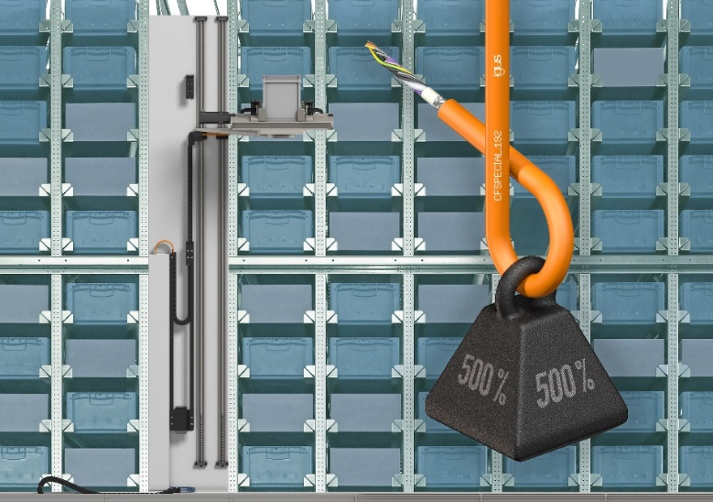
Picture PM1323-1
A special aramid support element gives the CFSPECIAL.192 500% more tensile force than a standard cable for MOVILINK DDI, and enables five times the distance in hanging applications. (Source: igus GmbH)

PRESS CONTACT:

Alexa Heinzelmann
Head of International Marketing

igus® GmbH
Spicher Str. 1a
51147 Cologne
Tel. 0 22 03 / 96 49-7272
aheinzelmann@igus.net
www.igus.eu/press

ABOUT IGUS:

igus GmbH develops and produces motion plastics. These lubrication-free, high-performance polymers improve technology and reduce costs wherever things move. In energy supplies, highly flexible cables, plain and linear bearings as well as lead screw technology made of tribo-polymers, igus is the worldwide market leader. The family-run company based in Cologne, Germany, is represented in 31 countries and employs 4,900 people across the globe. In 2021, igus generated a turnover of €961 million. Research in the industry's largest test laboratories constantly yields innovations and more security for users. 234,000 articles are available from stock and the service life can be calculated online. In recent years, the company has expanded by creating internal startups, e.g. for ball bearings, robot drives, 3D printing, the RBTX platform for Lean Robotics and intelligent "smart plastics" for Industry 4.0. Among the most important environmental investments are the "chainge" programme – recycling of used e-chains - and the participation in an enterprise that produces oil from plastic waste.

The terms "igus", “Apiro”, "chainflex", "CFRIP", "conprotect", "CTD", “drygear”, "drylin", "dry-tech", "dryspin", "easy chain", "e-chain", "e-chain systems", "e-ketten", "e-kettensysteme", "e-skin", "e-spool”, "flizz", “ibow”, “igear”, "iglidur", "igubal", “kineKIT”, "manus", "motion plastics", "pikchain", "plastics for longer life", "readychain", "readycable", “ReBeL”, "speedigus", "tribofilament“, "triflex", "robolink", “xirodur”, and "xiros" are protected by trademark laws in the Federal Republic of Germany and internationally, where applicable.

