Innovatively driving the circular economy forward: igus launches its new "Chainge" recycling platform
The platform is used not only to recycle old e-chains and other technical plastics, but also to buy recycled material

Don't dispose of old energy chains as industrial waste - let igus recycle them: customer feedback on the "Chainge" recycling initiative, which was launched in 2019, is so positive that igus is now expanding the project. In the future, a new, unique online platform will allow recycling not only of e-chains, but also other of technical plastic components. What is special here is that customers also have the option of purchasing processed material (ground material and regranulate) on the platform. At igus, you thus get everything from a single source. The new platform will also be presented at K 2022, an international plastics trade show, in Düsseldorf.

After the end of their service life, energy chains often end up in industrial waste and are thus incinerated. Their emissions then pollute the environment, and valuable resources are lost forever. These are linear economy problems that igus has been countering with its "Chainge" recycling program since 2019. Customers send worn-out e-chains - regardless of their manufacturer - to Cologne, where igus re-granulates them for reuse. Customers receive a voucher in return for their old chains. "What began as a small idea has rapidly picked up steam. Since the start of 'Chainge', we have already collected and recycled over 60 tons of high-performance plastics. Half of that was in 2022 alone," says Michael Blass, CEO e-chain systems at igus. "This positive feedback has motivated us to think even bigger about recycling. To accelerate the transformation to a circular economy, we will therefore start including not only e-chains in the recycling program, but also other components made from technical plastics."

Online platform makes global recycling even easier
In order to speed up the recycling process, igus will launch the new "Chainge" online platform in October 2022. There, owners of old plastic parts - such as bar stock and gears - can submit a recycling request, process returns and manage credits for purchasing new igus products. As part of the "Chainge" expansion, igus will include additional locations in the program and further broaden its recycling network. "Our recycling will no longer be limited to our headquarters in Cologne, but can be performed around the world. These additional capacities will allow us to make an even greater contribution to the circular economy," says Blass. The platform will also sell regranulate, which has so far been used only in in-house injection moulding. "That way, customers around the world can now also easily buy processed material from which new, high-quality plastic components can be created."

Everything from one source
Since the start of the "Chainge" program, igus has continuously expanded its range of products and services to further advance the circular economy. As from the beginning of this year, igus has been accepting old material as well as used e-chains as part of assembly orders. igus was also recently awarded the Rhineland Business Prize for sustainability for its recycling program. But igus goes one step further: "Chainge" gave rise to the world's first energy chain made entirely from recycled material, which was also created this year. Says Michael Blass, "The special thing about igus is that you get everything from a single source. We are a plastics producer and supplier, an assembly service provider, a disposal company, and a producer and supplier of recycled material used to create new products. What we offer is unique in this form and enables us to work with our customers to turn plastic into a sustainable resource."

To the online platform: https://chainge.igus.eu/
(To change language settings of the page, please scroll to the bottom of the page.)

Visit us at K 2022 in Düsseldorf, Hall 5, Trade Show Stand B36, to find out more about the new "Chainge" platform. Experience more igus product innovations live at Stand F75 in Hall 11.

Caption:
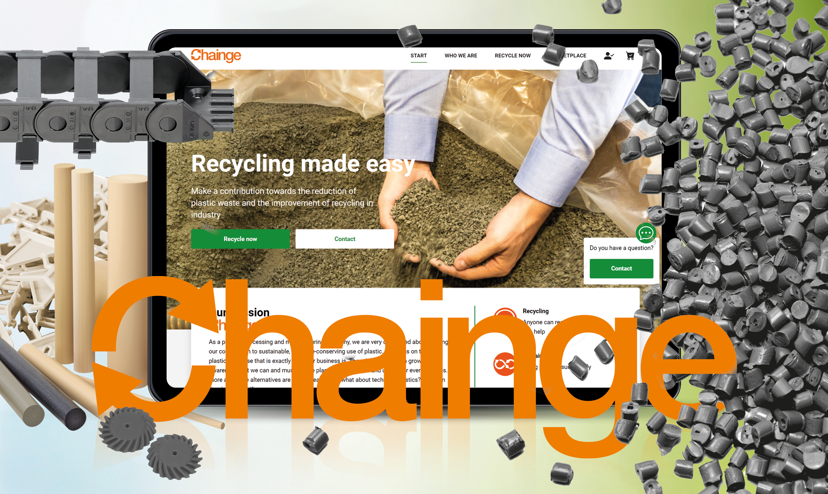
Picture PM6022-1
As part of the "Chainge" recycling initiative, igus is now launching a unique online platform that allows customers to recycle old plastic components and purchase processed material at the same time. (Source: igus GmbH)

PRESS CONTACT:

Alexa Heinzelmann
Head of International Marketing

igus® GmbH
Spicher Str. 1a
51147 Cologne
Tel. 0 22 03 / 96 49-7272
aheinzelmann@igus.net
www.igus.eu/press

ABOUT IGUS:

igus GmbH develops and produces motion plastics. These lubrication-free, high-performance polymers improve technology and reduce costs wherever things move. In energy supplies, highly flexible cables, plain and linear bearings as well as lead screw technology made of tribo-polymers, igus is the worldwide market leader. The family-run company based in Cologne, Germany, is represented in 31 countries and employs 4,900 people across the globe. In 2021, igus generated a turnover of €961 million. Research in the industry's largest test laboratories constantly yields innovations and more security for users. 234,000 articles are available from stock and the service life can be calculated online. In recent years, the company has expanded by creating internal startups, e.g. for ball bearings, robot drives, 3D printing, the RBTX platform for Lean Robotics and intelligent "smart plastics" for Industry 4.0. Among the most important environmental investments are the "chainge" programme – recycling of used e-chains - and the participation in an enterprise that produces oil from plastic waste.

The terms "igus", “Apiro”, "chainflex", "CFRIP", "conprotect", "CTD", “drygear”, "drylin", "dry-tech", "dryspin", "easy chain", "e-chain", "e-chain systems", "e-ketten", "e-kettensysteme", "e-skin", "e-spool”, "flizz", “ibow”, “igear”, "iglidur", "igubal", “kineKIT”, "manus", "motion plastics", "pikchain", "plastics for longer life", "readychain", "readycable", “ReBeL”, "speedigus", "tribofilament“, "triflex", "robolink", “xirodur”, and "xiros" are protected by trademark laws in the Federal Republic of Germany and internationally, where applicable.

