Service life extension made easy: just three online steps to your individual smart e-chain
Equip energy chains directly with smart condition monitoring in the igus online configurator and avoid unnecessarily early replacement

A quick and easy individual solution: igus, the motion plastics specialist, offers a wide range of online tools (among other things) to streamline the process. They include the "e-chain expert", which enables interested parties to assemble an individual energy chain system in just three steps. Price, service life and delivery time are displayed. For the first time, users now have the option of configuring their e-chain with the intelligent i.Sense EC.W wear sensor directly. This gives customers a complex, ready-to-connect e-chain system that includes real-time condition monitoring - in just a few clicks.

The igus "e-chain expert" online configurator finds the energy chain best suited for each customer's application - in just three steps. Users only have to select the harnessed or unharnessed cables in the online tool or indicate the rough fill weight. Then they choose environmental and application parameters, such as travel and required speed. Finally, they can pick the right energy chain from a pre-selection and tailor it further. A new function is now available: for the first time, they can also equip their e-chain directly with igus smart plastics technology - intelligent sensors. "As soon as the customer receives a pre-selection of suitable chain series, the online tool immediately shows which products are compatible with smart plastics. The selected chain can then be equipped with a smart wear sensor with a simple click," says Richard Habering, Head of Business Unit smart plastics at igus. The EC.W sensor can also be easily added to existing chain configurations. Users then assign interior e-chain separation as usual - automatically taking into account all interior separation rules, of course. Those who want to skip these setup steps can also work directly with the demo chain configuration.

Real-time condition monitoring costs less than ever
As Industry 4.0 advances, more and more companies are relying on smart sensors to monitor the technical condition of their systems. igus i.Sense EC.W provides real-time condition monitoring. This not only makes maintenance over the entire service life simpler and easier to plan, but also reduces its costs. Integrated, potential-free contacts allow the wear sensor to be connected directly to the PLC machine control system. Users can also connect the sensor to a wide range of networks and IoT systems via an i.Cee module and thus integrate it into a predictive-maintenance concept. "smart plastics enable users to avoid unplanned system downtimes and unnecessary or premature chain replacement. This can extend energy chain service life and greatly increase system availability," says Richard Habering, adding, "The integration of smart plastics technology into our online configurator now makes this even easier. Customers save valuable time and receive their ready-to-connect e-chain system, including intelligent service life monitoring, with the least possible effort."

You can find more information here:
https://www.igus.eu/info/smartconfigurator_instruction

Caption:

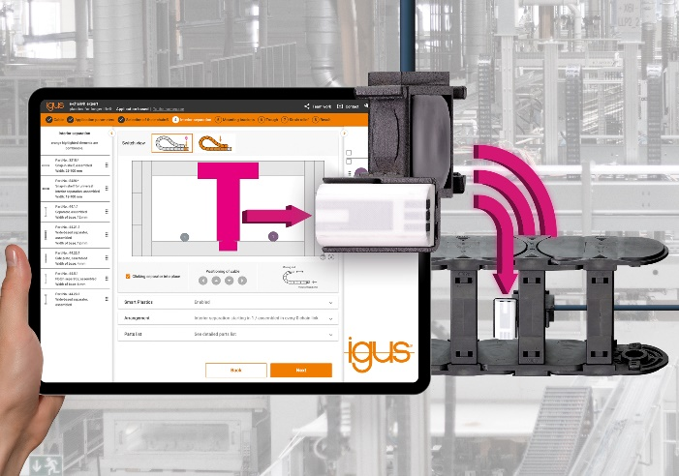
Picture PM0823-1
In the "e-chain expert", customers can now directly equip their ready-to-connect energy chain with smart condition monitoring - and avoid unnecessarily early replacement. (Source: igus GmbH)

PRESS CONTACT:

Alexa Heinzelmann
Head of International Marketing

igus® GmbH
Spicher Str. 1a
51147 Cologne
Tel. 0 22 03 / 96 49-7272
aheinzelmann@igus.net
www.igus.eu/press

ABOUT IGUS:

igus GmbH develops and produces motion plastics. These lubrication-free, high-performance polymers improve technology and reduce costs wherever things move. In energy supplies, highly flexible cables, plain and linear bearings as well as lead screw technology made of tribo-polymers, igus is the worldwide market leader. The family-run company based in Cologne, Germany, is represented in 31 countries and employs 4,900 people across the globe. In 2021, igus generated a turnover of €961 million. Research in the industry's largest test laboratories constantly yields innovations and more security for users. 234,000 articles are available from stock and the service life can be calculated online. In recent years, the company has expanded by creating internal startups, e.g. for ball bearings, robot drives, 3D printing, the RBTX platform for Lean Robotics and intelligent "smart plastics" for Industry 4.0. Among the most important environmental investments are the "chainge" programme – recycling of used e-chains - and the participation in an enterprise that produces oil from plastic waste.

The terms "igus", “Apiro”, "chainflex", "CFRIP", "conprotect", "CTD", “drygear”, "drylin", "dry-tech", "dryspin", "easy chain", "e-chain", "e-chain systems", "e-ketten", "e-kettensysteme", "e-skin", "e-spool”, "flizz", “ibow”, “igear”, "iglidur", "igubal", “kineKIT”, "manus", "motion plastics", "pikchain", "plastics for longer life", "readychain", "readycable", “ReBeL”, "speedigus", "tribofilament“, "triflex", "robolink", “xirodur”, and "xiros" are protected by trademark laws in the Federal Republic of Germany and internationally, where applicable.

