Extra sun protection: igus develops solar materials that triple UV-resistance
Two new lubrication-free tribo-polymers extend bearing service life in single-axis solar trackers

Solarmid and iglidur P UV are the names of the two new materials that igus has now developed specifically for pillow blocks in single-axis solar trackers. The new polymer's durability is showcased particularly well in 2P (two-in-portrait) tracker applications, which subject bearings to direct sunlight for hours at a time. The materials were convincing in real-life testing, exhibiting up to three times the UV-resistance.

It's the same in solar parks all over the world: more and more operators are relying on bifacial solar modules that can capture the incident light not only via the front but also via the back. In order to support the modules securely on square tubes, igus provides a reliable solution with its igubal pillow block bearings, which have proven themselves in thousands of applications for more than six years. So far, the bearings have seen classic use, installed behind the module, and were therefore subjected to sunlight only intermittently. To further increase the utilisation of solar parks, operators are increasingly relying on two bifacial modules laid out on top of each other, also known as a 2P (two-in-portrait) configuration. A space is left between the two, and that is where the pillow block is located, now subjected to greater UV radiation. igus has now developed two tribo-polymers, solarmid and iglidur P UV, specifically for this application (for use in the housing and the spherical ball). The materials require neither lubrication nor maintenance, and they are resistant to dirt and dust, so they are ideal for use in the solar industry. They also have extra UV protection.

Three times the service life in UV testing
A test according to ASTM-G154, a standard test for plastics, revealed that after 2,000 hours of extreme UV radiation, the bending properties of the new materials had changed by just 5%. For comparison, the figure for materials previously used in the solar industry was 14%. "The test shows that we have successfully developed new materials for the solar industry that will make solar trackers even more durable and reliable", says Richard Won, Renewable Energy Industry Manager at igus GmbH. "The new materials, solarmid and iglidur P UV, will enable us to offer customer-specific bearing solutions specifically for utility-scale projects. They are very UV-resistant, so they will greatly reduce maintenance work."

Caption:

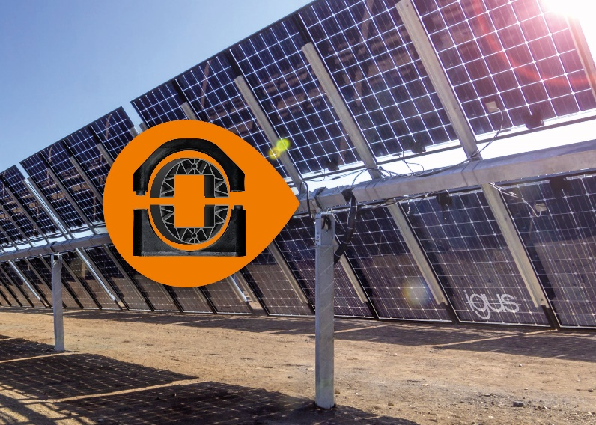
Picture PM3121-1
The new materials, solarmid and iglidur P UV for igubal pillow blocks, are very UV-resistant and especially well-suited to use in bifacial solar modules. (Source: igus GmbH)

PRESS CONTACT:  Oliver Cyrus  Head of PR and Advertising  Anja Görtz-Olscher  PR and Advertising  igus® GmbH  Spicher Str. 1a  51147 Cologne  Tel. 0 22 03 / 96 49-459 or -7153  Fax 0 22 03 / 96 49-631  ocyrus@igus.net  agoertz@igus.net  www.igus.eu/press | ABOUT IGUS:  igus GmbH develops and produces motion plastics. These lubrication-free, high-performance polymers improve technology and reduce costs wherever things move. In energy supplies, highly flexible cables, plain and linear bearings as well as lead screw technology made of tribo-polymers, igus is the worldwide market leader. The family-run company based in Cologne, Germany, is represented in 35 countries and employs 3,800 people across the globe. In 2019, igus generated a turnover of €764 million. Research in the industry's largest test laboratories constantly yields innovations and more security for users. 234,000 articles are available from stock and the service life can be calculated online. In recent years, the company has expanded by creating internal startups, e.g. for ball bearings, robot drives, 3D printing, the RBTX platform for Lean Robotics and intelligent "smart plastics" for Industry 4.0. Among the most important environmental investments are the "chainge" programme – recycling of used e-chains - and the participation in an enterprise that produces oil from plastic waste. (Plastic2Oil).

The terms "igus", “Apiro”, "chainflex", "CFRIP", "conprotect", "CTD", “drygear”, "drylin", "dry-tech", "dryspin", "easy chain", "e-chain", "e-chain systems", "e-ketten", "e-kettensysteme", "e-skin", "e-spool”, "flizz", “ibow”, “igear”, "iglidur", "igubal", “kineKIT”, "manus", "motion plastics", "pikchain", "plastics for longer life", "readychain", "readycable", “ReBeL”, "speedigus", "tribofilament“, "triflex", "robolink", “xirodur”, and "xiros" are protected by trademark laws in the Federal Republic of Germany and internationally, where applicable.

