Structural change in North Rhine-Westphalia: igus honoured as a future-oriented company
Mona Neubaur, NRW's State Minister for Economics, presents the "Wirtschaft im Wandel" ("Economy in Transition") prize in the SME & Group category

Digitalization, globalization, corona pandemic: As a business location, NRW is undergoing a process of transformation. igus is one of the companies that are particularly successful in managing this change. The Cologne-based plastics company was one of two companies to win the "Wirtschaft im Wandel" contest in the "SME & Group" category. igus was particularly honoured for the company's strong digital orientation.

Smoking chimneys and grey mining settlements are no longer what characterises North Rhine-Westphalia as a business location. Instead, its modern companies are skilfully adapting to structural change – with creative corporate strategies, new technologies and dynamic adjustment of production conditions. As part of the "NRW – Wirtschaft im Wandel" competition, Rheinische Post, a major German daily newspaper, has now honoured the nine most outstanding companies that are meeting challenges such as digitalization and globalization with new solutions and actively shaping the economic transformation process in NRW. The prize was presented by NRW State Minister for Economics Mona Neubaur at an awards ceremony in the Rheinische Post editorial office. For the fifth time, "Wirtschaft im Wandel" was hosted by the Rheinische Post, the "Deutschland – Land der Ideen" ("Germany – Land of Ideas") initiative, and the Bonn General-Anzeiger, a regional daily newspaper.

When strengths combine: family-owned companies and forward-looking companies
igus was one of two companies to win in the "SME & Group" category. "We are delighted to receive the award and the judges' encouragement and pleased to serve as a symbol and example of NRW as a future-oriented business location," says Tobias Vogel, Plain Bearings & Linear Technology CEO at igus, who accepted the prize. "The prize shows us that we set the right course for digitalization and globalization at an early stage and were able to combine the strengths of a dynamic family business with the challenges of an efficient forward-looking company." One of the things that won over the panel of judges, which included representatives from politics, business, science, and society, was the way igus dealt with the corona pandemic. During the first lockdown in March 2020, igus quickly synchronized the work of the thousands of employees at its worldwide branches in a home office network. Kanban boards, sprints, and planning with sticky notes: After having just introduced them on site, management has now moved into the digital space with planning tools, boards and collaboration platforms.

Virtual trade show stand constitutes an important component of the digital concept
At the beginning of the pandemic, igus set up its own 400 square metre trade show stand for Hannover Messe 2020 on the company premises, mirroring it on the Internet with a digital version. Since then, visitors have been able to visit this igus motion plastics show (IMPS) online and get advice, watch videos about products and applications, have an individual brochure with their favourite products created as a PDF and participate in online press conferences and webinars. "The real/virtual trade show stand made our motion plastics products come alive despite contact restrictions throughout the Corona pandemic. More than 70,500 customers have now visited our virtual stand online."

Caption:
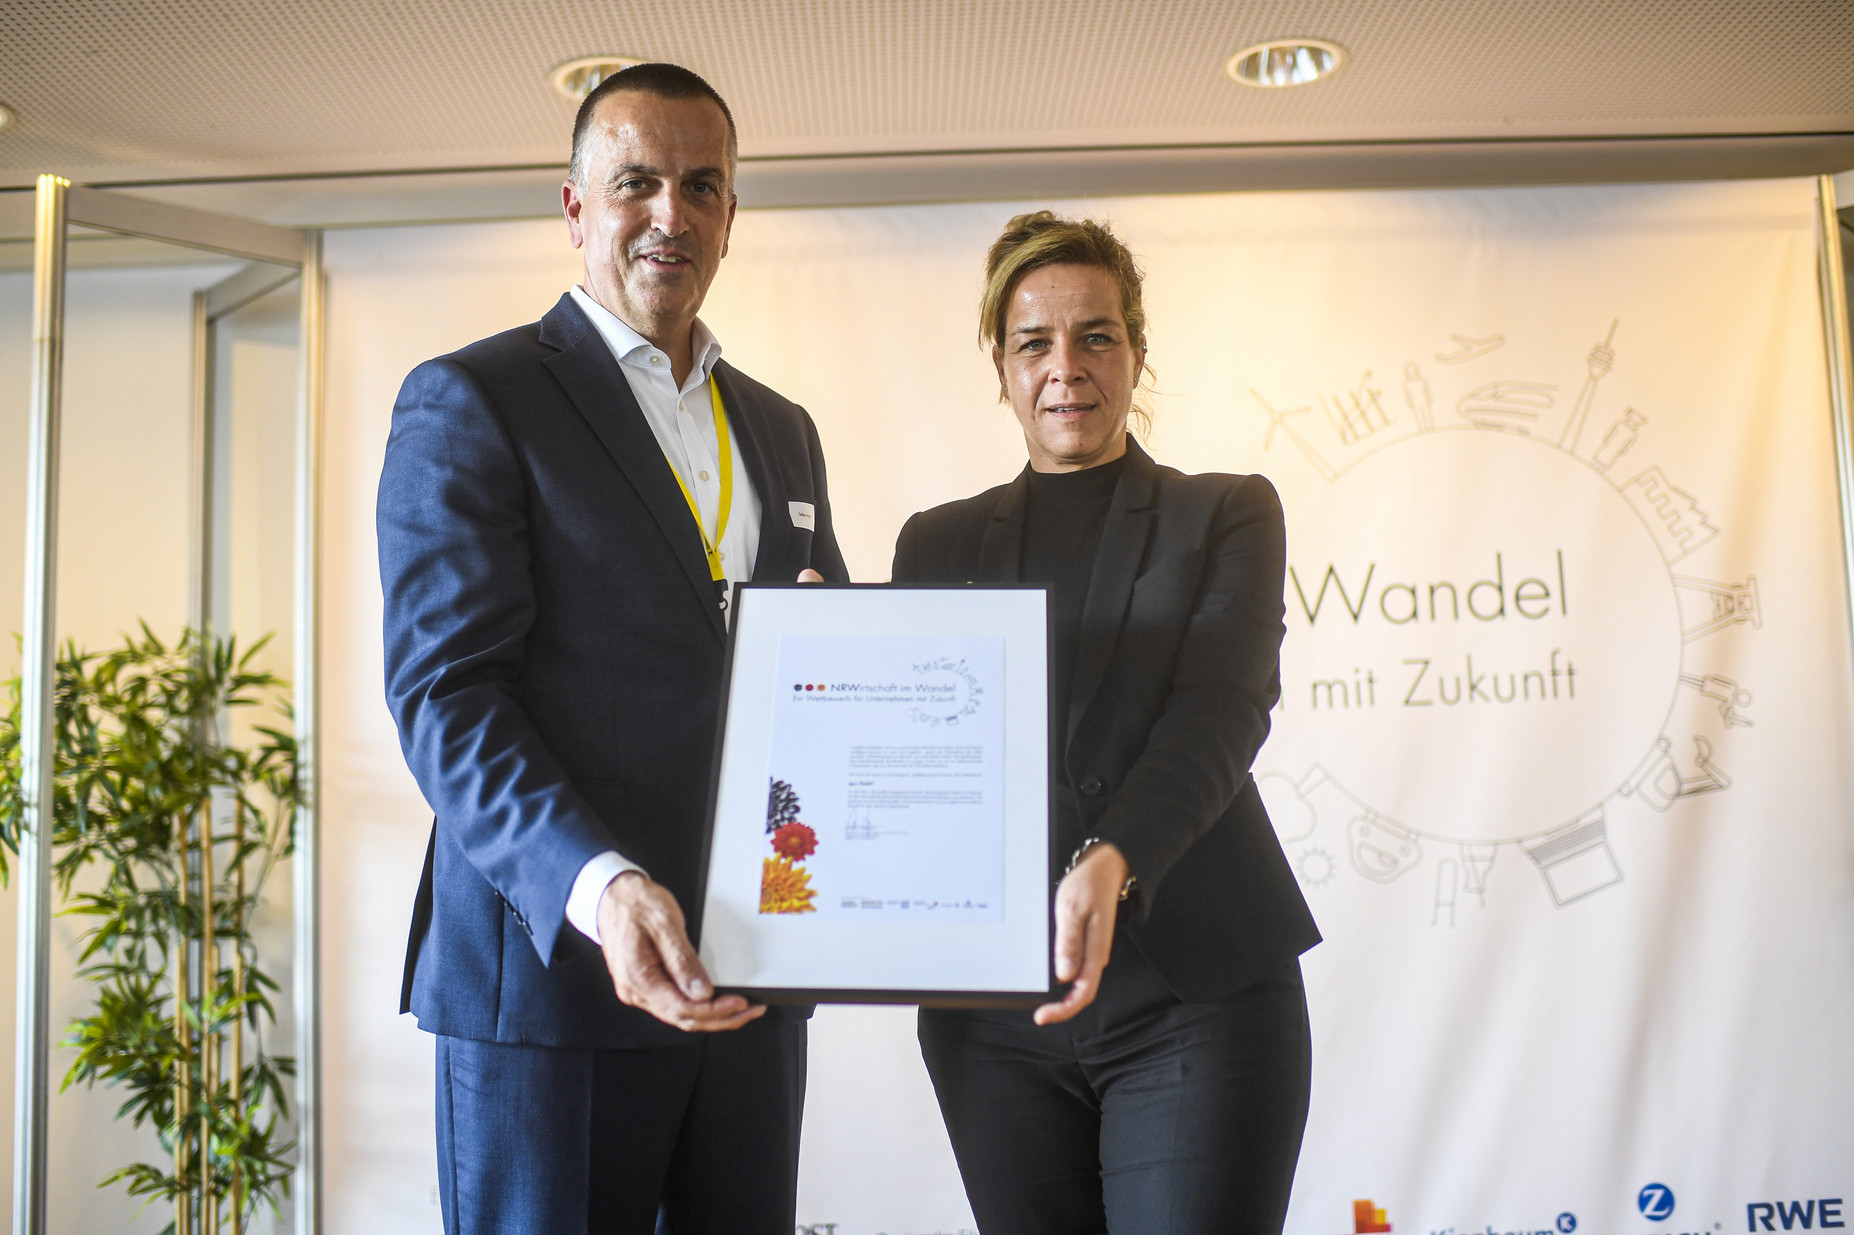
Picture PM6322-1
Mona Neubaur, State Minister for Economics, Industry, Climate Protection and Energy for North Rhine-Westphalia, presents the "Wirtschaft im Wandel" prize in the SME & Group category to Tobias Vogel, Plain Bearing & Linear Technology CEO at igus GmbH. (Source: Rheinische Post/Andreas Bretz)

PRESS CONTACT:

Alexa Heinzelmann
Head of International Marketing

igus® GmbH
Spicher Str. 1a
51147 Cologne
Tel. 0 22 03 / 96 49-7272
aheinzelmann@igus.net
www.igus.eu/press

ABOUT IGUS:

igus GmbH develops and produces motion plastics. These lubrication-free, high-performance polymers improve technology and reduce costs wherever things move. In energy supplies, highly flexible cables, plain and linear bearings as well as lead screw technology made of tribo-polymers, igus is the worldwide market leader. The family-run company based in Cologne, Germany, is represented in 31 countries and employs 4,900 people across the globe. In 2021, igus generated a turnover of €961 million. Research in the industry's largest test laboratories constantly yields innovations and more security for users. 234,000 articles are available from stock and the service life can be calculated online. In recent years, the company has expanded by creating internal startups, e.g. for ball bearings, robot drives, 3D printing, the RBTX platform for Lean Robotics and intelligent "smart plastics" for Industry 4.0. Among the most important environmental investments are the "chainge" programme – recycling of used e-chains - and the participation in an enterprise that produces oil from plastic waste.

The terms "igus", “Apiro”, "chainflex", "CFRIP", "conprotect", "CTD", “drygear”, "drylin", "dry-tech", "dryspin", "easy chain", "e-chain", "e-chain systems", "e-ketten", "e-kettensysteme", "e-skin", "e-spool”, "flizz", “ibow”, “igear”, "iglidur", "igubal", “kineKIT”, "manus", "motion plastics", "pikchain", "plastics for longer life", "readychain", "readycable", “ReBeL”, "speedigus", "tribofilament“, "triflex", "robolink", “xirodur”, and "xiros" are protected by trademark laws in the Federal Republic of Germany and internationally, where applicable.

