How igus energy chains become power-saving champions
Roller chain links reduce drive energy for the E4.1 energy chain series by 37%
Good news for users of the igus E4.1 energy chain series: newly developed roller chain links reduce required drive power by 37%. This allows customers to reduce their electricity costs in times of sharply rising energy prices.

Wholesale electricity prices are skyrocketing. This is a serious challenge to the competitiveness of many industrial companies, so saving electricity is on the agenda. This is true for entire production lines, individual machines or components such as energy chains that guide cables and hoses for energy, data and hydraulics in industrial plants. As a rule, the upper run of an e-chain glides on the lower run. On short routes, energy is not a problem because the igus high-performance plastics ensure low-friction operation. For longer travels (several hundred metres) and high payloads (up to 100kg/m), the coefficients of friction increase and, consequentially, energy consumption.

E4.1R: Rolling instead of gliding saves energy
For 20 years, igus has been offering energy chains for long distances, in which the upper run rolls over the lower run, reducing friction and wear. "Due to rising prices and energy costs, many industrial companies have become interested in cost-saving measures. They ask themselves how operating costs can be cut with the components in use, such as energy chains - especially on long travels with high additional loads", says Jörg Ottersbach, Head of the e-chains Business Unit at igus. "Our answer is that we also offer a version of our E4.1, the E4.1R, with integrated rollers. This series is one of our best-selling energy chains and a universal solution for 90% of gliding applications." Rollers reduce drive power by up to 37% - savings that minimise energy requirements now that electricity prices are soaring. A pleasant side effect is that the E4.1R runs more smoothly thanks to the rollers, with noise and vibrations reduced. The roller chain links are also fully compatible with the entire E4.1 series modular system, so that indoor linear robots in the machine tool industry can still be retrofitted, for example. In addition to internal heights of 42 and 56mm, a height of 80mm is available for the E4.1R. Add several widths and radii, and you have a total of over 900 variants for individual applications.

Watch a video about the E4.1R:
https://www.youtube.com/watch?v=WsE2Uo67sy0

Caption:
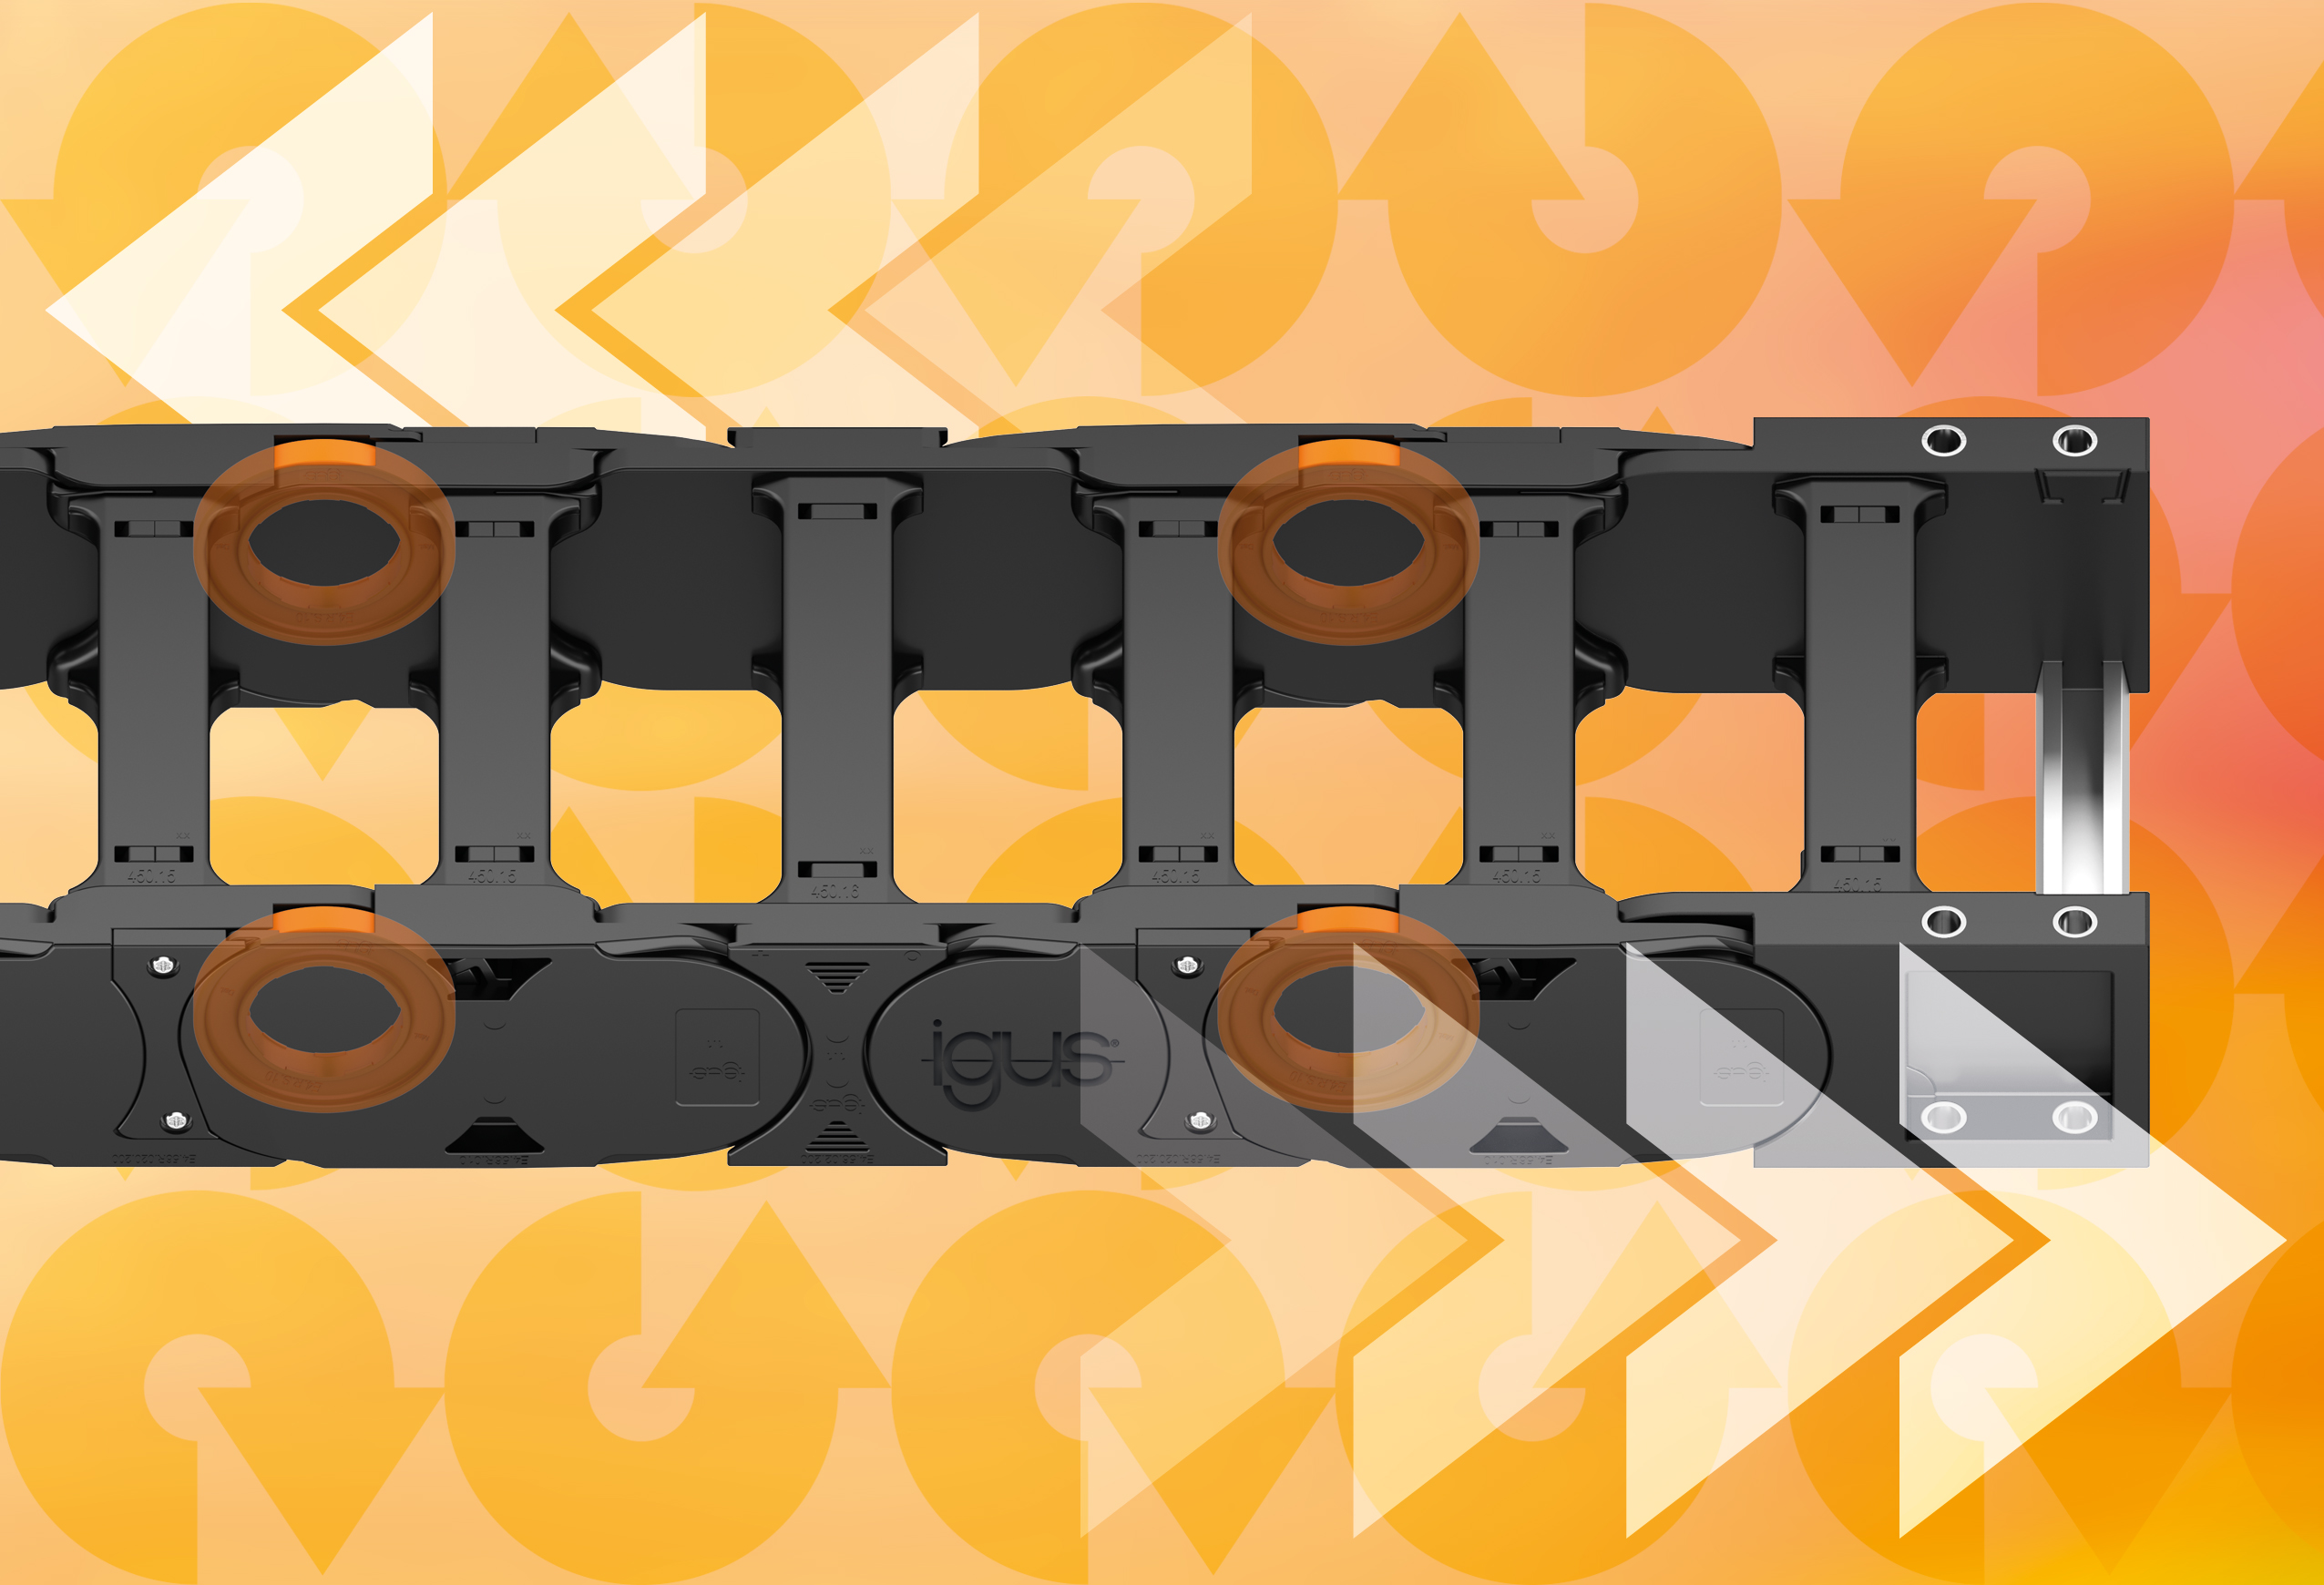

Picture PM1622-1
Reduce drive energy and thus costs with the E4.1R roller energy chains. (Source: igus GmbH)

PRESS CONTACT:

Alexa Heinzelmann
Head of International Marketing

igus® GmbH
Spicher Str. 1a
51147 Cologne
Tel. 0 22 03 / 96 49-7272
aheinzelmann@igus.net
www.igus.eu/press

ABOUT IGUS:

igus GmbH develops and produces motion plastics. These lubrication-free, high-performance polymers improve technology and reduce costs wherever things move. In energy supplies, highly flexible cables, plain and linear bearings as well as lead screw technology made of tribo-polymers, igus is the worldwide market leader. The family-run company based in Cologne, Germany, is represented in 35 countries and employs 4,900 people across the globe. In 2021, igus generated a turnover of €961 million. Research in the industry's largest test laboratories constantly yields innovations and more security for users. 234,000 articles are available from stock and the service life can be calculated online. In recent years, the company has expanded by creating internal startups, e.g. for ball bearings, robot drives, 3D printing, the RBTX platform for Lean Robotics and intelligent "smart plastics" for Industry 4.0. Among the most important environmental investments are the "chainge" programme – recycling of used e-chains - and the participation in an enterprise that produces oil from plastic waste.

The terms "igus", “Apiro”, "chainflex", "CFRIP", "conprotect", "CTD", “drygear”, "drylin", "dry-tech", "dryspin", "easy chain", "e-chain", "e-chain systems", "e-ketten", "e-kettensysteme", "e-skin", "e-spool”, "flizz", “ibow”, “igear”, "iglidur", "igubal", “kineKIT”, "manus", "motion plastics", "pikchain", "plastics for longer life", "readychain", "readycable", “ReBeL”, "speedigus", "tribofilament“, "triflex", "robolink", “xirodur”, and "xiros" are protected by trademark laws in the Federal Republic of Germany and internationally, where applicable.

