chainflex cables without PFAS: safety for people, nature and businesses
chainflex cables do not use PTFE and PFAS chemicals, guaranteed with the "PFAS-free" seal

Like the chemicals of the PFAS family, certain polytetrafluoroethylene compounds - PTFE for short - are considered "forever chemicals" and therefore potentially harmful to the environment, people and animals. The European Union is therefore working on a ban on the substances. With the "PFAS-free" seal, igus demonstrates that their own chainflex cables are free of the chemicals and already offer customers operational safety in the event of a ban.

PFAS and PTFE, that sounds very chemical and abstract. However, the abbreviations actually refer to chemical compounds that are used in many everyday applications. Polytetrafluoroethylene (PTFE) is better known under the brand name Teflon. Perfluorinated and polyfluorinated alkyl compounds (PFAS) can be found in coated clothing, baking paper, fire extinguishers, make-up, but also in a number of plastics. As PFAS are difficult to degrade in the environment and are long-lasting, the European Union is currently pushing for a restriction or even a ban on over 10,000 PFAS compounds. To arm themselves against a ban at an early stage, industrial companies are increasingly demanding their supplied plastics to be PFAS-free. igus now guarantees exactly that with the "PFAS-free" seal for its chainflex cables.

95 per cent of chainflex cables are PFAS-free
The Cologne-based plastics specialist already dispenses with the corresponding chemicals in 95 per cent of its cables, giving its customers planning security even in the event of an EU-wide ban. All chainflex cables labelled as "PFAS-free" are made from materials such as insulation, jacket, tapes etc. that are free from fluorine compounds. This excludes possible impurities or measured value limits that cannot be fully excluded due to external influences, for example. This means that igus already fulfils international requirements, as in some countries the export of PFAS has already been restricted and is subject to notification or authorisation. "With the 'PFAS-free' seal, we offer our customers security and continue to strongly promote igus's sustainability claim by doing without harmful compounds," explains Rainer Rössel, Head of Chainflex Cables at igus.

More than 1,350 cables in the range
The chainflex cables have been specially developed for use in moving applications and can be found in many systems worldwide. In addition to safe energy supply in the energy chain, they are also used in cranes, machine tools and robotics. The range has now grown to over 1,350 cables forming part of a wide range of cable types: igus offers control, bus, data, motor, fibre optic cables and more. They are characterised by their durability and robustness - a fact that the company owes, among other things, to its in-house test laboratory. On an area of 3,800 square metres at the company headquarters in Cologne, igus experts carry out over two billion test cycles per year. The expertise gained from the tests is also the reason why the company decided more than ten years ago to offer a 36-month guarantee for chainflex cables. Based on the positive experience, igus increased the guarantee period from three to four years last year. "This way, we are also increasing planning and operational reliability when purchasing our cables, even beyond the PFAS issue," explains Rössel.

Caption:

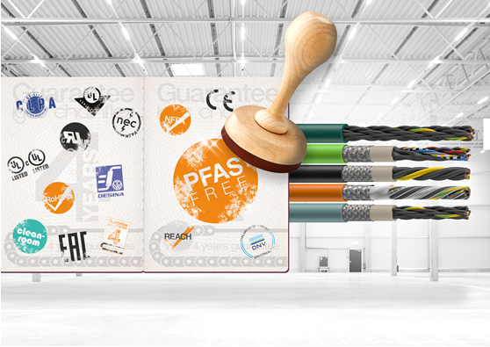
Picture PM1224-1
95 per cent of chainflex cables from igus are already PFAS-free. (Source: igus GmbH)

PRESS CONTACT:

Alexa Heinzelmann
Head of International Marketing

igus® GmbH
Spicher Str. 1a
51147 Cologne
Tel. 0 22 03 / 96 49-7272
aheinzelmann@igus.net
www.igus.eu/press

ABOUT IGUS:

igus GmbH develops and produces motion plastics. These lubrication-free, high-performance polymers improve technology and reduce costs wherever things move. In energy supplies, highly flexible cables, plain and linear bearings as well as lead screw technology made of tribo-polymers, igus is the worldwide market leader. The family-run company based in Cologne, Germany, is represented in 31 countries and employs 4,600 people across the globe. In 2022, igus generated a turnover of €1,15 billion. Research in the industry's largest test laboratories constantly yields innovations and more security for users. 234,000 articles are available from stock and the service life can be calculated online. In recent years, the company has expanded by creating internal startups, e.g. for ball bearings, robot drives, 3D printing, the RBTX platform for Lean Robotics and intelligent "smart plastics" for Industry 4.0. Among the most important environmental investments are the "chainge" programme – recycling of used e-chains - and the participation in an enterprise that produces oil from plastic waste.

The terms "igus", “Apiro”, "chainflex", "CFRIP", "conprotect", "CTD", “drygear”, "drylin", "dry-tech", "dryspin", "easy chain", "e-chain", "e-chain systems", "e-ketten", "e-kettensysteme", "e-skin", "e-spool”, "flizz", “ibow”, “igear”, "iglidur", "igubal", “kineKIT”, "manus", "motion plastics", "pikchain", "plastics for longer life", "readychain", "readycable", “ReBeL”, "speedigus", "tribofilament“, "triflex", "robolink", “xirodur”, and "xiros" are protected by trademark laws in the Federal Republic of Germany and internationally, where applicable.

