A real "hothead": igus launches new SLS printing material
iglidur i230: first igus 3D printing material for polymer components that withstands temperatures of up to 110°C

3D-printed polymer components will be able to resist much higher temperatures in future - in the engine compartment of a car, for example. While commercially available SLS printing materials threaten to deform at over 80°C, the new powdery material iglidur i230 from igus can withstand a long-term application temperature of 110°C. Furthermore, it is free of PTFE and around 80% more wear-resistant than the classic PA12.

More and more designers are turning to 3D printers to produce components quickly and cost-effectively, especially for small series and prototypes. Selective laser sintering (SLS) is particularly popular. In this additive process, a printer melts plastic powder layer by layer to form components, such as a plain bearing. The problem is that components made from standard SLS printing materials such as PA12 are generally only used in applications with temperatures of 80°C or less. Beyond this limit, the material becomes soft and loses its dimensional stability. A no-go for many areas of application, for example for bearings in the engine compartment of a car, industrial plants or various air-conditioning and cooling systems. "As the demand for 3D-printed plain bearings for applications with high ambient temperatures has increased, we have developed a new SLS printing material called iglidur i230," says Paul Gomer, Material Developer in 3D Printing at igus. Tests in certified external laboratories in accordance with DIN EN ISO 75 HDT-A and HDT-B have proven the heat resistance. Accordingly, the powdery printing material is suitable for long-term application temperatures of up to 110°C. It can even withstand extreme temperatures of up to 170°C for short periods without deforming. The material is also electrostatically dissipative and thus protects machines and systems from electrostatic discharges, which in the worst case can cause fires and explosions. iglidur i230, like many other igus materials, is also free of PTFE.

80% more wear-resistant than PA12
iglidur i230 is not only particularly temperature-resistant, but also withstands movement. Tests in the igus in-house laboratory have proven that the printing material is around 80% more wear-resistant than PA12. "3D-printed plain bearings made from iglidur i230 have a significantly longer service life, increase the efficiency of machines, systems and vehicles and reduce the need for maintenance," says Gomer. At the same time, the material has around 50% higher mechanical strength than PA12 at room temperature. In addition, the material withstood a pressure of 94MPa in bending tests. "This makes it possible, for example, to achieve the same component strength in plain bearings with a thinner wall thickness and to save room and weight in compact installation spaces," emphasises Gomer. Last but not least, users of the 3D-printed plain bearings made of iglidur i230 can dispense with time-consuming relubrication work. Solid lubricants are integrated into the SLS printing material to ensure low-friction dry operation.

Caption:
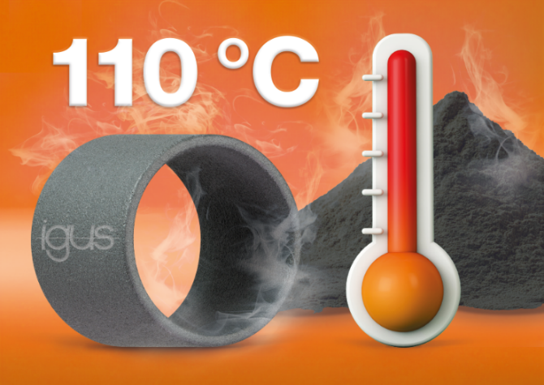
Picture PM0524-1
A true all-rounder at high temperatures: the new SLS material iglidur i230 can even withstand temperatures of 110°C - and is also particularly bend-resistant and free of PTFE. (Source: igus GmbH)

PRESS CONTACT:

Alexa Heinzelmann
Head of International Marketing

igus® GmbH
Spicher Str. 1a
51147 Cologne
Tel. 0 22 03 / 96 49-7272
aheinzelmann@igus.net
www.igus.eu/press

ABOUT IGUS:

igus GmbH develops and produces motion plastics. These lubrication-free, high-performance polymers improve technology and reduce costs wherever things move. In energy supplies, highly flexible cables, plain and linear bearings as well as lead screw technology made of tribo-polymers, igus is the worldwide market leader. The family-run company based in Cologne, Germany, is represented in 31 countries and employs 4,600 people across the globe. In 2022, igus generated a turnover of €1,15 billion. Research in the industry's largest test laboratories constantly yields innovations and more security for users. 234,000 articles are available from stock and the service life can be calculated online. In recent years, the company has expanded by creating internal startups, e.g. for ball bearings, robot drives, 3D printing, the RBTX platform for Lean Robotics and intelligent "smart plastics" for Industry 4.0. Among the most important environmental investments are the "chainge" programme – recycling of used e-chains - and the participation in an enterprise that produces oil from plastic waste.

The terms "igus", “Apiro”, "chainflex", "CFRIP", "conprotect", "CTD", “drygear”, "drylin", "dry-tech", "dryspin", "easy chain", "e-chain", "e-chain systems", "e-ketten", "e-kettensysteme", "e-skin", "e-spool”, "flizz", “ibow”, “igear”, "iglidur", "igubal", “kineKIT”, "manus", "motion plastics", "pikchain", "plastics for longer life", "readychain", "readycable", “ReBeL”, "speedigus", "tribofilament“, "triflex", "robolink", “xirodur”, and "xiros" are protected by trademark laws in the Federal Republic of Germany and internationally, where applicable.

