igus 2021 Motion Plastics Show: 168 tribo innovations on the trade show stand
The real-life/virtual trade show invites visitors to use high-performance polymers to improve their moving applications

More new products, product extensions and digital offerings than ever before: the 2021 "igus Motion Plastics Show" is opening digitally. Visitors can look forward to 168 innovations from all departments – from telescopic robot tube packages to dry-running ball bearings with 21 times the standard service life to large scale 3D printing.

Since the beginning of May 2020, the stand has been located in an exhibition hall in Cologne Porz-Lind, where it was recognised with the iF Design Award. The new igus motion plastics show (imps) for 2021 is now beginning. "We are in our second year without trade shows", says igus CEO Frank Blase. "This time we can start the presentation of our new products at full digital speed." The new trade show stand has been optimised based on experience gained in virtual customer consultation and tours last year. Solutions for various industries can be seen in a separate area: the space-saving and telescopic triflex TRX system for 3D energy supply on robots as well as the wound high-load bearing iglidur TX2 for construction machinery. The issue of plastics sustainability is now even more visible and is given a central position at the trade show.

Physical/virtual trade show stand with 168 motion plastics innovations
Overall, 168 product innovations from igus departments will be presented at the trade show, which takes up 400 square meters. For instance, the lightweight drygear cobot gear set for cost-effective automation will be exhibited, as will the iglidur I151 tribo-filament for FDA-compliant, detectable wear-resistant parts for food technology. The orange trade show stand has now hosted 55,000 visitors from all over the world, since its virtual twin is freely accessible. Another 16,000 visitors have also taken advantage of the offer of a digital visit with igus specialists. "We would normally have been represented at 222 trade shows and conventions last year, but we only made a total of 26", says Blase. "So we are very happy that the imps has become a fixed part of daily communication with customers." The real/virtual trade show stand is an important component of a digital igus concept that allows users to find the right lubrication-free, maintenance-free motion plastics for their specific requirements even faster. For instance, machine design and tutorials can be completed virtually with igus consultants, online seminars from the online seminar studio provide additional assistance, and the interactive digital catalogue variant also provides additional information with access to white papers, blog articles and explanatory videos.

Explore the igus Motion Plastics Show at www.igus.eu/imps

Caption:

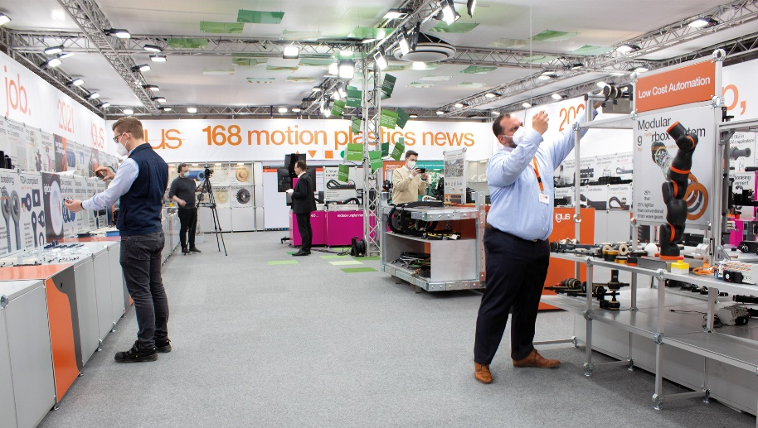
Picture PM2221-1
igus is introducing 168 motion plastics innovations this year at its trade show, which has been recognised with the iF Design Award. (Source: igus GmbH)

PRESS CONTACT:  Oliver Cyrus  Head of PR and Advertising  Anja Görtz-Olscher  PR and Advertising  igus® GmbH  Spicher Str. 1a  51147 Cologne  Tel. 0 22 03 / 96 49-459 or -7153  Fax 0 22 03 / 96 49-631  ocyrus@igus.net  agoertz@igus.net  www.igus.eu/press | ABOUT IGUS:  igus GmbH develops and produces motion plastics. These lubrication-free, high-performance polymers improve technology and reduce costs wherever things move. In energy supplies, highly flexible cables, plain and linear bearings as well as lead screw technology made of tribo-polymers, igus is the worldwide market leader. The family-run company based in Cologne, Germany, is represented in 35 countries and employs 3,800 people across the globe. In 2019, igus generated a turnover of €764 million. Research in the industry's largest test laboratories constantly yields innovations and more security for users. 234,000 articles are available from stock and the service life can be calculated online. In recent years, the company has expanded by creating internal startups, e.g. for ball bearings, robot drives, 3D printing, the RBTX platform for Lean Robotics and intelligent "smart plastics" for Industry 4.0. Among the most important environmental investments are the "chainge" programme – recycling of used e-chains - and the participation in an enterprise that produces oil from plastic waste. (Plastic2Oil).

The terms "igus", “Apiro”, "chainflex", "CFRIP", "conprotect", "CTD", “drygear”, "drylin", "dry-tech", "dryspin", "easy chain", "e-chain", "e-chain systems", "e-ketten", "e-kettensysteme", "e-skin", "e-spool”, "flizz", “ibow”, “igear”, "iglidur", "igubal", “kineKIT”, "manus", "motion plastics", "pikchain", "plastics for longer life", "readychain", "readycable", “ReBeL”, "speedigus", "tribofilament“, "triflex", "robolink", “xirodur”, and "xiros" are protected by trademark laws in the Federal Republic of Germany and internationally, where applicable.

