Securely sealed off! New interior separation for E4Q energy chain reduces assembly time
Universal separators and shelves with locking tabs ensure flexible and user-friendly e-chain assembly

For safe cable guidance in unsupported and long travels, igus has developed the E4Q energy chain. The bionically inspired design of the series saves weight, while a crossbar with locking tabs reduces the assembly time of the energy supply system by 40 per cent. To further facilitate cable filling, igus is now launching a new interior separation for the E4Q. Universal separators can simply be placed on the crossbars, shelves can be inserted from the left or right, either along the inner or outer radius. A mechanism in the separators automatically locks the chain when closing.

Simple and assembly-friendly, these were the goals that the igus developers set themselves with the E4Q energy chain. The result is an energy supply system for unsupported and long travels that saves material and 10 per cent weight through a naturalistic design. At the same time, it is more robust than its predecessor series E4.1. The special feature of the energy chain: it can be opened and closed completely without tools with the help of a special crossbar concept, saving the user 40 per cent assembly time. A concept that convinced users as well as the jury of the German Design Award 2021. In order to be able to fill the E4Q with cables even faster, igus GmbH has now developed a new flexible interior separation in co-operation with its customers. The system consists of universal separators and lockable shelves. The cable-protecting separators have a grid for inserting the shelves. To assemble the interior separation, first place the separators on the crossbars. The shelves can then be pushed into the desired level from both sides.

Double locked with slider and crossbar
An integrated slider allows the shelves to be positively locked in place so that they remain securely in place even during high accelerations. "Even if the fitter has forgotten to secure the shelf, it's not a problem", explains Jörg Ottersbach, Head of Business Division e-chains at igus. When the crossbar is inserted, the lock is automatically activated. A foolproof and safe concept for all occasions." If the user wants to change the interior separation of the energy chain, he can simply open the crossbar along the inner radius or the outer radius, depending on accessibility, unlock the shelf via the lateral slider and pull it out. igus offers the new interior separation for its four E4Q sizes in different widths.

Calculate guaranteed service life online and have it certified
The E4Q energy chain is available at the igus online shop and can be configured with cables and the interior separation in the e-chain expert. igus promises a guarantee of up to 36 months on the complete energy supply system. The customer can easily generate the certificate online using the service life calculator. When the machine and system reaches the end of their service life and the energy chain is no longer in use, igus will take it back and guarantee pure recycling. In return, the user receives a credit note based on the net weight.

Caption:
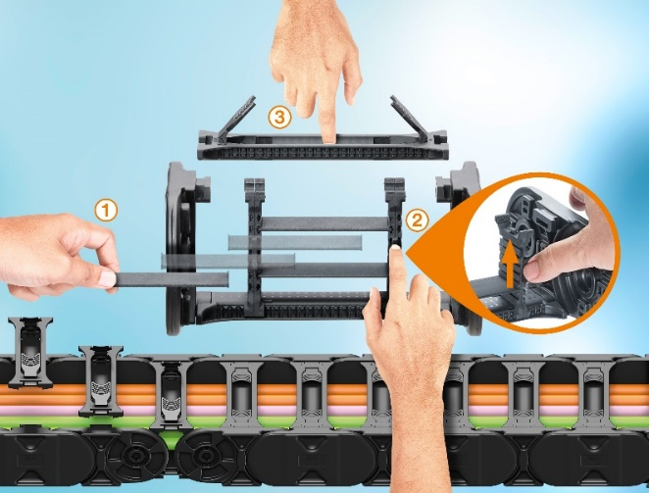
Picture PM0421-1
Quickly filled and doubly secured: 1. Flexibly slide the shelf into the separators, 2. Lock the shelves, 3. Securely close and automatically seal the chain with the locking tab crossbar. (Source: igus GmbH)

PRESS CONTACT:  Oliver Cyrus  Head of PR and Advertising  Anja Görtz-Olscher  PR and Advertising  igus® GmbH  Spicher Str. 1a  51147 Cologne  Tel. 0 22 03 / 96 49-459 or -7153  Fax 0 22 03 / 96 49-631  ocyrus@igus.net  agoertz@igus.net  www.igus.eu/press | ABOUT IGUS:  igus GmbH develops and produces motion plastics. These lubrication-free, high-performance polymers improve technology and reduce costs wherever things move. In energy supplies, highly flexible cables, plain and linear bearings as well as lead screw technology made of tribo-polymers, igus is the worldwide market leader. The family-run company based in Cologne, Germany, is represented in 35 countries and employs 3,800 people across the globe. In 2019, igus generated a turnover of €764 million. Research in the industry's largest test laboratories constantly yields innovations and more security for users. 234,000 articles are available from stock and the service life can be calculated online. In recent years, the company has expanded by creating internal startups, e.g. for ball bearings, robot drives, 3D printing, the RBTX platform for Lean Robotics and intelligent "smart plastics" for Industry 4.0. Among the most important environmental investments are the "chainge" programme – recycling of used e-chains - and the participation in an enterprise that produces oil from plastic waste. (Plastic2Oil).

The terms "igus", “Apiro”, "chainflex", "CFRIP", "conprotect", "CTD", “drygear”, "drylin", "dry-tech", "dryspin", "easy chain", "e-chain", "e-chain systems", "e-ketten", "e-kettensysteme", "e-skin", "e-spool”, "flizz", “ibow”, “igear”, "iglidur", "igubal", “kineKIT”, "manus", "motion plastics", "pikchain", "plastics for longer life", "readychain", "readycable", “ReBeL”, "speedigus", "tribofilament“, "triflex", "robolink", “xirodur”, and "xiros" are protected by trademark laws in the Federal Republic of Germany and internationally, where applicable.

