Connected in seconds: small plug-in energy chain from igus saves 80% assembly time
Plug-in principle of the readychain micro-speed enables fast connection of e-chain systems in tight installation spaces

The plug-in energy chain system readychain speed from igus connects harnessed e-chain systems in seconds and without the use of tools. This helps reduce both throughput times in assembly and machine downtimes, and also brings planned maintenance work to a minimum. The ready-to-connect e-chain system thus saves 80% installation time. With the new readychain micro-speed, this is now also possible for very small applications and in particularly tight installation spaces.

No matter which industry, which country or which company: if a cable in a machine is defective, leading to machine failure, the resulting downtime and consequential costs can be considerable. After all, just a few minutes of downtime often costs companies several thousand euros. With the ready-to-connect readychain speed from igus, the e-chain system can be replaced very easily and quickly in these cases, and the machine can start operation again immediately. For very narrow installation spaces, igus now offers the readychain micro-speed model.
Cables can be quickly replaced like the power cord of a laptop
With the new readychain micro-speed, igus is expanding the solution portfolio of fast plug-in energy chains. Thanks to its compactness, with a width and inner height of just 20 millimetres each, the system is particularly suitable for applications where space is at a premium, such as door interlocks in machine tools. With the readychain micro-speed, it is not necessary to separate cores from the terminal strips using tools before changing a cable. This is due to the fact that the connectors are integrated in the energy chain and the cable is already connected on both sides. Thus, the entire assembly is designed to be pluggable. The counterpart, an add-on housing with bushing, can be flanged to the machine housing. If a change is now required, the e-chain can be replaced as quickly as the power cord of a laptop using the plug-in principle - without tools, without know-how, without technicians. Any employee can perform this task without having to worry about making mistakes. Markus Hüffel, Product Manager of readychain at igus, points out: "Thanks to this flexibility, the response speed increases in case of failures, so that downtimes can be reduced many times over. And that's with a small investment."

Customised system for individual moving applications
With the readychain micro-speed, customers receive an interface solution tailored precisely to their application. It is virtually freely configurable and, like the larger readychain speed, can be combined with cables from the wide range of chainflex cables from igus - including power cables, bus cables, Ethernet cables and fibre optic cables. The cables are protected from mechanical damage thanks to the e-chain. "The required connectors, housings and connections can be planned individually", Hüffel emphasises. "This way, the customer obtains everything from a single source, and each energy chain becomes a tailor-made product."

Caption:

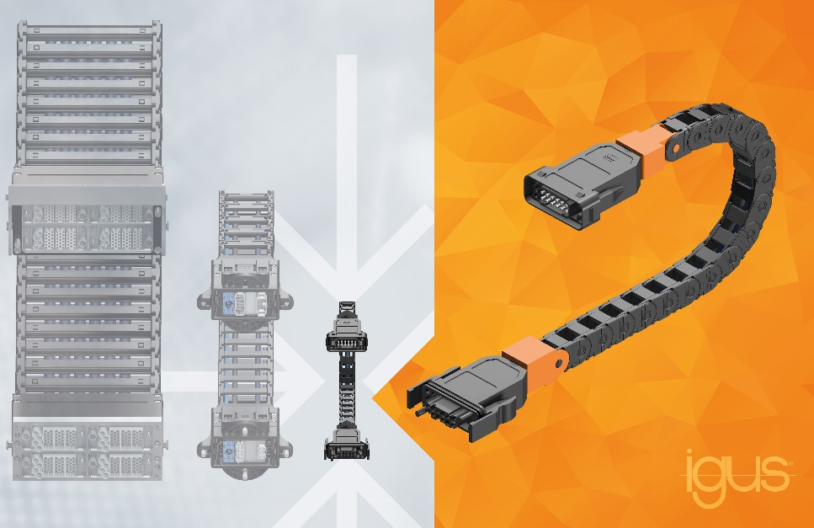
Picture PM0422-1
The readychain micro-speed is the smallest version of the pre-assembled, ready-to-connect e-chain systems from igus. (Source: igus GmbH)
PRESS CONTACT:

Alexa Heinzelmann
Head of International Marketing

igus® GmbH
Spicher Str. 1a
51147 Cologne
Tel. 0 22 03 / 96 49-7272
aheinzelmann@igus.net
www.igus.eu/press

ABOUT IGUS:

igus GmbH develops and produces motion plastics. These lubrication-free, high-performance polymers improve technology and reduce costs wherever things move. In energy supplies, highly flexible cables, plain and linear bearings as well as lead screw technology made of tribo-polymers, igus is the worldwide market leader. The family-run company based in Cologne, Germany, is represented in 35 countries and employs 4,150 people across the globe. In 2020, igus generated a turnover of €727 million. Research in the industry's largest test laboratories constantly yields innovations and more security for users. 234,000 articles are available from stock and the service life can be calculated online. In recent years, the company has expanded by creating internal startups, e.g. for ball bearings, robot drives, 3D printing, the RBTX platform for Lean Robotics and intelligent "smart plastics" for Industry 4.0. Among the most important environmental investments are the "chainge" programme – recycling of used e-chains - and the participation in an enterprise that produces oil from plastic waste.

The terms "igus", “Apiro”, "chainflex", "CFRIP", "conprotect", "CTD", “drygear”, "drylin", "dry-tech", "dryspin", "easy chain", "e-chain", "e-chain systems", "e-ketten", "e-kettensysteme", "e-skin", "e-spool”, "flizz", “ibow”, “igear”, "iglidur", "igubal", “kineKIT”, "manus", "motion plastics", "pikchain", "plastics for longer life", "readychain", "readycable", “ReBeL”, "speedigus", "tribofilament“, "triflex", "robolink", “xirodur”, and "xiros" are protected by trademark laws in the Federal Republic of Germany and internationally, where applicable.

