For highest precision and rigidity: new drylin linear bearings for shafts
Bearings made of iglidur W360 high-performance polymer ensure precise and easy movements in linear technology

In order to be able to move linear bearings on shafts with high precision, igus has now developed the W360CM series. The new polymer linear bearings consist of an aluminium housing and a thin liner, which ensure smooth and quiet operation combined with high rigidity. The bearings have hardly any clearance and allow precise movements. Thanks to the use of iglidur W360 high-performance polymers, the user does not need external lubrication. The dimensions of the new series match metallic ball bushings, so that they can be easily converted 1:1.

Linear guides are used wherever goods or objects need to be moved from A to B, or equipment or machines need to be adjusted. Precision often plays a major role for users, for example in microscope tables or in X-ray equipment. Therefore, the motion plastics specialist igus has now developed the linear plain bearing series W360CM. It ensures the highest precision and rigidity in drylin R shaft guides. The long-lasting sliding elements of the bearings are characterised by a thin wall thickness and high strength. They are produced cost-effectively in injection moulding from the high-performance polymer iglidur W360. The material enables very quiet and smooth operation. The operating temperature range is between 0-50 degrees Celsius. Due to the thin wall thickness and the higher material strength, the linear bearings ensure a low bearing clearance at the operating point due to reduced elasticity. The new bearings - like all plain and linear bearings from igus - are free of lubrication and therefore free of contamination and maintenance.

New polymer bearings convince in the test
The W360CM linear bearings can be easily mounted in all drylin housings as well as in all standard receptacles for linear ball bushings. This means that ball-based solutions can be converted 1:1 without a construction wall using the maintenance-free solution. The design of the new linear bearings is simple: the liners are pressed into the housing until a pre-loaded snap hook is inserted into a groove. Thus, the films are secured against displacement even under high loads and temperatures. The new drylin R series was also able to convince in tests in the in-house 3,800 square metre laboratory at igus in Cologne. Gauge measurements to check bearing clearance and precision showed that the W360CM series bearings performed far better than coated linear bearings.

Learn more about the new bearing at:
https://www.igus.eu/info/n21-drylin-linear-liners?L=en

Caption:

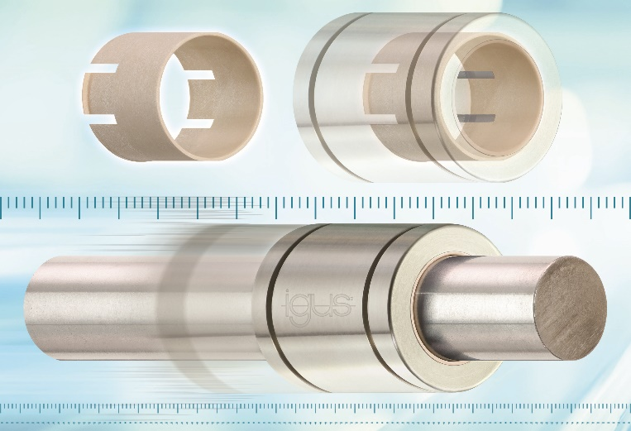
Picture PM2121-1:
Bearings made of iglidur W360 high-performance polymer ensure highest precision and rigidity on shafts. (Source: igus GmbH)

PRESS CONTACT:  Oliver Cyrus  Head of PR and Advertising  Anja Görtz-Olscher  PR and Advertising  igus® GmbH  Spicher Str. 1a  51147 Cologne  Tel. 0 22 03 / 96 49-459 or -7153  Fax 0 22 03 / 96 49-631  ocyrus@igus.net  agoertz@igus.net  www.igus.eu/press | ABOUT IGUS:  igus GmbH develops and produces motion plastics. These lubrication-free, high-performance polymers improve technology and reduce costs wherever things move. In energy supplies, highly flexible cables, plain and linear bearings as well as lead screw technology made of tribo-polymers, igus is the worldwide market leader. The family-run company based in Cologne, Germany, is represented in 35 countries and employs 3,800 people across the globe. In 2019, igus generated a turnover of €764 million. Research in the industry's largest test laboratories constantly yields innovations and more security for users. 234,000 articles are available from stock and the service life can be calculated online. In recent years, the company has expanded by creating internal startups, e.g. for ball bearings, robot drives, 3D printing, the RBTX platform for Lean Robotics and intelligent "smart plastics" for Industry 4.0. Among the most important environmental investments are the "chainge" programme – recycling of used e-chains - and the participation in an enterprise that produces oil from plastic waste. (Plastic2Oil).

The terms "igus", “Apiro”, "chainflex", "CFRIP", "conprotect", "CTD", “drygear”, "drylin", "dry-tech", "dryspin", "easy chain", "e-chain", "e-chain systems", "e-ketten", "e-kettensysteme", "e-skin", "e-spool”, "flizz", “ibow”, “igear”, "iglidur", "igubal", “kineKIT”, "manus", "motion plastics", "pikchain", "plastics for longer life", "readychain", "readycable", “ReBeL”, "speedigus", "tribofilament“, "triflex", "robolink", “xirodur”, and "xiros" are protected by trademark laws in the Federal Republic of Germany and internationally, where applicable.

