e-spool flex for continuous panel feed in industrial robots
ARAGON Industrieelektronik GmbH, a robotics service provider, uses a new slip ring-free igus cable unwinder

A control panel forms the robot's control centre. If it is to be used flexibly, its cable must be not only several metres long, but also movable and safely stowed. To this end, igus has developed the e-spool flex. The new igus cable reel has no slip ring, so it can even supply bus signals with no interruptions. The cable can also be easily retrofitted into the system. These advantages won ARAGON over. It offers a complete cable set, consisting of e-spool flex with a standard cable and a pre-assembled panel mount, as a service for its industrial robots.

The task of ARAGON Industrieelektronik GmbH is to breathe new life into old robots. The leading industrial robotics provider offers global solutions for repairing, maintaining, retrofitting and tuning industrial robots. Some of its customers are relatively small companies that use up to ten robot systems. But larger companies and OEMs in the automotive industry also rely on ARAGON's expertise. The company was looking for a practical cable solution specifically for use in control panels: "We are always trying to ensure our customers' safety with innovative solutions. Until now, the cable was always on the floor, which made it easy to damage or trip over. So we went looking for a cable reel that had no interruptions and was quick and easy to retrofit", says Iryna Geike, Global Country Manager at ARAGON. The company found what it was looking for in igus. "The new e-spool flex cable reel system was introduced to us and won us over immediately", Geike recalls. The major advantages of the e-spool flex over other cable reels is that it does not use a slip ring. Media, data, and the power and signal supply for the emergency stop button can also be integrated into the system. Existing panel cables can simply be inserted into the system's spiral guide and are automatically rolled up. "Our customers now receive a pre-assembled set consisting of the e-spool flex, ARAGON panel mount, cable, and a robot control cabinet mounting bracket for their control panels. The e-spool flex greatly extends the service life of the cable used and ensures more safety and order in the control panel", Geike explains.
Rolling and unrolling cables: manually or automatically
igus offers the e-spool flex in several variants. One is a low-cost version with a manual turner or a cordless screwdriver to wind up the cable. Another is an automatic solution with a spring-driven return mechanism, a locking mechanism, and an optional retraction brake. ARAGON decided on the variant with the retaining spring. The cable roller is available in three sizes for cables with diameters of 5 to 15 millimetres and extension lengths of 5 to 15 metres. Cables can be replaced quickly at any time. In addition to subsequent integration of the e-spool flex into an existing cable system, igus offers the cable reel solution fully harnessed with chainflex cables specifically designed for moving applications. Cable durability in the e-spool flex is currently being extensively tested in the in-house 3,800 square metre igus test laboratory.

Caption:
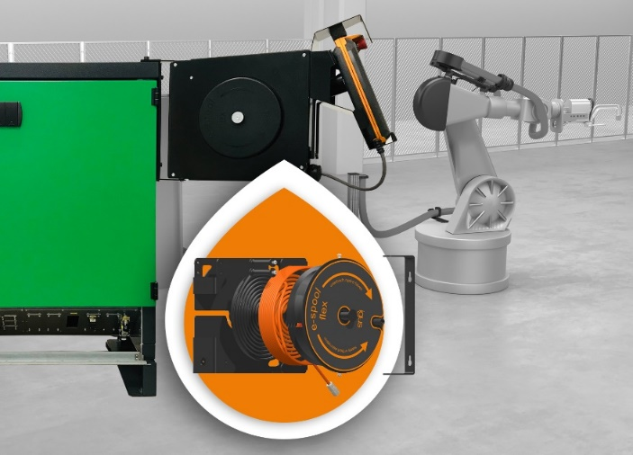
Picture PM0121-1
The e-spool flex ensures safe reeling and unreeling of control panel cables like those used by ARAGON Industrieelektronik GmbH. (Source: igus GmbH)

PRESS CONTACT:  Oliver Cyrus  Head of PR and Advertising  Anja Görtz-Olscher  PR and Advertising  igus® GmbH  Spicher Str. 1a  51147 Cologne  Tel. 0 22 03 / 96 49-459 or -7153  Fax 0 22 03 / 96 49-631  ocyrus@igus.net  agoertz@igus.net  www.igus.eu/press | ABOUT IGUS:  igus GmbH develops and produces motion plastics. These lubrication-free, high-performance polymers improve technology and reduce costs wherever things move. In energy supplies, highly flexible cables, plain and linear bearings as well as lead screw technology made of tribo-polymers, igus is the worldwide market leader. The family-run company based in Cologne, Germany, is represented in 35 countries and employs 3,800 people across the globe. In 2019, igus generated a turnover of €764 million. Research in the industry's largest test laboratories constantly yields innovations and more security for users. 234,000 articles are available from stock and the service life can be calculated online. In recent years, the company has expanded by creating internal startups, e.g. for ball bearings, robot drives, 3D printing, the RBTX platform for Lean Robotics and intelligent "smart plastics" for Industry 4.0. Among the most important environmental investments are the "chainge" programme – recycling of used e-chains - and the participation in an enterprise that produces oil from plastic waste. (Plastic2Oil).

The terms "igus", “Apiro”, "chainflex", "CFRIP", "conprotect", "CTD", “drygear”, "drylin", "dry-tech", "dryspin", "easy chain", "e-chain", "e-chain systems", "e-ketten", "e-kettensysteme", "e-skin", "e-spool”, "flizz", “ibow”, “igear”, "iglidur", "igubal", “kineKIT”, "manus", "motion plastics", "pikchain", "plastics for longer life", "readychain", "readycable", “ReBeL”, "speedigus", "tribofilament“, "triflex", "robolink", “xirodur”, and "xiros" are protected by trademark laws in the Federal Republic of Germany and internationally, where applicable.

