Construction projects reliably printed with igus energy chain system in XXL 3D printer
chainflex cables and three-dimensional e-chains ensure reliable operation, even with extremely tight bend radii

Unique store concepts, concrete stairs with futuristic designs or modern facades: Aectual, a Dutch company, implements special architecture projects with its XXL 3D printer. For reliable "lights out" robot operation, the design engineers decided to use highly flexible chainflex cables in a triflex R energy chain with a pneumatic retraction system. In the seventh axis, an E4/light energy supply system supplies the robot with energy and data.

The projects taken on by Aectual, are unique, modern and functional. The company manufactures customised floor coverings, walls and stairs, to create a very special experience. For instance, Aectual can implement even the most complex requirements of designers, project developers, builders and architects. Their printed masterpieces can be found in Amsterdam's Schiphol airport, for instance: the terminal's 2,000 square metres of flooring features an integrated floor marking system. The facades and interior elements are manufactured with an XXL robotic printer. It is one of the largest of its kind in Europe and the only printer that can run in "lights out" mode (that is, remotely without server access). It features printing speeds of up to half a metre per second. Aectual's extrusion technology is integrated directly into the robot. Granulate consisting of organic-based or recycled material is melted in the extruder, and a worm gear moves it directly to the printing nozzle. The extruder uses a number of different sensors and driven components. Laying power cables and analogue and digital signal cables proved to be a challenge. The many cables should be laid as compactly and robustly as possible in order to maintain lights out operation. igus, the motion plastics specialist, delivered the right cable protection system in the form of its energy chains.

Reliable cable guidance on the robot thanks to the retraction system
"The chainflex robot cables enabled us to make our system cleaner, more efficient and more reliable. Because all cables have the same connectors, they are easy to replace during maintenance. Easy cable replacement will also enable us to equip our extruders with other digital fabrication tools in the future", says Hedwig Heinsman, Aectual's Co-founder and Chief Commercial Officer. All cables are guided reliably in a triflex R energy chain designed specifically for three-dimensional applications in robots. It ensures that no cable twists or fails. For cable retraction at the robot head, Aectual used a pneumatic retraction system (RSP). "This allows us to ensure that the cables and hoses are guided safely, even with large arm diameters and very complex movements", says Jörg Ottersbach, Head of igus GmbH's e-chain Business Unit. "A pneumatic cylinder on the individual application makes retraction forces infinitely adjustable." And Aectual uses igus motion plastics products not only in the six robot axes, but also for supplying the robot via the seventh axis, where the developers use an E4/light energy chain to ensure safe cable movement. The chain is remarkable for its low weight, price and large interior.

Captions:

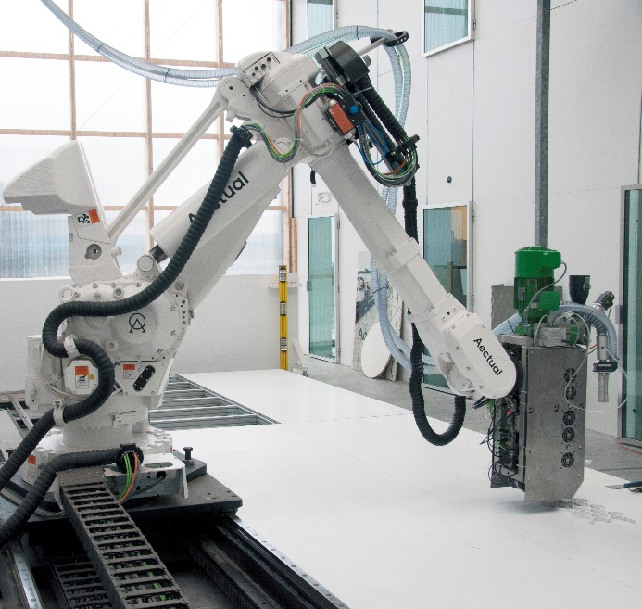
Picture PM4021-1
A triflex R energy chain filled with chainflex cables ensures fail-safe XXL 3D printer operation. The triflex RSP retraction system always keeps the energy chain at the right length. The cables in the seventh axis are guided with an E4/light energy chain. (Source: Aectual)
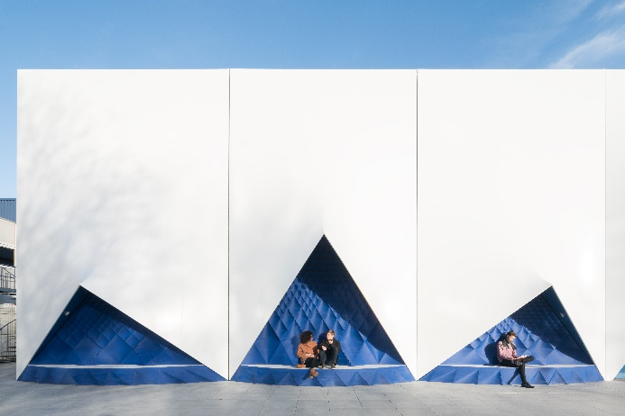
Picture PM4021-2
The printing shop produces unique products for architecture and interior design, such as room dividers and facade panels, protection and facade systems. (Source: Ossip)

ABOUT IGUS:

igus GmbH develops and produces motion plastics. These lubrication-free, high-performance polymers improve technology and reduce costs wherever things move. In energy supplies, highly flexible cables, plain and linear bearings as well as lead screw technology made of tribo-polymers, igus is the worldwide market leader. The family-run company based in Cologne, Germany, is represented in 35 countries and employs 4,150 people across the globe. In 2020, igus generated a turnover of €727 million. Research in the industry's largest test laboratories constantly yields innovations and more security for users. 234,000 articles are available from stock and the service life can be calculated online. In recent years, the company has expanded by creating internal startups, e.g. for ball bearings, robot drives, 3D printing, the RBTX platform for Lean Robotics and intelligent "smart plastics" for Industry 4.0. Among the most important environmental investments are the "chainge" programme – recycling of used e-chains - and the participation in an enterprise that produces oil from plastic waste (Plastic2Oil).

PRESS CONTACT:

Oliver Cyrus Anja Görtz-Olscher
Head of PR and Advertising Manager PR and Advertising

igus® GmbH igus® GmbH
Spicher Str. 1a Spicher Str. 1a
51147 Cologne 51147 Cologne
Tel. 0 22 03 / 96 49-459 Tel. 0 22 03 / 96 49-7153
ocyrus@igus.net agoertz@igus.net
www.igus.de/presse www.igus.de/presse

The terms "igus", “Apiro”, "chainflex", "CFRIP", "conprotect", "CTD", “drygear”, "drylin", "dry-tech", "dryspin", "easy chain", "e-chain", "e-chain systems", "e-ketten", "e-kettensysteme", "e-skin", "e-spool”, "flizz", “ibow”, “igear”, "iglidur", "igubal", “kineKIT”, "manus", "motion plastics", "pikchain", "plastics for longer life", "readychain", "readycable", “ReBeL”, "speedigus", "tribofilament“, "triflex", "robolink", “xirodur”, and "xiros" are protected by trademark laws in the Federal Republic of Germany and internationally, where applicable.

