ECOlogical: first range of igus plain bearings made from regranulated tribo-plastics
The sustainable iglidur ECO H, ECO P, ECO A180 and ECO G materials consist of regranulates and thus conserve resources

Social transformation, responsibility for the environment and changes in the way we use plastics are receiving notice in industry. For customers interested in more sustainable designs for their moving applications, igus now offers an interesting alternative: four new materials made from recycled plastic are available in the new product range iglidur ECO.

At its main site in Cologne, the motion plastics specialist igus develops and tests tribologically optimised high-performance plastics for moving applications: plain bearings, linear bearings, ball bearings, spherical bearings, energy chains, cables, 3D printing materials and plastic-based low-cost robotics. The advantages of tribo-polymers are obvious. They are lightweight and low-maintenance, and require no additional lubrication throughout their service life. This is a huge advantage because in Germany alone, more than a million metric tons of lubricating oil are sold every year, and the majority ends up in the environment. iglidur plain bearing technology can reduce this pollution while increasing the application's service life. With the plain bearing product range made of ECO materials, igus starts even earlier in the product life cycle and uses regranulate to produce new plain bearings.

Four iglidur ECO materials that require no lubrication or maintenance
The new series consists of 97 to 100% regranulated iglidur materials. To this end, sprue, a classic waste product in injection-moulding production, can be used. The new plain bearing product range includes four materials that demonstrate their advantages in a wide variety of applications: iglidur ECO H is especially resistant to temperature and media and can therefore be used in highly corrosive and hot environments. iglidur ECO P offers high mechanical strength with low moisture absorption and is therefore ideal for outdoor use. The affordable iglidur ECO A180 material is suitable for price-sensitive applications, while iglidur ECO G is extremely robust and versatile.

Fewer microplastic particles thanks to abrasion-resistant plastics
Like the entire product range of iglidur plain bearings, all ECO materials are lubricant-free, and their service life can be calculated online. In 15,000 tribological tests per year, the new ECO series and the other 58 iglidur materials prove how resistant they are to abrasion and wear. Less abrasion means less microplastic pollution and a considerably longer service life. It is not necessary to replace the machine or individual components soon. If these components are also "smart" and so that they exactly predict their service life during real operation, regular maintenance and replacement are no longer required. The plain bearing is only replaced when it has to be. This can also increase the service life of the individual components in the application. It is not necessary to routinely replace components that are still functioning correctly.

Caption:

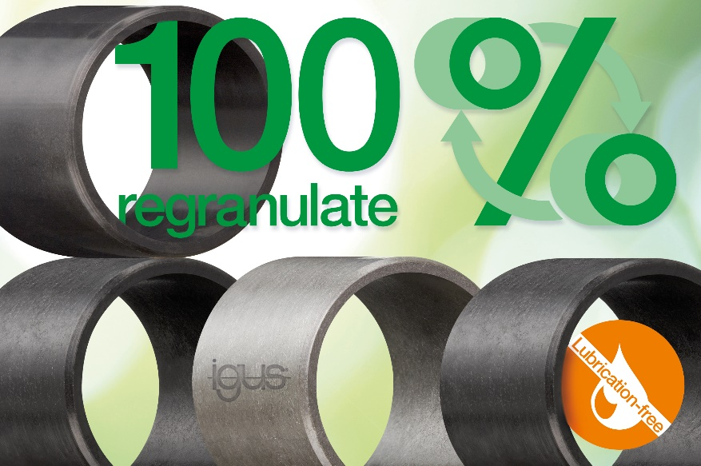
Picture PM2822-1
igus ECO plain bearing products are rely on regranulated materials and, like all igus tribo-polymers, require no lubrication or maintenance. (Source: igus GmbH)

PRESS CONTACT:

Alexa Heinzelmann
Head of International Marketing

igus® GmbH
Spicher Str. 1a
51147 Cologne
Tel. 0 22 03 / 96 49-7272
aheinzelmann@igus.net
www.igus.eu/press

ABOUT IGUS:

igus GmbH develops and produces motion plastics. These lubrication-free, high-performance polymers improve technology and reduce costs wherever things move. In energy supplies, highly flexible cables, plain and linear bearings as well as lead screw technology made of tribo-polymers, igus is the worldwide market leader. The family-run company based in Cologne, Germany, is represented in 35 countries and employs 4,900 people across the globe. In 2021, igus generated a turnover of €961 million. Research in the industry's largest test laboratories constantly yields innovations and more security for users. 234,000 articles are available from stock and the service life can be calculated online. In recent years, the company has expanded by creating internal startups, e.g. for ball bearings, robot drives, 3D printing, the RBTX platform for Lean Robotics and intelligent "smart plastics" for Industry 4.0. Among the most important environmental investments are the "chainge" programme – recycling of used e-chains - and the participation in an enterprise that produces oil from plastic waste.

The terms "igus", “Apiro”, "chainflex", "CFRIP", "conprotect", "CTD", “drygear”, "drylin", "dry-tech", "dryspin", "easy chain", "e-chain", "e-chain systems", "e-ketten", "e-kettensysteme", "e-skin", "e-spool”, "flizz", “ibow”, “igear”, "iglidur", "igubal", “kineKIT”, "manus", "motion plastics", "pikchain", "plastics for longer life", "readychain", "readycable", “ReBeL”, "speedigus", "tribofilament“, "triflex", "robolink", “xirodur”, and "xiros" are protected by trademark laws in the Federal Republic of Germany and internationally, where applicable.

