Double coupling lasts longer: new elastic double joint from igus
Flexible housing material ensures that the ball stud is firmly enclosed and prevents dirt from penetrating into the bearing

Coupling joints are exposed to various types of loads, such as permanent vibrations, edge loads and high tensile forces and compressive strength. The demands on the material used are therefore extremely high. With the igubal GPZM coupling joint, the motion plastics specialist is now presenting a double joint that is not only lubrication-free and maintenance-free, but also 20 per cent more flexible than the conventional solution thanks to a new housing material. This firmly encloses the ball stud, prevents the penetration of dirt and increases the dependability of the moving application.

Spherical bearings made of tribologically optimised polymers are already used in many industries today, the agricultural industry as well as machine and plant construction amongst them,. In the automotive industry alone, the variety of application areas is extremely large: from sensor connections, actuators, valve flaps, shift levers to turbochargers - almost any application of metallic coupling joints can also be implemented with the tribo-polymer version. Light weight, use at temperatures up to 300 degrees Celsius, corrosion resistance and long service life speak for themselves, as do the 40 per cent lower costs when using igubal coupling joints. They are maintenance-free due to the incorporated dry lubrication, no external lubricants are necessary. This also applies to the new GPZM double joint, which igus is currently presenting as part of its autumn innovations.

New material makes coupling joint more elastic
The double joint is extremely flexible and at the same time resilient. Tests in the 3,800 square metre igus laboratory showed a 25 per cent higher elasticity of the RN283 material compared to the standard material igumid G. The housing material ensures that the ball stud is tightly enclosed in the movement so that it is sealed against the ingress of dust and dirt. Liquefied dust was injected in the test; this contamination has no negative influence on the function due to the elastic material. The abrasion resistance of the metal ball studs was also tested in our own laboratory. The result convinced the igus designers: with a coefficient of wear that is 20 times better than polyamide, the new TPU material prevailed over polyamide and ensures significantly increased dependability in movement.

Caption:

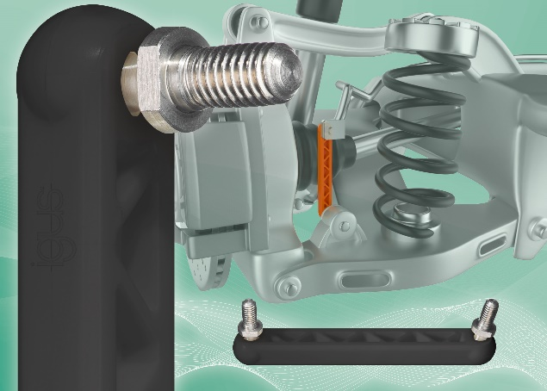
Picture PM5920-1
The new igus GPZM coupling joint is not only particularly low-maintenance and lubrication-free, but also prevents the penetration of dirt by choosing a new flexible material. (Source: igus GmbH)

PRESS CONTACT:  Oliver Cyrus  Head of PR and Advertising  Anja Görtz-Olscher  PR and Advertising  igus® GmbH  Spicher Str. 1a  51147 Cologne  Tel. 0 22 03 / 96 49-459 or -7153  Fax 0 22 03 / 96 49-631  ocyrus@igus.net  agoertz@igus.net  www.igus.eu/press | ABOUT IGUS:  igus GmbH is a global leading manufacturer of energy chain systems and polymer plain bearings. The Cologne-based family business has offices in 35 countries and employs 4,150 people around the world. In 2019, igus generated a turnover of 764 million euros from motion plastics, plastic components for moving applications. igus operates the largest test laboratories and factories in its sector to offer customers quick turnaround times on innovative products and solutions tailored to their needs.

The terms "igus", “Apiro”, "chainflex", "CFRIP", "conprotect", "CTD", “drygear”, "drylin", "dry-tech", "dryspin", "easy chain", "e-chain", "e-chain systems", "e-ketten", "e-kettensysteme", "e-skin", "e-spool”, "flizz", “ibow”, “igear”, "iglidur", "igubal", “kineKIT”, "manus", "motion plastics", "pikchain", "plastics for longer life", "readychain", "readycable", “ReBeL”, "speedigus", "tribofilament“, "triflex", "robolink", “xirodur”, and "xiros" are protected by trademark laws in the Federal Republic of Germany and internationally, where applicable.

