ROIBOT 2022: igus is looking for exciting applications with cost-effective robotics
The award for automation solutions with a fast return on investment is entering the second round.

igus's cost-effective robotics and automation solutions automate packaging, sort products, and help with dangerous tasks in everyday work. In 2022, the motion plastics specialist will once again be presenting the ROIBOT Award for the most creative applications. The judges are looking for projects that have achieved a quick return on investment using igus Low Cost Automation and drylin drive axes. The winners will receive a robotics package of their choice from the RBTX.com marketplace worth up to 5,000 euros.

Over 70 submissions from around the world were received last year for the 2019/2020 ROIBOT Award. The award honours automation projects that use cost-effective igus robotics and automation solutions. The winners from Salzburg (Austria) received prize money of 5,000 euros. The students constructed a mobile robot system with grippers to carry out dangerous handling tasks from a distance. It uses a glove equipped with sensor technology allowing intuitive control by means of gestures and providing feedback. The engineers developed a drive system, a battery system, and a mechanical framework for the cost-effective, maintenance-free igus robolink D articulated arm. The project impressed the expert judges enough to win first place. Second place went to Apostore's pick-and-place system for the healthcare sector. It consisted of a robot cell and a supply system for the bulk material to be fed. Third place went to Superwurm, a German company. The earthworm farmers used igus Low Cost Automation to develop a system that counts worms automatically and packs them in cans.

ROIBOT Award goes into the next round in 2022
The ROIBOT competition is once again searching the globe for existing Low Cost Automation applications that have led to a rapid return on investment. They can use igus's robolink articulated arm robots, drylin delta robots, Cartesian robots, and drylin drive technology. A panel of expert judges will evaluate the concepts. An exciting submission characterised by creativity and an idea for optimization will receive a high rating. The winner will receive a freely configurable robotics package worth 5,000 euros, second place 2,500 euros, and third place 1,000 euros from RBTX.com. The deadline for entries is 30 April 2022. igus will present the awards in Munich at automatica 2022, the leading trade fair for intelligent automation and robotics. Participants can apply on the website: www.igus.eu/roibot-registration

Check out the 2019/2020 ROIBOT Award winners now: https://youtu.be/HAvJHEvj-pU

Caption:

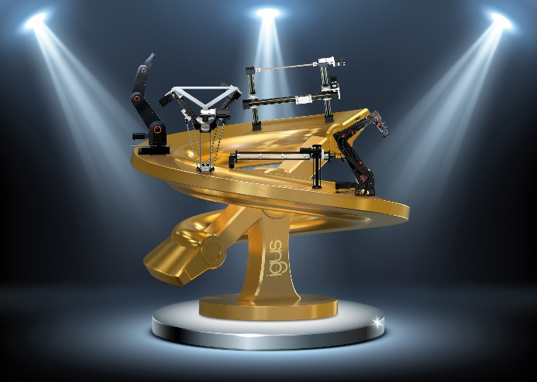
Picture PM4621-1
The igus ROIBOT Award team are looking for creative automation solutions that have achieved a quick return on investment. (Source: igus GmbH)

ABOUT IGUS:

igus GmbH develops and produces motion plastics. These lubrication-free, high-performance polymers improve technology and reduce costs wherever things move. In energy supplies, highly flexible cables, plain and linear bearings as well as lead screw technology made of tribo-polymers, igus is the worldwide market leader. The family-run company based in Cologne, Germany, is represented in 35 countries and employs 4,150 people across the globe. In 2020, igus generated a turnover of €727 million. Research in the industry's largest test laboratories constantly yields innovations and more security for users. 234,000 articles are available from stock and the service life can be calculated online. In recent years, the company has expanded by creating internal startups, e.g. for ball bearings, robot drives, 3D printing, the RBTX platform for Lean Robotics and intelligent "smart plastics" for Industry 4.0. Among the most important environmental investments are the "chainge" programme – recycling of used e-chains - and the participation in an enterprise that produces oil from plastic waste (Plastic2Oil).

PRESS CONTACT:

Oliver Cyrus Anja Görtz-Olscher
Head of PR and Advertising Manager PR and Advertising

igus® GmbH igus® GmbH
Spicher Str. 1a Spicher Str. 1a
51147 Cologne 51147 Cologne
Tel. 0 22 03 / 96 49-459 Tel. 0 22 03 / 96 49-7153
ocyrus@igus.net agoertz@igus.net
www.igus.de/presse www.igus.de/presse

The terms "igus", “Apiro”, "chainflex", "CFRIP", "conprotect", "CTD", “drygear”, "drylin", "dry-tech", "dryspin", "easy chain", "e-chain", "e-chain systems", "e-ketten", "e-kettensysteme", "e-skin", "e-spool”, "flizz", “ibow”, “igear”, "iglidur", "igubal", “kineKIT”, "manus", "motion plastics", "pikchain", "plastics for longer life", "readychain", "readycable", “ReBeL”, "speedigus", "tribofilament“, "triflex", "robolink", “xirodur”, and "xiros" are protected by trademark laws in the Federal Republic of Germany and internationally, where applicable.

