chainflex bus cables save costs with new 300V UL approval
10 times higher UL voltage provides design freedom in the assignment of the energy chain

By increasing the voltage to 300V, users can now install the chainflex bus cables directly next to cables with a higher voltage level. Previously, all cables with different voltage classes had to be laid separately according to the specifications of the UL testing organisation. With the new, enhanced and UL-approved voltage class, the user optimises their technology and saves costs and time for the energy chain design.

The Underwriters Laboratories (short: UL) is an independent organisation in the USA that tests various products for their safety. The regulations with regard to fire protection are very high. Only tested products receive the UL certificate which guarantees easy distribution of the machines and systems worldwide. With regard to cables, the UL stipulates that all cables with different voltage classes in an energy supply system must always be mechanically separated from one another. As a result, the design department has had to spend a lot of time and costs in the designing of the energy chain. To reduce this expenditure and improve technology, igus has now increased the 30V UL voltage to 300V for its CF888, CFBUS.PVC, CF898 and CFBUS.PUR chainflex bus cables and received the UL certificate. This means that cables with the same voltage level can be laid directly next to each other. It is now no longer necessary to separate the cables. "And that can reduce the size of the chain and cut down on the installation work required for separators", explains Rainer Rössel, Business Unit Manager for chainflex cables at igus.

Bus cables withstand 17 million double strokes in test
The bus cables are available in four cable qualities with PVC or PUR outer jacket. In this way, the user always gets technically the best and at the same time most cost-effective cable that works in motion. The durability of the 300V UL bus cables was also demonstrated in the in-house 3,800 square metre igus test laboratory. Here the motion plastics expert checks all its products for all events up to total failure. In a test with the CFBUS.PUR.049 bus cable with a bend radius of 10.3xd, it withstood 17 million double strokes. Due to the numerous test series, igus can grant a unique guarantee of 36 months on all chainflex cables. For the simple and fast selection of technically the best cable at a reasonable price, the chainflex service life calculator is ideal. Here the user can simply enter the ambient parameters of the application and directly obtain information on service life and price comparison of the different cable qualities.

Caption:

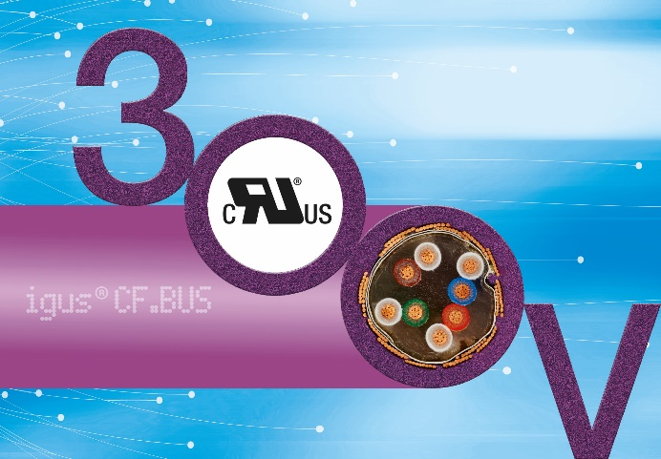

Picture PM3520-1
The new 300V UL voltage class of chainflex bus cables provides design freedom in the assignment of the energy chain and saves costs. (Source: igus GmbH)

PRESS CONTACT:  Oliver Cyrus  Head of PR and Advertising  Anja Görtz-Olscher  PR and Advertising  igus® GmbH  Spicher Str. 1a  51147 Cologne  Tel. 0 22 03 / 96 49-459 or -7153  Fax 0 22 03 / 96 49-631  ocyrus@igus.net  agoertz@igus.net  www.igus.eu/press | ABOUT IGUS:  igus GmbH is a global leading manufacturer of energy chain systems and polymer plain bearings. The Cologne-based family business has offices in 35 countries and employs 4,150 people around the world. In 2019, igus generated a turnover of 764 million euros from motion plastics, plastic components for moving applications. igus operates the largest test laboratories and factories in its sector to offer customers quick turnaround times on innovative products and solutions tailored to their needs.

The terms "igus", “Apiro”, "chainflex", "CFRIP", "conprotect", "CTD", “drygear”, "drylin", "dry-tech", "dryspin", "easy chain", "e-chain", "e-chain systems", "e-ketten", "e-kettensysteme", "e-skin", "e-spool”, "flizz", “ibow”, “igear”, "iglidur", "igubal", “kineKIT”, "manus", "motion plastics", "pikchain", "plastics for longer life", "readychain", "readycable", “ReBeL”, "speedigus", "triflex", "robolink", “xirodur”, and "xiros" are protected by trademark laws in the Federal Republic of Germany and internationally, where applicable.

