iglidur plain bearings allow the "Solaris" solar boat to move easily across the water
Lubrication-free igus polymer plain bearings support the steering system maintenance-free

A team of Polish students in Wrocław is developing the transportation of the future. The autonomous speedboat called Solaris is powered exclusively with solar energy. So that the boat can drive easily and maintenance-free over rivers and lakes, the young engineers rely on igus plain bearings made of the high-performance polymer iglidur J in the steering system. The bearings offer the necessary stability, reduce the boat's weight and ensure lubrication-free use.

Ecological vehicles that feature low operating costs and high efficiency are in greater demand than ever. A team of students in the Polish city of Wrocław, the city of a hundred bridges, has now developed a solar-powered speedboat. The Solaris I project is being implemented by the PWR Solar Boat Team under the auspices of the Faculty of Mechanical and Power Engineering. The young engineers are relying entirely on photovoltaic cells to ensure environmentally friendly propulsion. The project encompasses boat development, construction and implementation. One important part of this is the computerised steering system and enhancement of boat movement, much like the fly-by-wire system used in aviation. The design engineers were looking for plain bearings for this system. They had to be lubrication-free, resistant to seawater, mechanically robust and easy to assemble. The solution: iglidur plain bearings from igus.

Cruising on the water without lubricants
The double flange bearings made of iglidur J high-performance polymer are used in the yoke's steering system. "igus bearings ensure long service life. They reduce overall system weight, eliminate lubricants and are easy to install", says Dominika Dewor of the PWR Solar Boat Team. The team's project was sponsored by the igus young engineers support (yes) programme. The university initiative supports school and university student projects with free samples, sponsorship and consultations.

Take a look at the boat in action:
https://www.youtube.com/watch?v=GRz5xyKJpvg

Captions:

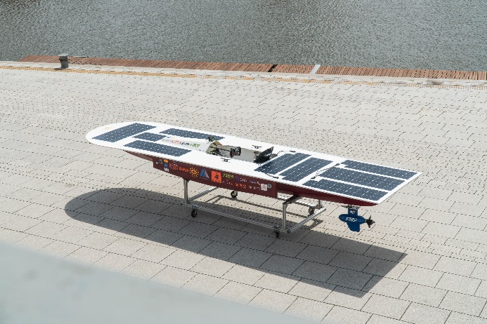
Picture PM3921-1
The Solaris speedboat glides through the water powered exclusively with solar energy. (Source: PWR Solar Boat Team)

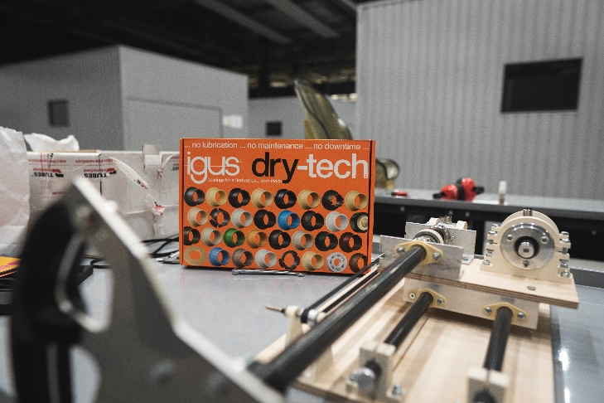
Picture PM3921-2
The lubrication-free igus plain bearings are used in the boat's steering system. (Source: PWR Solar Boat Team)

ABOUT IGUS:

igus GmbH develops and produces motion plastics. These lubrication-free, high-performance polymers improve technology and reduce costs wherever things move. In energy supplies, highly flexible cables, plain and linear bearings as well as lead screw technology made of tribo-polymers, igus is the worldwide market leader. The family-run company based in Cologne, Germany, is represented in 35 countries and employs 4,150 people across the globe. In 2020, igus generated a turnover of €727 million. Research in the industry's largest test laboratories constantly yields innovations and more security for users. 234,000 articles are available from stock and the service life can be calculated online. In recent years, the company has expanded by creating internal startups, e.g. for ball bearings, robot drives, 3D printing, the RBTX platform for Lean Robotics and intelligent "smart plastics" for Industry 4.0. Among the most important environmental investments are the "chainge" programme – recycling of used e-chains - and the participation in an enterprise that produces oil from plastic waste (Plastic2Oil).

PRESS CONTACT:

Oliver Cyrus Anja Görtz-Olscher
Head of PR and Advertising Manager PR and Advertising

igus® GmbH igus® GmbH
Spicher Str. 1a Spicher Str. 1a
51147 Cologne 51147 Cologne
Tel. 0 22 03 / 96 49-459 Tel. 0 22 03 / 96 49-7153
ocyrus@igus.net agoertz@igus.net
www.igus.de/presse www.igus.de/presse

The terms "igus", “Apiro”, "chainflex", "CFRIP", "conprotect", "CTD", “drygear”, "drylin", "dry-tech", "dryspin", "easy chain", "e-chain", "e-chain systems", "e-ketten", "e-kettensysteme", "e-skin", "e-spool”, "flizz", “ibow”, “igear”, "iglidur", "igubal", “kineKIT”, "manus", "motion plastics", "pikchain", "plastics for longer life", "readychain", "readycable", “ReBeL”, "speedigus", "tribofilament“, "triflex", "robolink", “xirodur”, and "xiros" are protected by trademark laws in the Federal Republic of Germany and internationally, where applicable.

