**A well-rounded concept: igus develops ball bearings from recycled plastic**

**The plastics specialist presents a green recycling variant of the proven xiros deep groove ball bearing**

**igus is taking another step towards sustainable plastic production: The company uses xirodur B180 high-performance plastic residue from injection moulding production to produce an ECO version of the proven xiros deep groove ball bearing. The recycled version has almost the same technical specifications and load limits.**

Even the best injection moulding production cannot recycle plastics in a 100% closed loop. Missing parts and sprues are often unavoidable. This also applies to the production of igus deep groove ball bearings, whose inner and outer rings are made of the high-performance plastic xirodur B180, among other materials. However, manufacturers can choose what happens to the excess material. Discarding them in the industrial waste is not an option, for obvious reasons. It means that valuable raw material is lost forever. And emissions from incineration add to pollution. "As a plastics manufacturer, we are aware of our responsibility to people and nature. So we have developed a process to recycle xirodur B180 high-performance plastic residue into a regranulate," says Marcus Semsroth, Head of the xiros Polymer Ball Bearings Business Unit. Excess amounts of the engineered plastic xirodur B180 ECO, which is a characteristic green colour, is used in injection moulding production at igus to produce a recycled version of the xiros deep groove ball bearing.

**Recycling variant with proven physical properties in tests**

The new ECO variant is made from four components: The inner and outer races are made of recycled xirodur B180 ECO, the cage is made of recycled iglidur J4 material, and the balls are made of either stainless steel or glass – a combination that ensures that customers do not have to sacrifice quality. "Our test laboratory in Cologne proves that the recycled version of the ball bearing achieves almost the same technical properties and load limits as the original," says Semsroth. "The only drawback is that the recycled xirodur B180 ECO plastic is no longer FDA-compliant, and therefore no longer suitable for direct contact with food." But there are so many non-food applications that make a recycled version worthwhile. Just like the original, the green recycled ball bearings enable quiet, lubricant-free and hygienic dry running in machines and systems, for example in the printing industry, in labelling and packaging machines. Here, the ECO variant polymer bearings also show some advantages compared with classic metal bearings as. The recycled deep groove plastic ball bearing is corrosion-free, particularly resistant to chemicals, non-magnetic and electrically insulating. In addition, It is up to 60 percent lighter and costs 40 percent less than the equivalent metal bearings.

**Step by step towards sustainable plastics production**

The new recycled material xirodur B180 ECO is a further step on the igus’ journey to sustainability in plastics production. Cylindrical plain bearings made of high-performance plastics have been available in an ECO version since mid-2022. For 16 of its iglidur materials, igus provides the exact same CO2 footprint as Scope 3 emissions. In addition, in 2019 the company launched Chainge, a recycling program for disused energy chains, from any manufacture. The E2.1CG cradle chain is the first energy chain in the world made from 100% regranulate. Since the start of the program, igus has collected and recycled 60 tons of high-performance plastics, recycled them into new chains and transferred them from the classic linear economy to the circular economy. And another exciting “net zero” measure is igus’s investment in Mura Technology, a company whose technology converts non-recyclable plastic waste into petroleum within 20 minutes. The oil can then be used to produce new plastic granulate.

**Caption:**

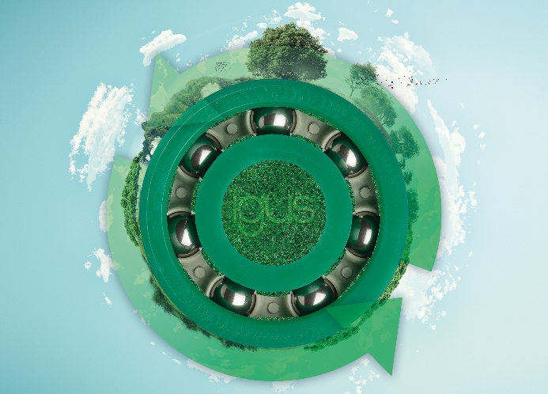

**Picture PM6222-1**

xirodur B180 gives igus a ball bearing made from recycled plastic. (Source: igus GmbH)

**PRESS CONTACT:**

Alexa Heinzelmann

Head of International Marketing

igus® GmbH

Spicher Str. 1a

51147 Cologne

Tel. 0 22 03 / 96 49-7272

[aheinzelmann@igus.net](mailto:aheinzelmann@igus.net)

[www.igus.eu/press](http://www.igus.eu/press)

**ABOUT IGUS:**

igus GmbH develops and produces motion plastics. These lubrication-free, high-performance polymers improve technology and reduce costs wherever things move. In energy supplies, highly flexible cables, plain and linear bearings as well as lead screw technology made of tribo-polymers, igus is the worldwide market leader. The family-run company based in Cologne, Germany, is represented in 31 countries and employs 4,900 people across the globe. In 2021, igus generated a turnover of €961 million. Research in the industry's largest test laboratories constantly yields innovations and more security for users. 234,000 articles are available from stock and the service life can be calculated online. In recent years, the company has expanded by creating internal startups, e.g. for ball bearings, robot drives, 3D printing, the RBTX platform for Lean Robotics and intelligent "smart plastics" for Industry 4.0. Among the most important environmental investments are the "chainge" programme – recycling of used e-chains - and the participation in an enterprise that produces oil from plastic waste.

The terms "igus", “Apiro”, "chainflex", "CFRIP", "conprotect", "CTD", “drygear”, "drylin", "dry-tech", "dryspin", "easy chain", "e-chain", "e-chain systems", "e-ketten", "e-kettensysteme", "e-skin", "e-spool”, "flizz", “ibow”, “igear”, "iglidur", "igubal", “kineKIT”, "manus", "motion plastics", "pikchain", "plastics for longer life", "readychain", "readycable", “ReBeL”, "speedigus", "tribofilament“, "triflex", "robolink", “xirodur”, and "xiros" are protected by trademark laws in the Federal Republic of Germany and internationally, where applicable.