Award-winning! igus:bike designed by mtrl receives German Design Award 2023
All-plastic bicycle wins in the category "Excellent Product Design – Bicycles and E-Bikes"

A wide, angular frame made of plastic, black wheels with Y-spokes: The futuristic look of the bike designed by mtrl, a Dutch bicycle developer, with motion plastics from igus has won the prestigious German Design Award 2023. The award brings an important step in realising the sustainability vision of a bicycle production with post-consumer-waste recycled plastic for urban mobility.

From "ocean plastics" to motion plastics: igus managing director Frank Blase and the start-up company mtrl had the dream of an urban bike made of plastic back in the late 2000s. Thanks to modern high-performance plastics, it should be rust-free, lubricant-free and maintenance-free and ride reliably in all weather conditions. The Dutch circular start-up mtrl (formerly DutchFiets) manufactures bicycles from recyclable plastics since 2015. With the cooperation partner igus, the development of the components began, in which many things were thought of in a new or different way. However, the innovation of this project is not limited to the plastic bicycle alone. With its experience in motion plastics, igus makes plastic bicycle parts available to other manufacturers on its igus:bike platform. Also, the platform showcases new technology and helps bicycle and component manufacturers to network as well as exchange information with each other.

This bike does not have much in common with the appearance of a normal bicycle. It looks more like something out of a science fiction film. The frame made of plastic has almost no curves, is characterised by angular shapes and is wider than usual. The Y-shaped spokes also catch the eye. A futuristic design of mtrl that has now won the German Design Award 2023 - in the category "Excellent Product Design - Bicycles and E-Bikes". "We are delighted to receive this award, which many novel and pioneering products have received before us in recent years," says Frank Blase. “The award rewards the teams at mtrl and igus for their innovative spirit and disruptive thinking. After all, an all-plastic bicycle made from recycled plastic would be a great leap forward in modern urban mobility", adds Johannes Alderse Baas, founder of mtrl.

"Outstanding design means providing answers to the challenges of our time"
The prize is awarded for the eleventh time by the German Design Council, a Frankfurt-based foundation established in 1953 on the initiative of the German Bundestag. It supports the economy in achieving brand added value through design. "Outstanding design means providing answers to the challenges of our time and thinking further ahead," explains the foundation. "The high-calibre international jury recognises these ground-breaking design achievements." The award ceremony will take place in February 2023. But to which challenge of our time does the bike made by mtrl and the igus:bike platform provide the answer? The world is drowning in plastic waste. Some of the plastic ends up in the sea, enters the food chain and becomes a danger to humans and animals. Other parts find their way into incineration plants and produces environmentally harmful emissions. Therefore, it is most urgent to transfer plastics into a circular economy. The all-plastic bicycle makes this transformation possible.

With high-performance plastics for a long service life
Lightweight and lubrication-free high-performance plastics from igus are used everywhere on the bicycle – from ball bearings in the wheel to bearings in the brake levers and pedals. All components have integrated solid lubricants and ensure low-friction dry running – without a single drop of lubricating oil. Owners can leave the bike outdoors in all weathers without hesitation and clean it in seconds with a garden hose. The bike, which is suitable for everyday use, does not rust and is virtually maintenance-free. Delivery for the first bikes is planned for the end of Q1 2023. An e-bike and a children's model are to follow. And upcycling is also possible with this bike: four children's bikes can be turned into an adult bike. For the future, igus is planning in close collaboration with mtrl local production sites around the world near plastic landfills.

Caption:

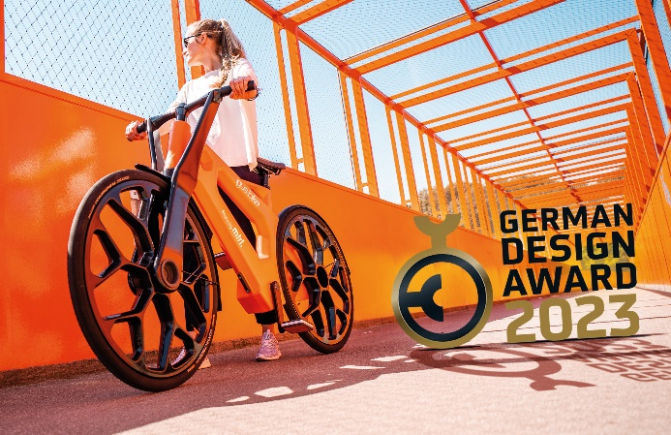
Picture PM7522-1
The futuristic look of the igus:bike designed by mtrl has won the prestigious German Design Award 2023. (Source: igus GmbH)

PRESS CONTACT:

Alexa Heinzelmann
Head of International Marketing

igus® GmbH
Spicher Str. 1a
51147 Cologne
Tel. 0 22 03 / 96 49-7272
aheinzelmann@igus.net
www.igus.eu/press

ABOUT IGUS:

igus GmbH develops and produces motion plastics. These lubrication-free, high-performance polymers improve technology and reduce costs wherever things move. In energy supplies, highly flexible cables, plain and linear bearings as well as lead screw technology made of tribo-polymers, igus is the worldwide market leader. The family-run company based in Cologne, Germany, is represented in 31 countries and employs 4,900 people across the globe. In 2021, igus generated a turnover of €961 million. Research in the industry's largest test laboratories constantly yields innovations and more security for users. 234,000 articles are available from stock and the service life can be calculated online. In recent years, the company has expanded by creating internal startups, e.g. for ball bearings, robot drives, 3D printing, the RBTX platform for Lean Robotics and intelligent "smart plastics" for Industry 4.0. Among the most important environmental investments are the "chainge" programme – recycling of used e-chains - and the participation in an enterprise that produces oil from plastic waste.

The terms "igus", “Apiro”, "chainflex", "CFRIP", "conprotect", "CTD", “drygear”, "drylin", "dry-tech", "dryspin", "easy chain", "e-chain", "e-chain systems", "e-ketten", "e-kettensysteme", "e-skin", "e-spool”, "flizz", “ibow”, “igear”, "iglidur", "igubal", “kineKIT”, "manus", "motion plastics", "pikchain", "plastics for longer life", "readychain", "readycable", “ReBeL”, "speedigus", "tribofilament“, "triflex", "robolink", “xirodur”, and "xiros" are protected by trademark laws in the Federal Republic of Germany and internationally, where applicable.

