Low Cost Automation in XXL: large DIY palletiser from igus at a small price
The drylin XXL room linear robot is up to 60 percent more cost-effective than comparable solutions and particularly easy to commission

The company igus is expanding its broad Low Cost Automation range with a new drylin XXL room linear robot. The linear robot has an action radius of 2,000 x 2,000 x 1,500 millimetres and is particularly suitable for palletising applications of up to 10 kilograms. The robot is available from 7,000 euros, including the control system, and is easy to set up and programme yourself using the do-it-yourself principle - without the help of a system integrator.

Too expensive to purchase, too complex to programme, too complicated to maintain: many small and medium-sized companies shy away from getting started with automation. That way, they jeopardise their competitiveness in the long term. But it's easy to get started. This is proven by the drylin XXL linear robot from igus. The DIY kit offers companies the opportunity to quickly and easily put a pick-and-place linear robot into operation for tasks related to palletising, sorting, labelling and quality inspection. "Palletising robots created in collaboration with external service providers cost between €85,000 and €120,000. This is beyond the budget of many small companies", says Alexander Mühlens, Head of the Low Cost Automation Business Unit at igus. "We have therefore developed a solution that is many times more cost-effective due to the use of high-performance plastics and lightweight materials, such as aluminium. For example, the drylin XXL room linear robot costs between €7,000 and €10,000, depending on the expansion stage. It is a low-risk investment that usually pays off within a few weeks."

DIY kit can be quickly assembled without prior knowledge
The buyer receives the room linear robot as a DIY kit. It consists of two toothed belt axes and a toothed rack cantilever axis with stepper motors and an action range of 2,000 x 2,000 x 1,500 millimetres. In the maximum length, up to 6,000 x 6,000 x 1,500 millimetres are also possible. In addition, the package includes a switch cabinet, cables and energy chains as well as the free igus Robot Control (iRC) control software. Users can assemble the components into a ready-to-use linear robot in just a few hours - without external help, prior knowledge or a long training period. And if additional components such as camera systems or grippers are still needed, users will quickly find them on the robotics marketplace RBTX.

Automation relieves employees
The Cartesian robot is used, for example, on conveyor belts that transport products away from injection-moulding machines. Here, the robot takes parts with a maximum weight of 10 kilograms from the conveyor belt, transports them at a speed of up to 500mm/s and positions them on a pallet with a repeatability of 0.8 millimetres. "Thanks to this automation, plants can relieve their employees of physically demanding and time-consuming palletising work and free up resources for more important tasks." The system itself does not require any maintenance. The linear axes consist of corrosion-free aluminium, and the carriages move via plain bearings made of high-performance plastic, which, thanks to integrated solid lubricants, enable a low-friction dry operation without external lubricants for many years - even in dusty and dirty environments.

Digital robot 3D twin enables foolproof programming
However, not only the assembly, but also the programming of motion sequences is not an entry barrier. "For many companies that don't have in-house IT specialists, programming robots is often fraught with problems", Mühlens said. "That's why we developed iRC, a free software that visually resembles commonly used office software and allows intuitive programming of movements. What makes it special is that the software is free and the resulting low-code programming can then be used 1:1 on the real robot." The core of the software is a digital twin of the linear robot, which can be used to define movements with just a few clicks. Even in advance, before the robot is in operation. "Prospective buyers can use the 3D model to check whether desired movements are actually feasible before making a purchase. Furthermore, we invite all interested parties to try out our robots live or via the Internet free of charge. We support them during commissioning and show what is possible with low-cost robots. It makes the investment virtually risk-free."

Caption:

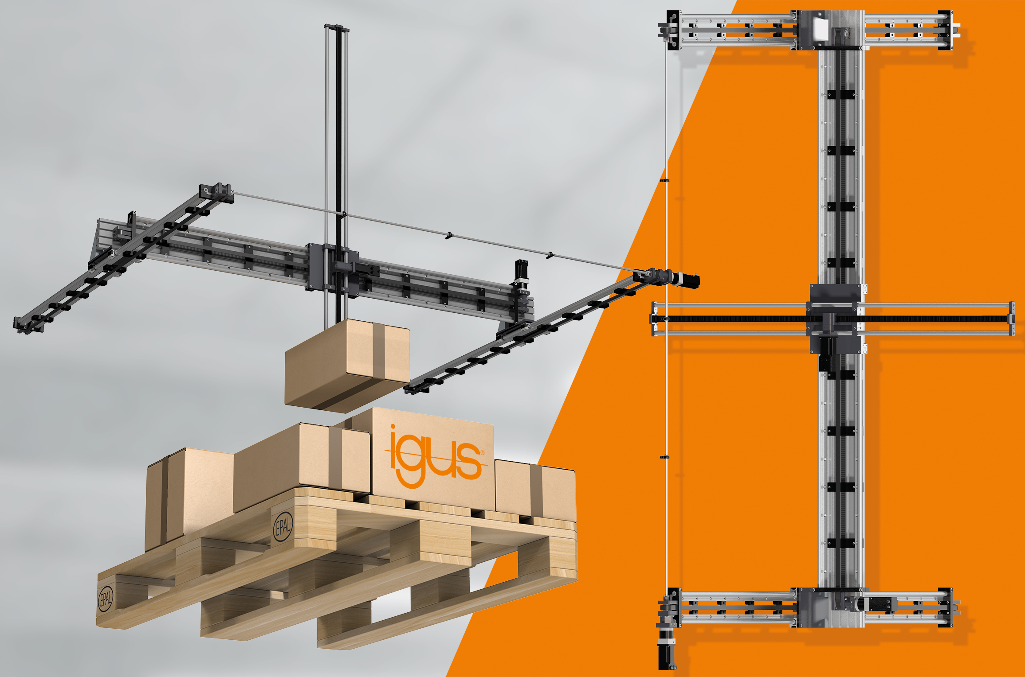
Picture PM0822-1
The lubrication-free and maintenance-free drylin XXL room linear robot from igus lifts up to 10 kilograms and costs up to 60 percent less than comparable solutions. (Source: igus GmbH)

PRESS CONTACT:

Alexa Heinzelmann
Head of International Marketing

igus® GmbH
Spicher Str. 1a
51147 Cologne
Tel. 0 22 03 / 96 49-7272
aheinzelmann@igus.net
www.igus.eu/press

ABOUT IGUS:

igus GmbH develops and produces motion plastics. These lubrication-free, high-performance polymers improve technology and reduce costs wherever things move. In energy supplies, highly flexible cables, plain and linear bearings as well as lead screw technology made of tribo-polymers, igus is the worldwide market leader. The family-run company based in Cologne, Germany, is represented in 35 countries and employs 4,150 people across the globe. In 2020, igus generated a turnover of €727 million. Research in the industry's largest test laboratories constantly yields innovations and more security for users. 234,000 articles are available from stock and the service life can be calculated online. In recent years, the company has expanded by creating internal startups, e.g. for ball bearings, robot drives, 3D printing, the RBTX platform for Lean Robotics and intelligent "smart plastics" for Industry 4.0. Among the most important environmental investments are the "chainge" programme – recycling of used e-chains - and the participation in an enterprise that produces oil from plastic waste.

The terms "igus", “Apiro”, "chainflex", "CFRIP", "conprotect", "CTD", “drygear”, "drylin", "dry-tech", "dryspin", "easy chain", "e-chain", "e-chain systems", "e-ketten", "e-kettensysteme", "e-skin", "e-spool”, "flizz", “ibow”, “igear”, "iglidur", "igubal", “kineKIT”, "manus", "motion plastics", "pikchain", "plastics for longer life", "readychain", "readycable", “ReBeL”, "speedigus", "tribofilament“, "triflex", "robolink", “xirodur”, and "xiros" are protected by trademark laws in the Federal Republic of Germany and internationally, where applicable.

