The rotating lightning conductor: new guide roller from igus protects against sparks
Lubrication and maintenance-free xiros stainless steel guide roller ensures safe operation thanks to electrostatic dissipation

In the industry, sparks due to a lack of electrostatic discharge can lead to expensive breakdowns of machines and systems and worst case explosions. In order to increase protection here, igus has expanded the range of lubrication and maintenance-free xiros guide rollers to include a dissipative variant made of stainless steel.

When you are in a department store with rubber soled shoes and you grab the banister of the escalator, you get an electric shock: unpleasant, but not a major problem. On the other hand, the situation is different in many industrial production and processing operations, such as machines and systems for film production or food packaging. Here, uncontrolled electrostatic discharges and sparks can lead to machine damage, high downtime and repair costs and worst case scenario can even trigger fires and explosions. To protect companies from such damage, igus has developed the xiros stainless steel guide roller - a kind of rotating lightning conductor that ensures a controlled electrostatic discharge. They are a cost-effective alternative to antistatic brushes and expensive proprietary designs. The ready-to-install guide rollers are available in stock sizes 608, 6000 and 6001 with a stainless steel tube length of 100 to 1,000 millimetres.

The freedom from lubrication enables barrier-free electrostatic discharge
The new xiros stainless steel guide roller is suitable as a deflection roller for films in packaging machines. It is made of a stainless steel/plastic material mix that provides electrostatic dissipation: the tube and balls of the rolling bearing are made of stainless steel. The inner and outer rings are made of the company's own antistatic high-performance plastic xirodur F180. They can be used in the temperature ranges between -40°C and +80°C. Unlike classic metal bearings, there is no need for lubricants that have an insulating effect and could prevent conduction. The absence of lubricants ensures the electrostatic dissipation is possible via the outer surface of the tube, onto the outer ring, then to the balls in the bearing and finally via the inner ring to the shaft.

Individual components suitable for contact with food
However, the antistatic specifications are not the only advantage of lubrication free xiros stainless steel guide roller's. The dry operation also improves the hygiene of machines and systems and reduces the risk of contamination. All individual components are also suitable for contact with food. Users benefit from the long service life and reduced maintenance costs, as there are no inserts for re lubricating the rolling bearings. For the quick selection of the right guide roller, igus has developed the guide roller expert. In the online tool, the user has to specify the outer and inner diameter as well as the length of the roller, the load, the load case and the ambient temperature. By entering the force and the degree of wrap, the online expert calculates the resulting force on the roller and displays the best solutions. In the second step, the user can select their guide roller based on the data for deflection, weight and price, can download the CAD data for the configuration and order the roller online.

Caption:

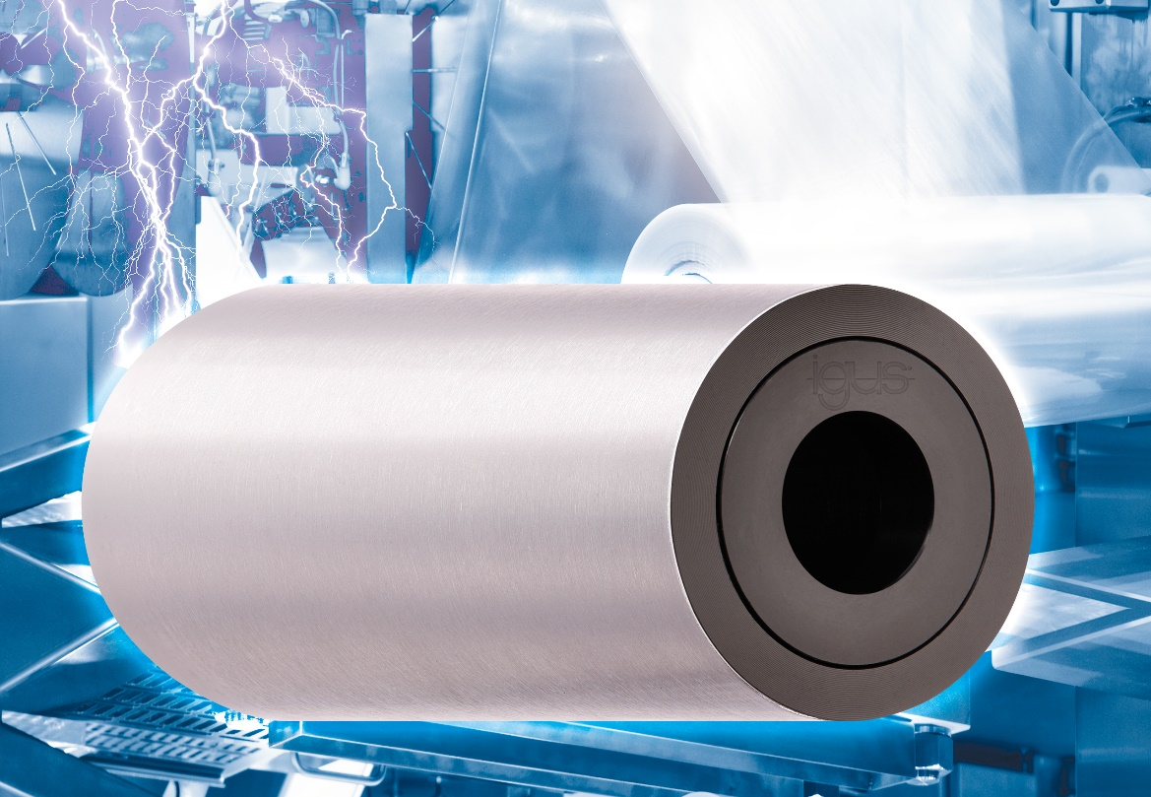
Picture PM6821-1
Antistatic: the absence of lubricants in the xiros stainless steel guide roller gives users a clear plus in terms of safety. (Source: igus GmbH)

PRESS CONTACT:

Alexa Heinzelmann
Head of International Marketing

igus® GmbH
Spicher Str. 1a
51147 Cologne
Tel. 0 22 03 / 96 49-7272
aheinzelmann@igus.net
www.igus.eu/press

ABOUT IGUS:

igus GmbH develops and produces motion plastics. These lubrication-free, high-performance polymers improve technology and reduce costs wherever things move. In energy supplies, highly flexible cables, plain and linear bearings as well as lead screw technology made of tribo-polymers, igus is the worldwide market leader. The family-run company based in Cologne, Germany, is represented in 35 countries and employs 4,150 people across the globe. In 2020, igus generated a turnover of €727 million. Research in the industry's largest test laboratories constantly yields innovations and more security for users. 234,000 articles are available from stock and the service life can be calculated online. In recent years, the company has expanded by creating internal startups, e.g. for ball bearings, robot drives, 3D printing, the RBTX platform for Lean Robotics and intelligent "smart plastics" for Industry 4.0. Among the most important environmental investments are the "chainge" programme – recycling of used e-chains - and the participation in an enterprise that produces oil from plastic waste (Plastic2Oil).

The terms "igus", “Apiro”, "chainflex", "CFRIP", "conprotect", "CTD", “drygear”, "drylin", "dry-tech", "dryspin", "easy chain", "e-chain", "e-chain systems", "e-ketten", "e-kettensysteme", "e-skin", "e-spool”, "flizz", “ibow”, “igear”, "iglidur", "igubal", “kineKIT”, "manus", "motion plastics", "pikchain", "plastics for longer life", "readychain", "readycable", “ReBeL”, "speedigus", "tribofilament“, "triflex", "robolink", “xirodur”, and "xiros" are protected by trademark laws in the Federal Republic of Germany and internationally, where applicable.

