Clean, safe, lubrication-free: igus presents the hygienic design linear guide
A self-draining design, iglidur high-performance plastic and stainless steel ensure an exceptionally hygienic linear guide

Cleaning with chemicals is a daily occurrence for machines in the food processing industry. Even the smallest blind spot can collect moisture and can lead to contamination within the machine. More and more operators are therefore designing parts with an emphasis on Hygienic Design. igus is a member of the EHEDG and has developed the first linear guide system, based on the Hygienic Design guidelines. Using FDA-compliant materials such as the high-performance polymer iglidur A160, high-alloy stainless steel and a washable interior of the carriage ensures the hygienic design is adhered to.

Special rules apply in the food, pharmaceutical and cosmetics industries. Hygiene is the highest requirement that is placed on parts within machines. It is important to ensure that there is never any contamination on products. Therefore, machine builders and plant operators ensure they design parts with the best materials for the components. Best case, they comply with the FDA and EU regulations. "More and more customers want an optimised design based on hygienic design principles. They are looking for parts to have an open design that withstands regular cleaning processes with chemicals, steam and high pressure water," says Stefan Niermann, Head of drylin Linear and Drive Technology at igus GmbH. Companies are now demanding lubrication-free components that can be cleaned quickly ensuing downtimes are limited. igus has now developed a drylin W linear guide according to hygienic design guidelines. The plastics specialist has joined the EHEDG, an association of suppliers to the food industry, universities, health authorities and research institutes.

A gap-free construction with the right materials
The main challenge was how to construct a gap-free design. The focus was on designing a self-draining carriage and rail that would allow liquids to drain freely without collecting water. "This is a brand new innovation for the linear technology market. So far, most hygienic design solutions have been based on a completely enclosed unit," explains Niermann. This new self-draining carriage consists entirely of the high-performance polymer iglidur A160, one of the FDA- and EU10/2011-compliant igus materials. The lubrication-free material has already proved itself as a plain bearing material in numerous applications in the food industry. Hygienic screws and large grooves are also used as a method to prevent water from accumulating and bevelled edges allow cleaning solutions to run off easily. The bottom seal protects the space under the rail from dirt accumulation, ensuring no residues of food can be caught. The shafts are also sealed to prevent any gaps from collecting debris. A corrosion-free and high-alloy 316 stainless steel is used as the linear rail to avoid microscopic surface structures that prevent dirt from adhering.

Caption:
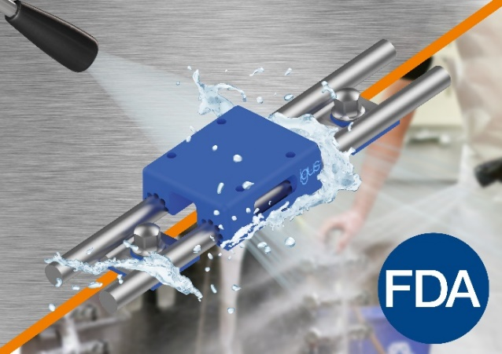
Picture PM2323-1
For fast cleaning, igus has developed a linear guide in hygienic design with an FDA-compliant and lubrication-free linear carriage. (Source: igus GmbH)

PRESS CONTACT:

Alexa Heinzelmann
Head of International Marketing

igus® GmbH
Spicher Str. 1a
51147 Cologne
Tel. 0 22 03 / 96 49-7272
aheinzelmann@igus.net
www.igus.eu/press

ABOUT IGUS:

igus GmbH develops and produces motion plastics. These lubrication-free, high-performance polymers improve technology and reduce costs wherever things move. In energy supplies, highly flexible cables, plain and linear bearings as well as lead screw technology made of tribo-polymers, igus is the worldwide market leader. The family-run company based in Cologne, Germany, is represented in 31 countries and employs 4,600 people across the globe. In 2022, igus generated a turnover of €1,15 billion. Research in the industry's largest test laboratories constantly yields innovations and more security for users. 234,000 articles are available from stock and the service life can be calculated online. In recent years, the company has expanded by creating internal startups, e.g. for ball bearings, robot drives, 3D printing, the RBTX platform for Lean Robotics and intelligent "smart plastics" for Industry 4.0. Among the most important environmental investments are the "chainge" programme – recycling of used e-chains - and the participation in an enterprise that produces oil from plastic waste.

The terms "igus", “Apiro”, "chainflex", "CFRIP", "conprotect", "CTD", “drygear”, "drylin", "dry-tech", "dryspin", "easy chain", "e-chain", "e-chain systems", "e-ketten", "e-kettensysteme", "e-skin", "e-spool”, "flizz", “ibow”, “igear”, "iglidur", "igubal", “kineKIT”, "manus", "motion plastics", "pikchain", "plastics for longer life", "readychain", "readycable", “ReBeL”, "speedigus", "tribofilament“, "triflex", "robolink", “xirodur”, and "xiros" are protected by trademark laws in the Federal Republic of Germany and internationally, where applicable.

